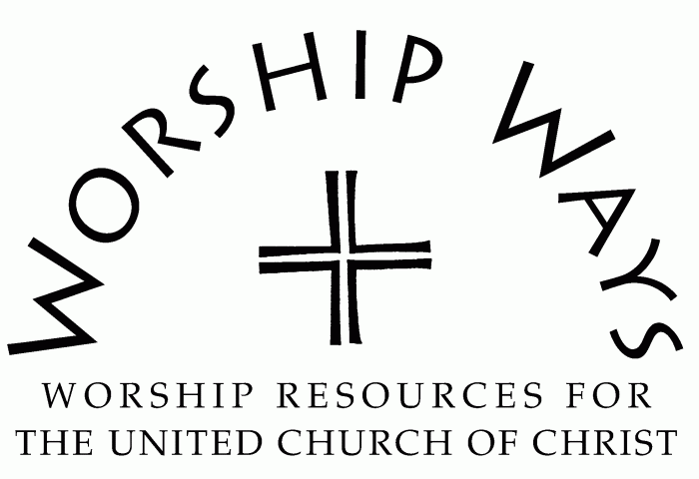

Sunday, August 23, 2026
Thirteenth Sunday after Pentecost | Year A
Exodus 1:8-2:10 | "Out of the Water"

Call to Worship (inspired by Psalm 124)
One: Blessed be the Holy One. If it had not been God on our side—the people proclaim!
Many: With God on our side, we find our help in the name of the Holy One!
One: Blessed be the Holy One, who draws us from aimlessness, despair, and bitterness.
Many: With God on our side, we find purpose, hope, and peace.
One: Blessed be the Holy One, who calls us to love one another—neighbors, enemies, family and friends.
Many: With God on our side, we find compassion, grace, and mercy for one another. Blessed be the Holy One!

Invocation
Living God, you draw us from the waters that offer both life and death, nourishment and destruction, peace and power. We gather as your people to remember your timely and tangible works. We call upon your many names as we have known you to be Redeemer, Counselor, Shepherd, and Friend. We worship you for who you are, and we draw near to become who you have crafted us to be. Amen.

Prayer for Transformation and New Life
Sovereign God, we often forget important truths and lessons the past offers us, devalue the relationships brought to us, and misuse the power given to us. Help us to live in truth, with integrity, and for peace. May love and compassion guide us in all our actions and interactions. Amen.

Words of Grace
Body of Christ, in the words of Romans 12:2, "Do not be conformed to this age, but be transformed by the renewing of the minds, so that you may discern what is the will of God--what is good and acceptable and perfect." Receive the grace of God and the power of being in community to proceed in the newness of life as the One who loves us draws us from the threat of the depths into the hope of a blessed future.

Invitation to Generosity
When we share our resources in community, we demonstrate our faith and trust in God's provision and in our collective discernment. When we give, we replicate the Holy One's generosity and creativity. When we offer ourselves, we magnify the blessings Creator has bestowed upon us. Let us give in a spirit of joy and hope for the kindom of God.

Prayer of Dedication and Thanksgiving
Wonderful God, please sanctify these gifts for your glory, amplify them for your people, and replicate them for your kindom. May they meet the needs and hopes of the world and community in which we belong.

Benediction
With keys to the kindom,
Given by the Creator of all,
Draw from the water of salvation and redemption.
Live in the purpose and promise of God.
Proclaim the power of heaven on earth.
Be the body of Christ wherever you go,
And know that Holy one goes before you.

Out of the Water: Service Prayers for the Thirteenth Sunday after Pentecost Year A was written by the Rev. Dr. Cheryl A. Lindsay, Minister for Worship and Theology for the United Church of Christ.

