April 28, 2024  
Fifth Sunday of Easter

+ Pacific Islander and Asian American Ministries (PAAM) Sunday

Waiting for the Feast Easter Series: “Much Fruit”

(rev. 3/21/24)

Acts 8:26-40, Psalm 22:25-31, 1 John 4:7-21, **John 15:1-8**

For use by all UCC churches on April 28, 2024

Optional pre-worship preparation: “Sharing Much Fruit” If your congregation has a time for fellowship (“coffee hour”) after or between Sunday worship services, consider enhancing your worship day experience in keeping with the “Much Fruit” worship theme for this Fifth Sunday of Easter, Year B. Invite your fellowship hour hosts to share or provide fruit salad as healthy mid-morning refreshment. Moreover, in keeping with the spirit of Pacific Islander and Asian American Ministries Sunday, invite them to include tropical or Asian fruits that they might find in their backyards or local Asian or Polynesian markets: mango, papaya, guava, lychee, rambutan, longan, dragon fruit, mangosteen, kumquat, persimmon, starfruit, pomelo, pineapple, banana, etc. (Purchasing a giant jackfruit or durian would be quite an investment, but oh! What an experience for your congregation!) An alternative experience might be to purchase a variety of Asian or Hawaiian fruit drinks in cans: various guava, mango, lychee, passionfruit (lilikoi), mangosteen fruit drinks, are available in the canned beverage section of your local Asian supermarket. Enjoy tasting much fruit!

Passing of the Peace [Greet one another with “Peace be with you” in the language of your choice. For more responsive signs of peace in other languages see Appendix.]

Call to Worship [congregation respond in **bold print**] (Psalm 22:25-31, John 15:4-11)

God rules over the nations of the earth:

**Peoples of the Pacific, families on farmlands, all worship God Almighty!**

This One is God of our ancestors and our descendants.

**In Jesus, we are connected to one another in a vine of covenant.**

Bear and share the fruit of Christ’s love

**That we may proclaim a just world for all!**

Children’s Sermon (John 15:1-8) You Can Tell by the Fruit

You may share your message using grape clusters purchased from your local market. However, to acknowledge UCC PAAM Sunday, I encourage you to feature an Asian or tropical fruit available in greater variety at your local Asian supermarket. Or you may use these pictures of Asian fruits to enhance your message [Some pictures below include an apple or oranges for size comparison]:

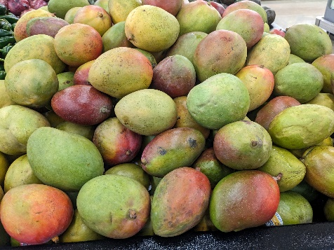

1.Mango 2. Pomelo (cf. orange) 3. Longan

1.Dragonfruit (and it’s the Year of the Dragon!) 2. Jackfruit (cf. apple) 3. Durian (cf. orange)

Do you like to eat fruit? For a healthy body, it is important for you to eat a variety of fruits and vegetables every day. [Share a story about your favorite fruit.]

Fruits are grown on trees, bushes, vines and other kinds of plants. Farmers who grow our food need to care for the plants which produce fruits.

Look at UCC member Fred, our Filipino farmer growing *calamansi* (Filipino lime). He needs to take care of the calamansi tree which may include pruning off dead branches that are completely dry and have no leaves or fruit.

1.Removing dead branches 2. Look! Flowers and fruit 3. Harvesting much fruit

With the right kind of soil, fertilizer, and especially water and sunlight, the plant will produce fragrant white flowers which eventually bring forth the budding fruit. Before long the tree will produce much fruit so you can boost the deliciousness of your *pancit* (Filipino noodles) with a tangy, sweet squeeze of calamansi juice. Pick them green if you love more sour taste.

It’s like a story Jesus told. Jesus once compared himself to a vine and compared God to a vine grower. The vine grower removes the branches that don’t produce fruit (grapes) and throws them away (to be burned).

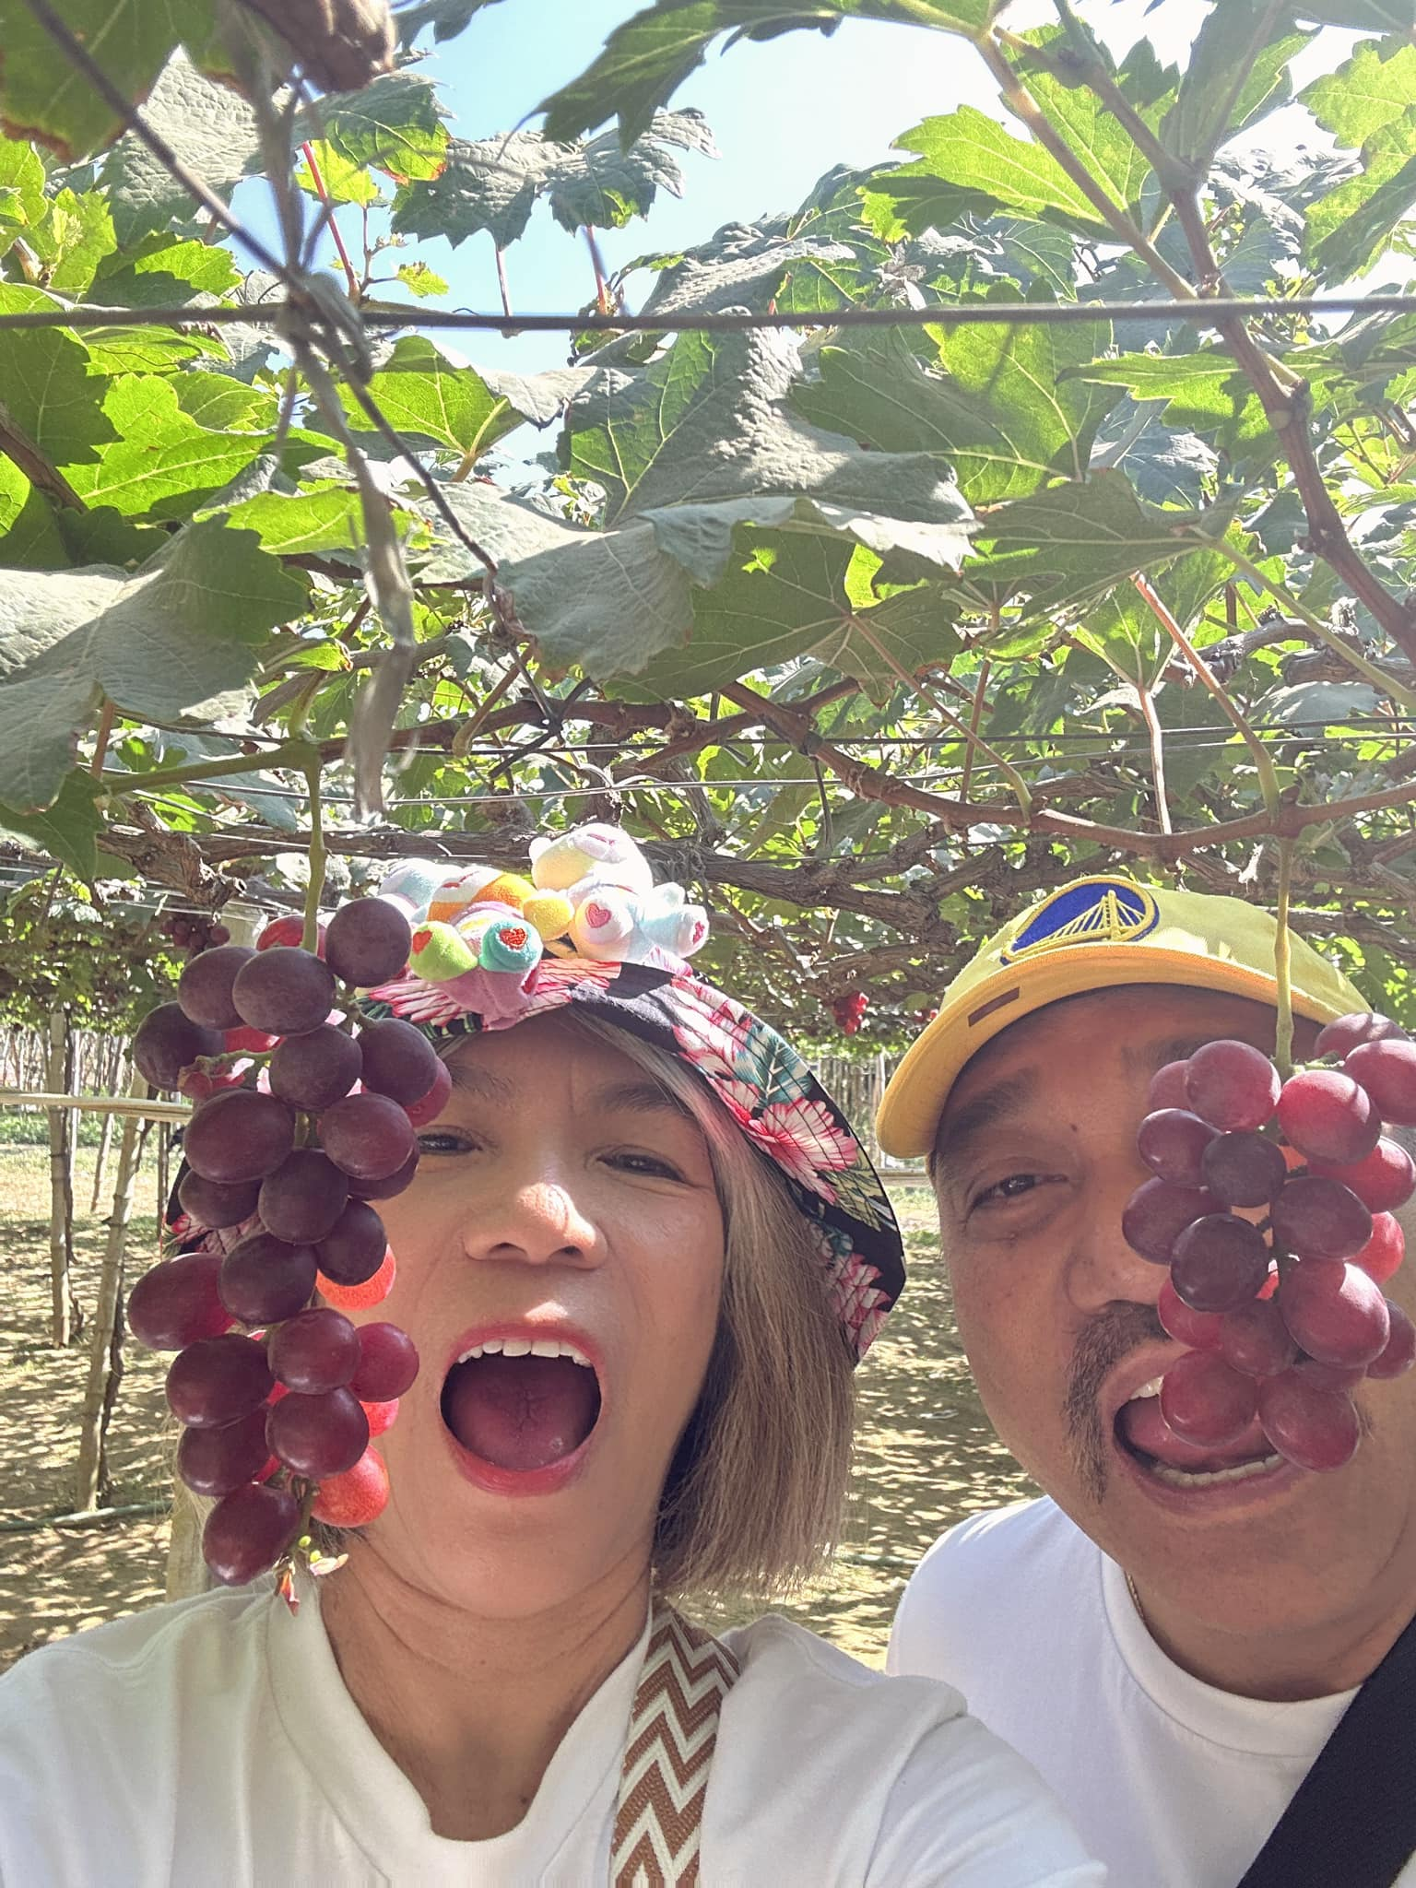

1.Withered branches for burning. 2.Vineyard in the Philippines with Much Fruit

Moreover, Jesus says “I am the vine, you are the branches.” Jesus wants us to know that it is important to stay connected to him and each other. Imagine this: grapes only grow from the healthy branches of a grapevine. If we want to see fruit (good results), we need to stay connected to Jesus. Not only is this how we glorify God, but staying connected to Jesus is also how we produce fruit that shows that we are followers (disciples) of Jesus.

Prayer: Thank you, God, for delicious fruit from your Creation. Thank you for sun, soil, water and farmers that help plants produce fruit for us to enjoy. And thank you that we can be connected to Jesus like branches on a grapevine. Help us to produce your fruit of love and peace. Amen.

Pastoral Prayer (Psalm 22:27-28, John 15:1-7)

God of love, Jesus, the true vine extends to connect the continents and oceans of this world. We recognize that we are all immigrants from different islands, small and large, with all nations under your dominion, no matter where we are on life’s journey.

On this PAAM Sunday, we give you thanks and pray for the Pacific Islander and Asian American Ministries of our United Church of Christ: for 50 continuous years seeking justice and lifting up the voices of the Pacific Islander and Asian American churches. Guide all our churches as we share in mutual ministry embracing all the families of the earth.

God of all nations, we pray for the brokenness within our nation. We are sisters and brothers and yet we struggle to find love with one another. Open our ears and our hearts to one another that we may live as you command us to love, even and especially those who differ from us. Give us courage to seek your perfect love which casts out all fear.

God of wholeness and healing, we pray for all who suffer in body and spirit. Remove that which takes life from them; restore to them that which is life-giving, that we may all bear the fruit of your love. We offer all our prayers to you in the name of Jesus Christ, our true vine. Amen.

Prayer of Confession (Psalm 22:30, John 15:1-2, 5-8, 1 John 4:12,17-18)

**Abundant God, we desire to be a part of your Vine of Love. Yet we confess how we have too often tried to assume your role as Holy Vine Grower: we have judged other branches as unworthy to be connected to us and we have tried to prune them off the True Vine saying “You don’t belong; you don’t produce fruit; you don’t produce the right kind of fruit; your fruit smells funny; you belong in the compost heap.” By living in our comfort zones and our arrogance, we have failed to see our own bad fruit of smug self-righteousness.**

**Can we even begin to ask forgiveness for ourselves so that the sins of our ancestors might not become the legacy of our descendants? Graft us back to abide in the true vine: entwine us in your lei of perfect love. Amen.**

Assurance of Forgiveness (1 John 4:9-12,20; John 15:1, 5)

God's love was revealed among us in this way: God’s own beloved Child was sent into the world to be the atoning sacrifice for our sins, so that we might live through Christ. On behalf of the God whom no one has ever seen, look into the eyes of the persons sitting next to you who you can see, and extend your arms as symbols of branches of Jesus, the true vine, and proclaim: “In God’s love, you are forgiven.”

Call to Offering (Psalm 22:25-26; John 15:5,10-11)

We praise God by sharing the abundant fruit of God’s love with our sisters and brothers throughout the world, so that every empty bowl may be filled with enough rice, every empty plate covered with enough tortillas, every empty stomach satisfied with enough taro. Let us live in God’s love so that our joy may be complete.

Prayer of Dedication (John 15:1; 1 John 4:8,21; Psalm 22:26)

Dear God, Holy Vine Grower, you are love. May the offerings we share today be a source of hope for the poor. Help us to live out your commandment to love others, not just because we reach out to them as our sisters and brothers, but also because as *our* sisters and brothers, *they* reach out to *us* as well. Amen.

Benediction (1 John 4:7,19-21)

We love because God first loved us.

You who love God must love your brothers and sisters also.

E aloha kekahi i kekahi. Love one another.

[Additional benedictions may be added in the language of your choice.]

Ia outou fealofani!**[Samoan]**

Mag-ibigan sa isat-isa. [Tagalog]

Iakwe im iakwe ro jet. [Marshallese]

互いに愛し合いなさい。(Tagaini aishiai nasai.)  [Japanese]

**서로 사랑하**라. (Saw-roh sa-rang-ha-rah.) [Korean]

**Aménse los unos a los otros. [Spanish]**

Need help with pronunciation? Ask a native speaker of those languages or try cut and paste phrases into Google Translate.

Possible/Suggested music selections

E Ka Makua E (Abide with Me) Nā Hīmeni O Ka ‘Ekalesia 63, TNCH 99

Praise to God TNCH 5

There Are Many Lightbeams TNCH 163

Like the Murmur of the Dove’s Song TNCH 270

Sun of My Soul, O Savior Dear TNCH 96

Golden Breaks the Dawn TNCH 470

Enter the Realm of God TNCH 615

Lei Mekia Sing! 64

When I Was Baptized Sing! 53

You Are the Vine (Danny Daniels)

Sunday School songs: “His Banner Over Me is Love” and “The Papaya Song”

Artwork for slides:

Border strip:



A PAAM Sea Honu (Sea Turtle):



You may include this brief description of PAAM in your worship materials space providing:

Pacific Islander & Asian American Ministries (PAAM) was organized in 1974 at a gathering in San Francisco, California, of representatives from different regions throughout the United States. The vision was to unite and move forward at the national, regional, and local levels as Pacific Islanders & Asian Americans in the United Church of Christ, sharing our unique gifts with one another. This year marks PAAM’s 50th Anniversary!

PAAM was voted into existence at the 10th General Synod, in 1975, as a recognized Special Interest Group within the UCC.  The 17th General Synod adopted the pronouncement, “A United Church of Christ ministry with Pacific Islanders & Asian Americans” calling to establish an implementation committee to make requests about the ministries of the PAAM churches.  The 18th General Synod passed a resolution designating the last Sunday of April as PAAM Sunday when all UCC churches recognize and celebrate the gifts and contribution of Pacific Islanders & Asian Americans in the life of the UCC.

PAAM has initiated, sponsored, supported and participated in many activities at all levels of the conference, worked for greater PAAM representation on all levels of the conference boards, committees, and staff.

PAAM continues to address institutional racism within the church and society, is concerned with issues of human rights and justice, and helps to support and strengthen clergy and lay leadership at the local level.

Appendix: Multi-lingual Responsive Worship Greetings

**Hawaiian**

**Paschal Greeting (Easter Acclamation)**

**Ua ala hou ka Haku.         The Lord is risen!**

**Ua ala no ‘o ia.            He is risen indeed!**

**Sign of Peace**

**Aloha ‘oukou.             Peace be with you.**

**Me ‘oe pu.           And also with you.**

**Benediction**

**Aloha i kekahi i kekahi.      Love one another. (John 13:34)**

**Aloha i kekahi i kekahi me ka na‘au ma‘ema‘e.**Love one another deeply from the heart. (1 Peter 1:22)

**Japanese**

**Paschal Greeting (Easter Acclamation)**

キリストは復活なさった。(Kirisuto wa fukkatsu nasatta.)

**Christ is risen.**

実に、彼は復活なさった。 (Jitsuni kare wa fukkatsu nasatta.)

**Indeed, he is risen.**

**Sign of Peace**

平安があなたにあるように。 (Heian ga anata ni aru yō ni.) 

**Peace be with you.**

そしてあなたと共に。 (Soshite anata to tomoni.)

**And also with you.**

**Benedictions**

互いに愛し合いなさい。 (Tagaini aishiai nasai.)

**Love one another. (John 13:34)**

互いに心から深く愛し合いなさい。

(Tagaini kokorokara fukaku aishiainasai.) 

Love one another deeply from the heart. (1 Peter 1:22)

**Korean**

**Paschal Greeting (Easter Acclamation)**  
예수님이 부활 하셨다!  (Yea-sue-nim-ee boo-hwal ha-shut-da!)**Christ is risen!**

그는 실제로 일어났습니다!

(Keu-neun shill-jee-roh ill-raw-nat-sup-nee-da!)

He is risen indeed!

**Sign of Peace**

**에게 평화가 있을지**어다. (Ae-kae pyung-hwa-ka ee-sool-jee-aw-da.) **Peace be with you.**

너와도. (Naw-wha-do.) **And also with you.**

**Benediction**

**서로 사랑하**라. (Saw-roh sa-rang-ha-rah.) **Love one another.**

**마음에서 깊이 서로 사랑하십시오.**

**(Ma-eum-**ae-saw kee-pee saw-roh sa-rang-ha-ship-see-oh.)

Love one another deeply from the heart. (1 Peter 1:22)

**Marshallese**

**Paschal Greeting**

An anij jerkakbije! **The Lord is risen!**

Rej ba iroj elukkun jekakbije! **He is risen indeed!**

**Sign of Peace**

Aenoman nan kom. **Peace be with you. (John 20:26)**

Bar einwot kwe. **And also with you.**

**Benediction**

Iakwe im iakwe ro jet.  **Love one another. (John 13:34)**

Iakwe im iakwe ro jet kin aolepen burwom.

Love one another deeply from the heart. (1 Peter 1:22)

**Samoan**

**Paschal Greeting (Easter Acclamation)**

Ua toe tu le Ali'i!**The Lord is risen! (Luke 24:34)**

E moni ua toe tu!**He is risen indeed!**

**Sign of Peace**

Ia outou manuia!**Peace be with you. (John 20:26)**

Ia fa'apea ia te oe!**And also with you.**

**Benediction**

Ia outou fealofani!**Love one another. (John 13:34)**

Ia matua fealofani ai outou ma le loto naunau!

Love one another deeply from the heart. (1 Peter 1:22)

**Spanish**

**Paschal Greeting (Easter Acclamation)**

**¡Cristo ha resucitado!             Christ is risen! (Luke 24:34)**

**¡En verdad ha resucitado! He is risen indeed!**

**Sign of Peace**

**La paz sea con ustedes.         Peace be with you. (John 20:26)**

**Y tambien contigo. And also with you.**

**Benediction**

**Aménse los unos a los otros. Love one another. (John 13:34)**

**Aménse los unos a los otros ardientemente y de corazón puro.**

Love one another deeply from the heart. (1 Peter 1:22)

**Tagalog**

**Paschal Greeting (Easter Acclamation)**

**Si Cristo ay nabuhay! Christ is risen!**

**Si Cristo ay nabuhay na tunay! He is risen indeed!**

**Sign of Peace**

**Kapayapaan ay sumainyo. Peace be with you.**

**Gayon din sa inyo. And also with you.**

**Benediction**

Mag-ibigan sa isat-isa. **Love one another. (John 13:34)**

**Magka-ibigan sa isat-isa sa kaibuturan na puso.**

Love one another deeply from the heart. (1 Peter 1:22)

Need help with pronunciation? Ask a native speaker of those languages or try cut and paste phrases into Google Translate.

**Much Fruit: Liturgical Resources for the Fifth Sunday of Easter, Year B, and PAAM Sunday,** was written by the Rev.Mitchell Young, pastor of Montebello Plymouth Congregational Church, UCC in Montebello, CA with acknowledgements to Federico “Fred” Alimboyao, Junko Ashida, Roland and Josie Faustino, Rev. Ronald Fujiyoshi, Tomoko Hino, Dick Hom, Pastor Randon Jello, Lori Katayama, Rev. Hyo-Jung Kim, Kahu Kekapa Lee, Lutie Lee, Kahu Kenneth Makuakane, Rev. Dr. Ernie Reyes, Mac and Bien Reyes, Foai Tanuvasa, the late Rev. Sepulona Tanuvasa, Rev. Teogenes Tawagon, Rev. Dr. Felix Villanueva, Rev. Young Jun Yang. All pictures in this resource are all taken by Mitchell Young, except for the picture of vineyard grapes which appears courtesy of Magdelena and Bienvenidos Reyes. Thanks! Explore how God is still speaking in Montebello at [www.montebelloucc.org](http://www.montebelloucc.org)

Easter 5B Lectionary Passages for Reference Only

**John 15:1-8**

### Jesus the True Vine

**15**“I am the true vine, and my Father is the vinegrower. **2**He removes every branch in me that bears no fruit. Every branch that bears fruit he prunes[[a](https://www.biblegateway.com/passage/?search=John%2015%3A1-8&version=NRSVUE#fen-NRSVUE-26691a)] to make it bear more fruit. **3**You have already been cleansed[[b](https://www.biblegateway.com/passage/?search=John%2015%3A1-8&version=NRSVUE#fen-NRSVUE-26692b)] by the word that I have spoken to you. **4**Abide in me as I abide in you. Just as the branch cannot bear fruit by itself unless it abides in the vine, neither can you unless you abide in me. **5**I am the vine; you are the branches. Those who abide in me and I in them bear much fruit, because apart from me you can do nothing. **6**Whoever does not abide in me is thrown away like a branch and withers; such branches are gathered, thrown into the fire, and burned. **7**If you abide in me and my words abide in you, ask for whatever you wish, and it will be done for you. **8**My Father is glorified by this, that you bear much fruit and become[[c](https://www.biblegateway.com/passage/?search=John%2015%3A1-8&version=NRSVUE#fen-NRSVUE-26697c)] my disciples.

#### Footnotes

1. [15.2](https://www.biblegateway.com/passage/?search=John%2015%3A1-8&version=NRSVUE#en-NRSVUE-26691) The same Greek root refers to pruning and cleansing
2. [15.3](https://www.biblegateway.com/passage/?search=John%2015%3A1-8&version=NRSVUE#en-NRSVUE-26692) The same Greek root refers to pruning and cleansing
3. [15.8](https://www.biblegateway.com/passage/?search=John%2015%3A1-8&version=NRSVUE#en-NRSVUE-26697) Or *be*

Acts 8:26-40

Philip and the Ethiopian Eunuch

**26**Then an angel of the Lord said to Philip, “Get up and go toward the south[[a](https://www.biblegateway.com/passage/?search=Acts+8%3A26-40&version=NRSVUE#fen-NRSVUE-27192a)] to the road that goes down from Jerusalem to Gaza.” (This is a wilderness road.) **27**So he got up and went. Now there was an Ethiopian eunuch, a court official of the Candace, the queen of the Ethiopians, in charge of her entire treasury. He had come to Jerusalem to worship **28**and was returning home; seated in his chariot, he was reading the prophet Isaiah. **29**Then the Spirit said to Philip, “Go over to this chariot and join it.” **30**So Philip ran up to it and heard him reading the prophet Isaiah. He asked, “Do you understand what you are reading?” **31**He replied, “How can I, unless someone guides me?” And he invited Philip to get in and sit beside him. **32**Now the passage of the scripture that he was reading was this:

“Like a sheep he was led to the slaughter,  
    and like a lamb silent before its shearer,  
        so he does not open his mouth.  
**33**In his humiliation justice was denied him.  
    Who can describe his generation?  
        For his life is taken away from the earth.”

**34**The eunuch asked Philip, “About whom, may I ask you, does the prophet say this, about himself or about someone else?” **35**Then Philip began to speak, and starting with this scripture he proclaimed to him the good news about Jesus. **36**As they were going along the road, they came to some water, and the eunuch said, “Look, here is water! What is to prevent me from being baptized?”[[b](https://www.biblegateway.com/passage/?search=Acts+8%3A26-40&version=NRSVUE#fen-NRSVUE-27202b)] **38**He commanded the chariot to stop, and both of them, Philip and the eunuch, went down into the water, and Philip[[c](https://www.biblegateway.com/passage/?search=Acts+8%3A26-40&version=NRSVUE#fen-NRSVUE-27203c)] baptized him. **39**When they came up out of the water, the Spirit of the Lord snatched Philip away; the eunuch saw him no more and went on his way rejoicing. **40**But Philip found himself at Azotus, and as he was passing through the region he proclaimed the good news to all the towns until he came to Caesarea.

#### Footnotes

1. [8.26](https://www.biblegateway.com/passage/?search=Acts+8%3A26-40&version=NRSVUE#en-NRSVUE-27192) Or *go at noon*
2. [8.36](https://www.biblegateway.com/passage/?search=Acts+8%3A26-40&version=NRSVUE#en-NRSVUE-27202) Other ancient authorities add all or most of 8.37, *And Philip said, “If you believe with all your heart, you may.” And he replied, “I believe that Jesus Christ is the Son of God.”*
3. [8.38](https://www.biblegateway.com/passage/?search=Acts+8%3A26-40&version=NRSVUE#en-NRSVUE-27203) Gk *he*

Psalm 22:25-31

**25**From you comes my praise in the great congregation;  
    my vows I will pay before those who fear him.  
**26**The poor[[a](https://www.biblegateway.com/passage/?search=Psalm+22%3A25-31++&version=NRSVUE#fen-NRSVUE-14231a)] shall eat and be satisfied;  
    those who seek him shall praise the Lord.  
    May your hearts live forever!

**27**All the ends of the earth shall remember  
    and turn to the Lord,  
and all the families of the nations  
    shall worship before him.[[b](https://www.biblegateway.com/passage/?search=Psalm+22%3A25-31++&version=NRSVUE#fen-NRSVUE-14232b)]  
**28**For dominion belongs to the Lord,  
    and he rules over the nations.

**29**To him,[[c](https://www.biblegateway.com/passage/?search=Psalm+22%3A25-31++&version=NRSVUE#fen-NRSVUE-14234c)] indeed, shall all who sleep in[[d](https://www.biblegateway.com/passage/?search=Psalm+22%3A25-31++&version=NRSVUE#fen-NRSVUE-14234d)] the earth bow down;  
    before him shall bow all who go down to the dust,  
    and I shall live for him.[[e](https://www.biblegateway.com/passage/?search=Psalm+22%3A25-31++&version=NRSVUE#fen-NRSVUE-14234e)]  
**30**Posterity will serve him;  
    future generations will be told about the Lord  
**31**and[[f](https://www.biblegateway.com/passage/?search=Psalm+22%3A25-31++&version=NRSVUE#fen-NRSVUE-14236f)] proclaim his deliverance to a people yet unborn,  
    saying that he has done it.

#### Footnotes

1. [22.26](https://www.biblegateway.com/passage/?search=Psalm+22%3A25-31++&version=NRSVUE#en-NRSVUE-14231) Or *afflicted*
2. [22.27](https://www.biblegateway.com/passage/?search=Psalm+22%3A25-31++&version=NRSVUE#en-NRSVUE-14232) Gk Syr Jerome: Heb *you*
3. [22.29](https://www.biblegateway.com/passage/?search=Psalm+22%3A25-31++&version=NRSVUE#en-NRSVUE-14234) Cn: Heb *They have eaten and*
4. [22.29](https://www.biblegateway.com/passage/?search=Psalm+22%3A25-31++&version=NRSVUE#en-NRSVUE-14234) Cn: Heb *all the fat ones*
5. [22.29](https://www.biblegateway.com/passage/?search=Psalm+22%3A25-31++&version=NRSVUE#en-NRSVUE-14234) Compare Gk Syr Vg: Heb *and he who cannot keep himself alive*
6. [22.31](https://www.biblegateway.com/passage/?search=Psalm+22%3A25-31++&version=NRSVUE#en-NRSVUE-14236) Compare Gk: Heb *it will be told about the Lord to the generation, they will come and*

1 John 4:7-21

### God Is Love

**7**Beloved, let us love one another, because love is from God; everyone who loves is born of God and knows God. **8**Whoever does not love does not know God, for God is love. **9**God’s love was revealed among us in this way: God sent his only Son into the world so that we might live through him. **10**In this is love, not that we loved God but that he loved us and sent his Son to be the atoning sacrifice for our sins. **11**Beloved, since God loved us so much, we also ought to love one another. **12**No one has ever seen God; if we love one another, God abides in us, and his love is perfected in us.

**13**By this we know that we abide in him and he in us, because he has given us of his Spirit. **14**And we have seen and do testify that the Father has sent his Son as the Savior of the world. **15**God abides in those who confess that Jesus is the Son of God, and they abide in God. **16**So we have known and believe the love that God has for us.

God is love, and those who abide in love abide in God, and God abides in them. **17**Love has been perfected among us in this: that we may have boldness on the day of judgment, because as he is, so are we in this world. **18**There is no fear in love, but perfect love casts out fear; for fear has to do with punishment, and whoever fears has not reached perfection in love. **19**We love[[a](https://www.biblegateway.com/passage/?search=1+John+4%3A7-21+&version=NRSVUE#fen-NRSVUE-30605a)] because he first loved us. **20**Those who say, “I love God,” and hate a brother or sister are liars, for those who do not love a brother or sister, whom they have seen, cannot love God, whom they have not seen. **21**The commandment we have from him is this: those who love God must love their brothers and sisters also.

#### Footnotes

1. [4.19](https://www.biblegateway.com/passage/?search=1+John+4%3A7-21+&version=NRSVUE#en-NRSVUE-30605) Other ancient authorities add *him* or *God*