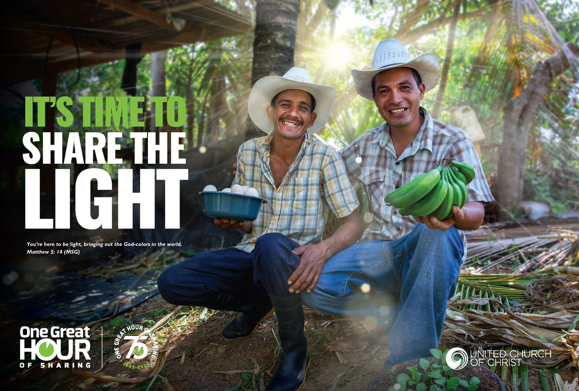

1
SHARE
THE LIGHT TABLE OF CONTENTS

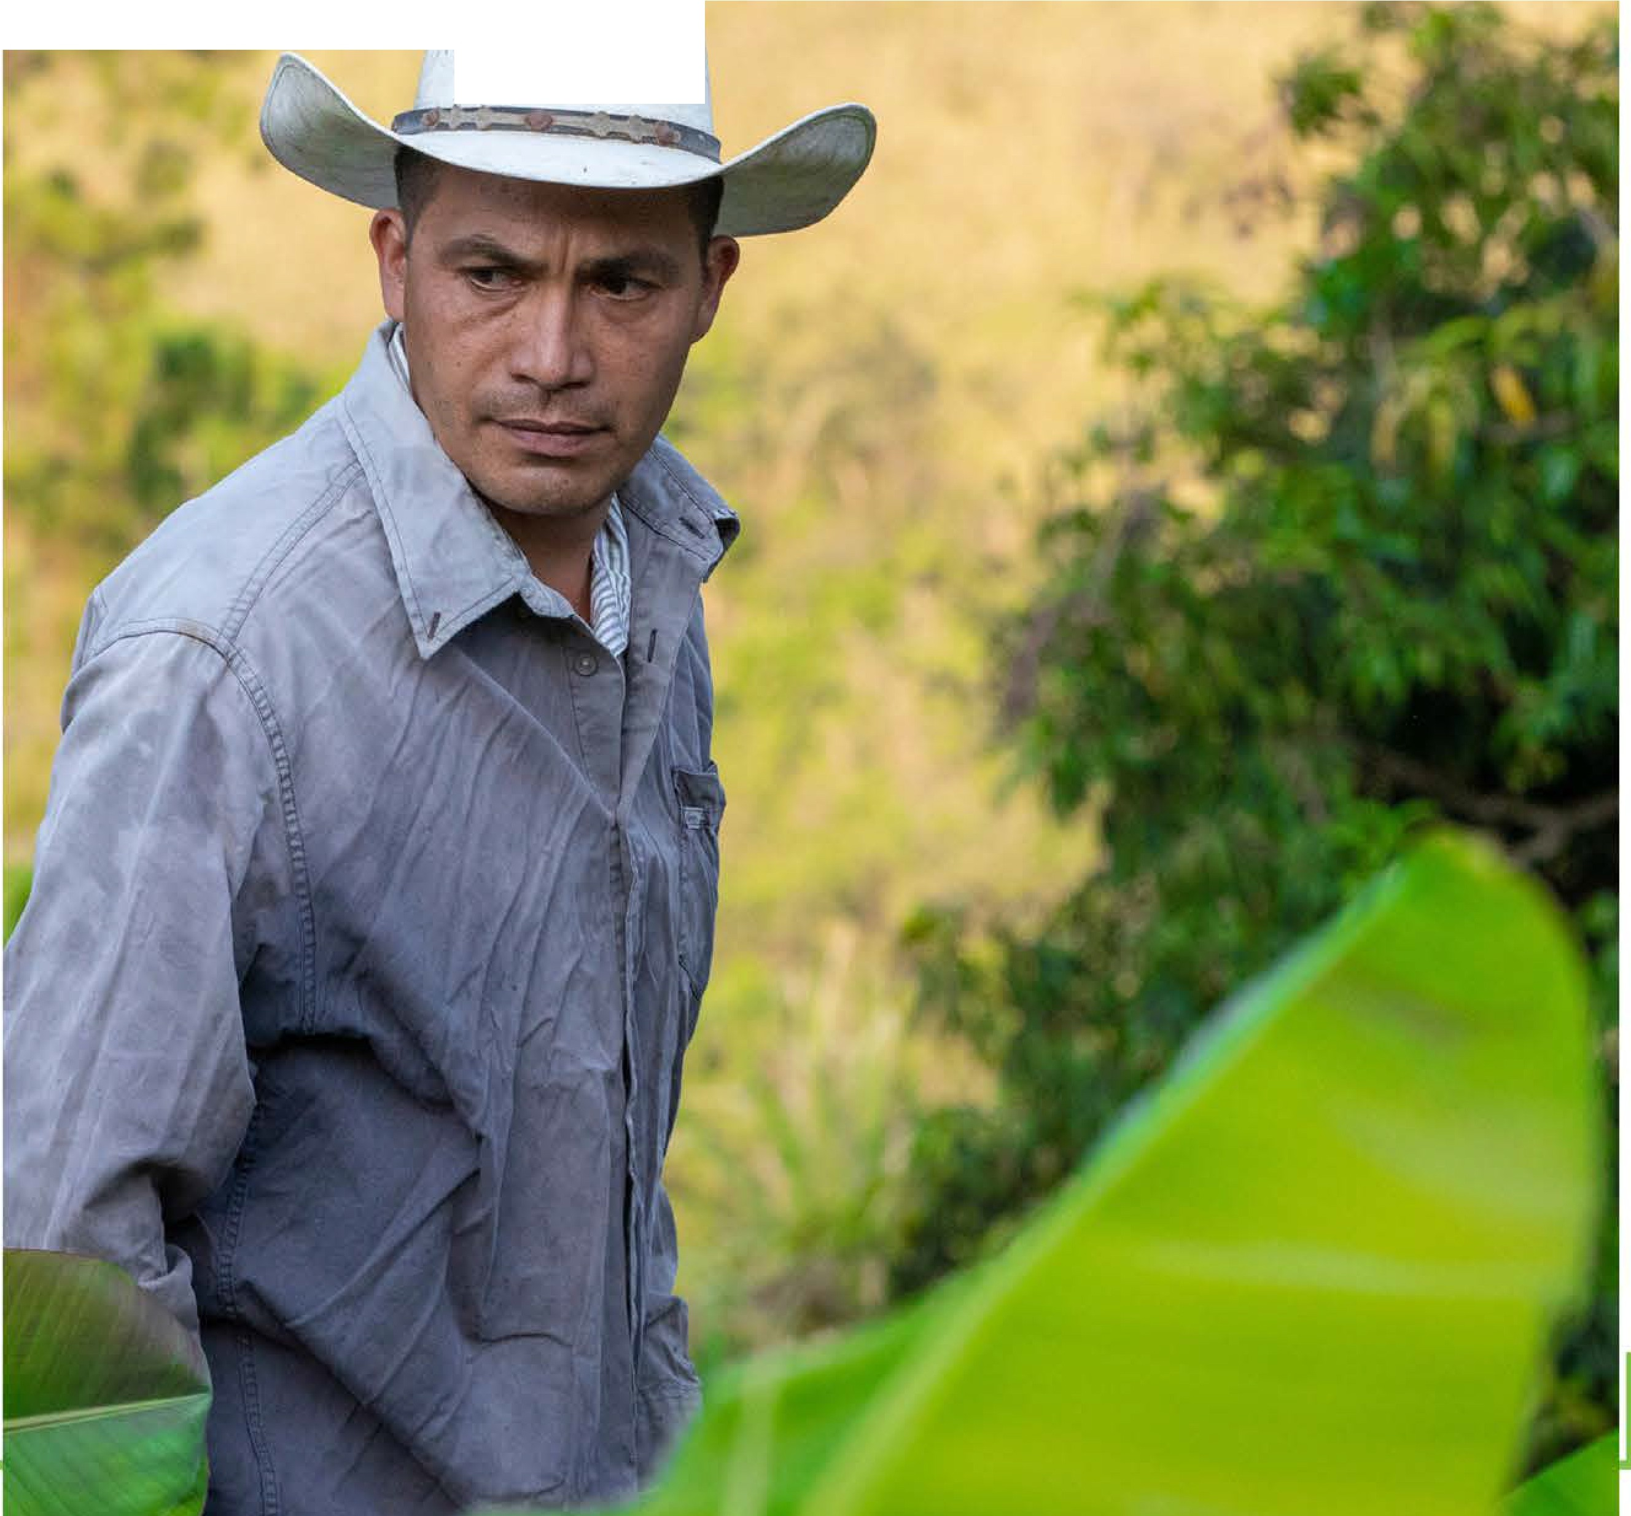
OGHS OPENING LETTER
2
Acting Associate General Minister and Co-Executive of Global Ministries, United Church of Christ
4
CONNECT WITH US
Promoting the OGHS Offering in 4 Easy Steps
6
SHARE THE LIGHT
Theme and Scripture

WORSHIP RESOURCES
7
Theme Development and Scriptural Exegesis:
Share the Light
8
SERMON STARTER
Scripture Commentary and Sermon Starter
9
CALL TO WORSHIP
Worship Material

CHILDREN'S ACTIVITY
11
Children's Activity: Would You Rather?
Empowered to Share the Light
14
CHILDREN'S SERMON
Children's Sermons

MISSION MOMENTS
16
OGHS Giving Stories

TOP GIVING CHURCHES
19
Acknowledgement of Top Giving Churches

ADDITIONAL RESOURCES
23
Other Links and Resources

f .- • f I • • "

j ' ''
I • ,. • " • ,. ,' 'I
I''

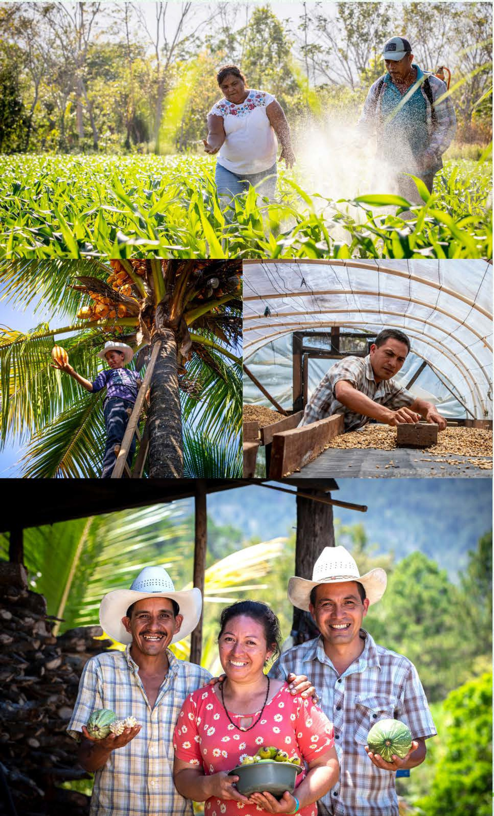
2
SHARE THE

"Let me tell you why you are here.........You're here to be light, bringing out the God-colors in the world...Keep open house; be generous with your lives." (Matthew 5:13-16, The Message)

Dear partners in ministry,

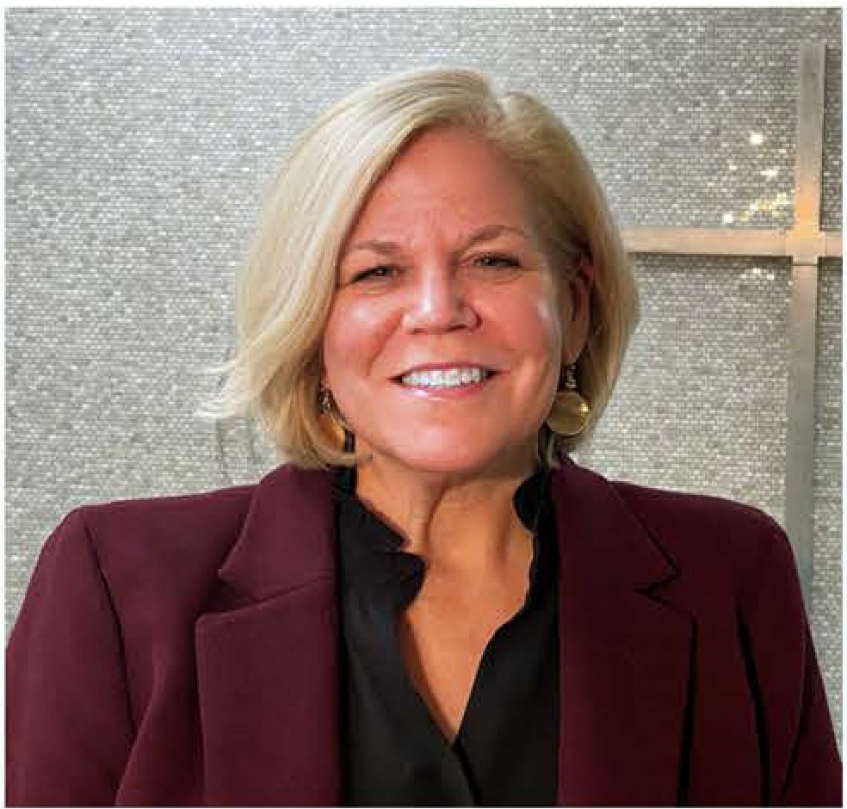
I love Eugene Peterson's paraphrase of these verses in Matthew 5, and the clear commission they give to show up brightly in the world and be generous with our lives. That is the invitation extended in this year's One Great Hour of Sharing theme, Share the Light.

The scriptures tell us that huge crowds were gathering, drawn to Jesus by his teachings and the miracles of healing he performed. So, Jesus climbed a hill, and delivered his "sermon on the mount" to an audience captivated by his message and ways. He offered them blessings, affirming them in ways probably no one had before.

Then he described a life of discipleship characterized by prayer, humility, love of one's enemies, and a steady practice of being 'salt and light,' generously sharing the goodness of God in all the world.

One Great Hour of Sharing is a beautiful opportunity to do just that. When we participate in One Great Hour of Sharing, we become a dazzling prism of light scattering blessing in places that desperately need it. We offer hope to people forced to flee their homes in search of safety and new promise.

3
SHARE THE

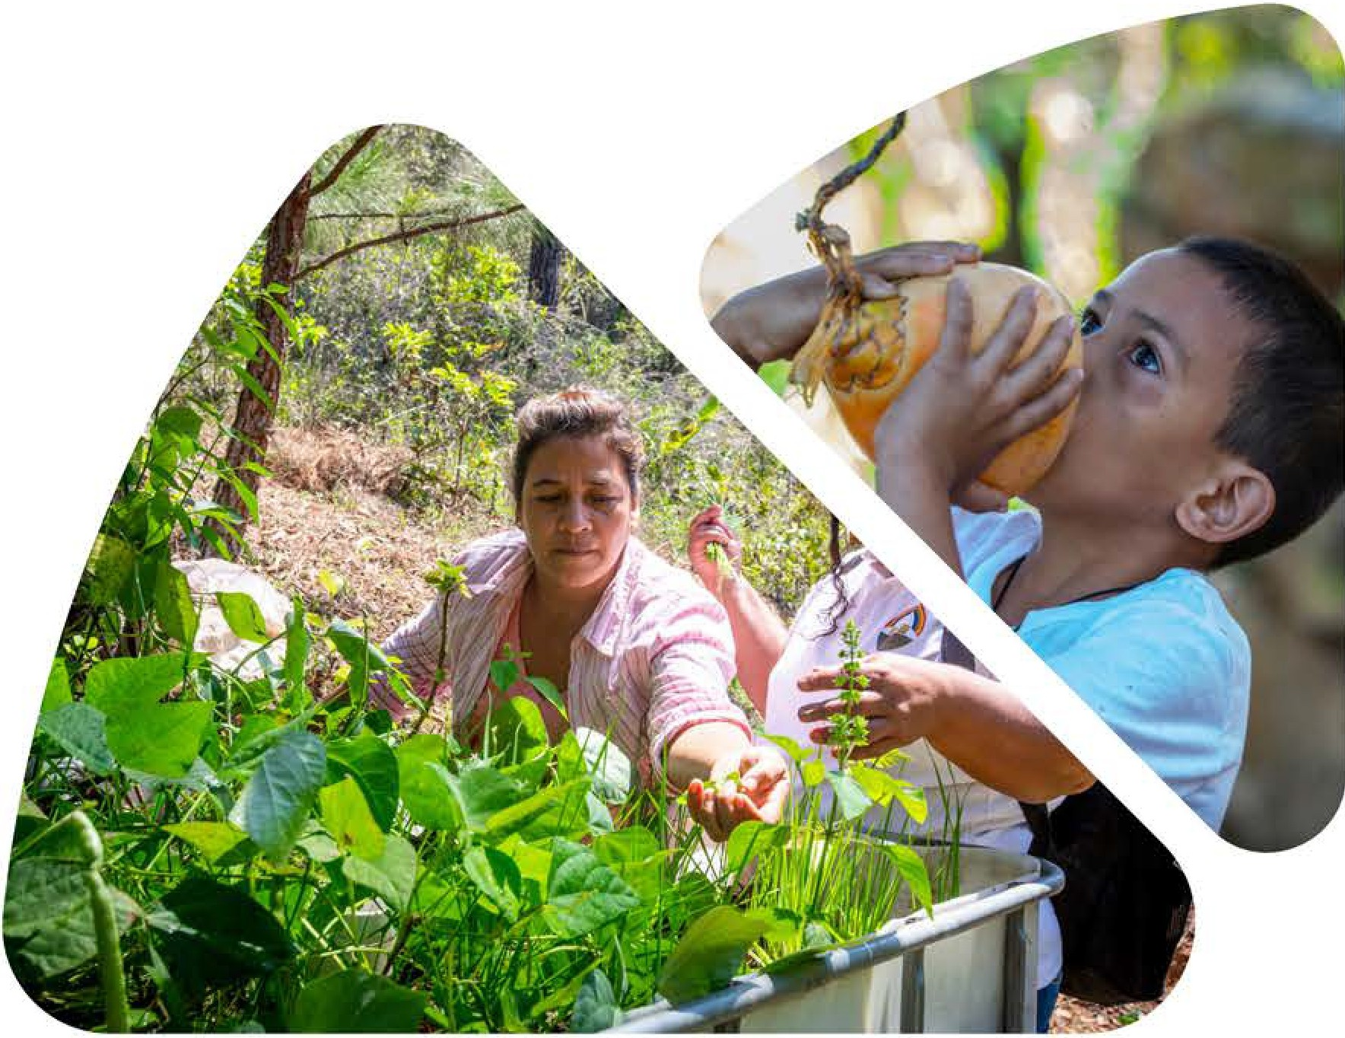
We support life-giving recovery efforts when disasters devastate communities and lives. We empower partners worldwide in their labors to build sustainable futures. We plant seeds of peace where war has multiplied despair and destruction.

Our communities and world need these blessings so very much right now. Our role as faithful light-bearers carries a witness of love and hope and persevering possibility that counteracts the cynicism, hatred, and hopelessness that are all too prevalent in this moment.

I hope you'll invite giving to the One Great Hour of Sharing offering this year with
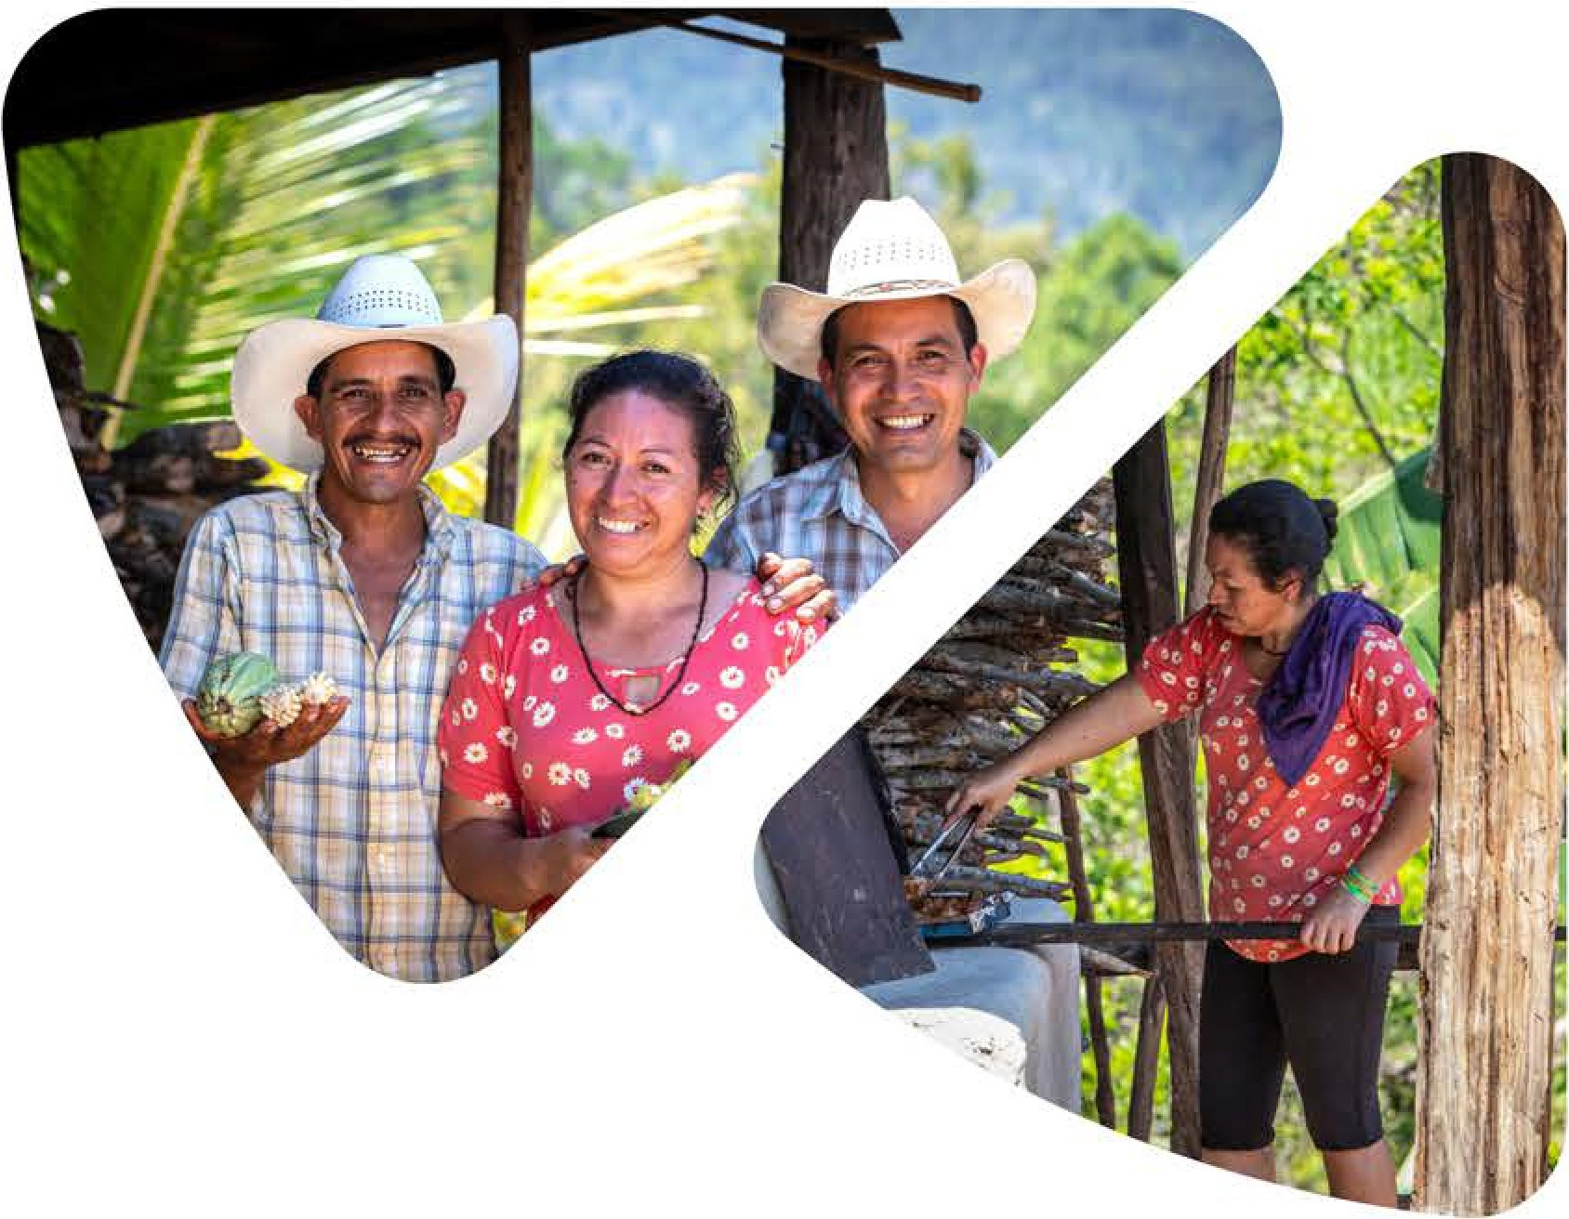
a spirit of joyful generosity! The OGHS Planning and Resource Guide can be found online to help you promote the offering in your setting. It includes a short message I have recorded that may be used as a mission moment in worship or a piece for viewing in your mission and stewardship committees. The suggested date for the OGHS offering this year is March I 0, but we welcome your gifts whenever your church calendar allows.

Thank you for 'bringing out the God-colors in the world' by generously sharing your OGHS gifts. This is why we are here: to be shining witnesses of uncommon love and enduring hope and to be generous with our lives.

Grateful for you,
)(
The Rev. Shari Prestemon, Acting Associate General Minister and
Co-Executive of Global Ministries United Church of Christ

4
Connect With Us
Promoting the OGHS Offering inG Easy Steps
Thank you for your support of One Great Hour of Sharing. Each year, congregations promote the offering to help reach those in need worldwide. This guide aims to make promoting the offering easy by putting the resources in your hands and sharing where to find additional resources. Thank you, on behalf of each life that will be blessed because of our support.

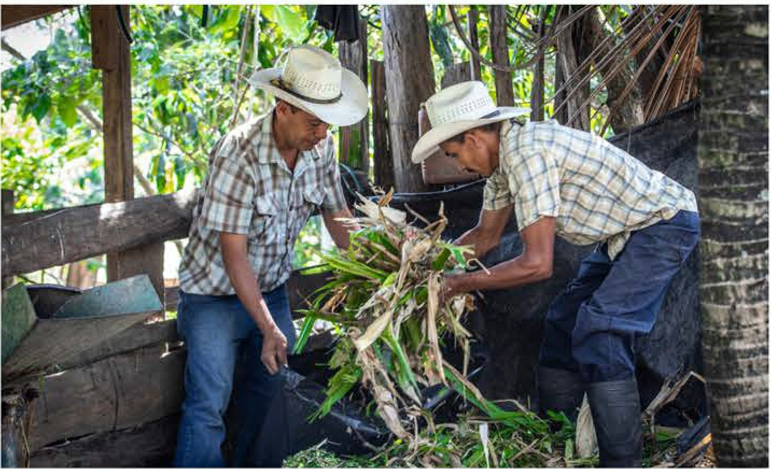
ORDER MATERIALS at www.uccresources.com to ensure you have adequate quantities. Discuss promotional and worship service ideas with your ministry leaders.

GENERATE EXCITEMENT by getting others involved. Set a goal. Invite participation through a pastoral letter or regular newsletter. Get the children involved. Remind people of the offering at weekly services and gatherings or by sharing the moments for mission included in this guide, and available at ucc.org/oghs resources.

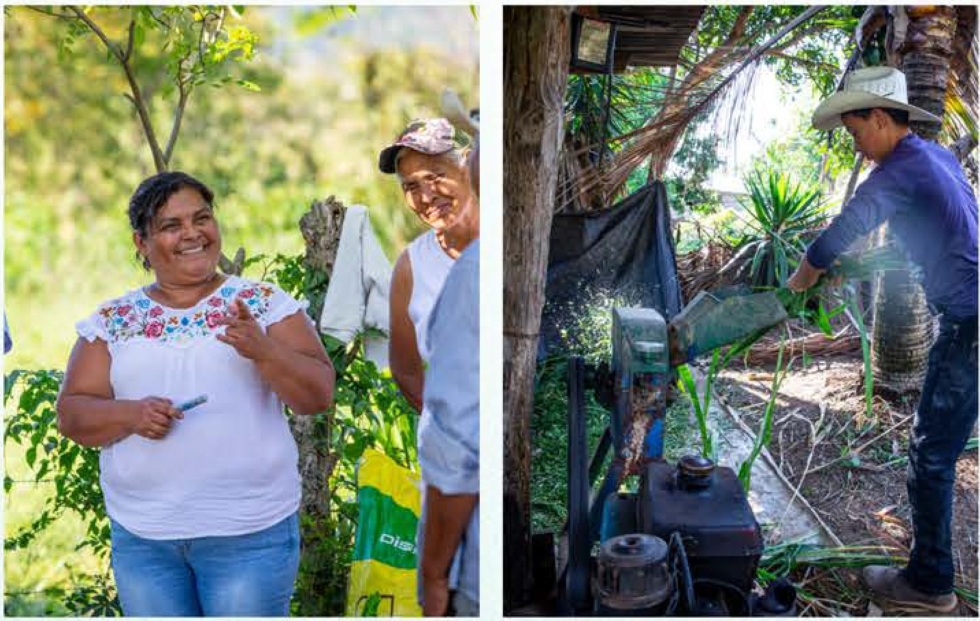
HELP THE CONGREGATION learn something new about the offering. Use the mission moments, adult and children's sermon suggestions, stories, skits, and video resources. Make OGHS a special part of the service on multiple dates prior to the offering. The suggested OGHS offering date is March I 0, 2024.

SHARE THE GOOD NEWS. After thanking the congregation for their support, announce the amount received for the offering in worship and in your church newsletter. Celebrate reaching your goal and send your congregation's gift to your UCC Conference Office making sure it is clearly marked "OGHS." Let members know they can give to One Great Hour of Sharing all year round using the OGHS donation website.

The suggested Sunday for the OGHS Offering is March I 0, 2024.
4

IS YOUR CHURCH
SHARE THE

In addition to Our Church's Wider Mission (Basic Support), The United Church of Christ has 4 Special Mission Offerings (SMOs). The SMOs allow congregations and individuals to meet people at points of critical need in their lives. Though many options exist for direct, individual support of these needs, the SMOs allow a common witness and make a collective positive impact.
Our church has identified four areas where these critical human needs exist:

- In places lacking health and educational resources and/or where disaster has struck.
- Within systems of injustice that oppress daily life and opportunity.
- In the nurture of youth and congregations just beginning their lives of faith.
- In the lives of church leaders without sufficient
resources to live with dignity.
5

4 SPECIAL MISSION OFFERINGS

The One Great Hour of Sharing offering is received on the fourth Sunday of Lent. It supports partners worldwide with ministries that fund health, education and agricultural development, emergency relief, refugee ministries and both international and domestic disaster response.

The Strengthen the Church offering is received on Pentecost Sunday. It supports church growth, pastoral and lay leadership development, and youth and young adult ministries within conferences.

The Neighbors in Need offering is received on the first Sunday of October as part of World Communion Sunday and supports the Council for American Indian Ministry (CAIM) and Love of Church. It supports a variety of justice initiatives, advocacy efforts, and direct service projects through grants.

The Christmas Fund offering is received the Sunday before Christmas. It provides direct financial assistance to retired and active United Church of Christ authorized ministers and lay employees and their surviving spouses, including pension and health premiums.

Order Additional OGHS Materials at www.uccresources.com

THE LIGHT
SHARE THE 6

"Here's another way to put it: You're here to be light,
Since that first offering, OGHS has expanded its mission to support domestic and

bringing out the God-colors in the world. God is not a secret to be kept. We're going public with this, as public as a city on
international development, fight poverty and its consequences, bring aid and relief to communities torn by war or ravaged by national disaster, advocate and offer

a hill. If I make you light-bearers, you don't think I'm going to hide you under a bucket, do you? I'm putting you on a light stand. Now that I've put you there on a hilltop, on a light stand-shine! Keep open house; be generous with your lives. By opening up to others, you'll prompt people to open up with God, this generous [Parent] in heaven."
Matthew 5:14 [The Message]

BACKGROUND
On Easter Sunday in 1949, on nation-wide radio, Christians were challenged to donate one million dollars in one hour to help people devastated by the aftermath of World War II. Faithful Christians answered the challenge and the goal was met.

That was the beginning of the One Great Hour of Sharing (OGHS) offering. This year marks the 75th Anniversary of its inception. Our world has changed since 1949, but human needs remain. OGHS continues to carry God's message of love and hope to people in crisis.
resettlement assistance for refugees and displaced persons, and combat injustice in its many forms. OGHS provides funding and hands-on assistance in collaboration with local and international partners.

Each year, the Offering is gathered by several denominations and Church World Service (CWS) under a single theme developed by the ecumenical OGHS Committee. In addition to posters, brochures, and interactive media, the Committee commissions a "Planning and Resource Guide" that contains a variety of resources and activities for pastors and church leaders to use as they promote and receive the offering.

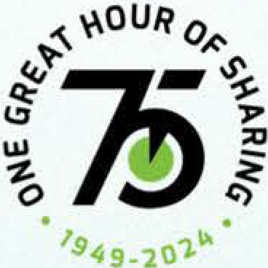
one Great
R

OF SHARING

Thank you for supporting One Great Hour of Sharing for 75 years. You continue to share light in places that need it.

The suggested Sunday for the OGHS Offering is March I 0, 2024.

Thenie Developnient and Scriptural Exegesis: Share the Light
This little light of mine, I'm gonna let it shine...
Let it shine, let it shine, let it shine... [I]

If Jesus had a playlist of music, surely this familiar hymn would be among the top five; at least, Matthew's Jesus would rank it high. Matthew opens the Gospel by placing Jesus squarely within the story of God's ongoing relationship to and intention for humanity-people called into God's own household, as sons and daughters, grounded in loving connection to each other and creation. God invites all of humanity into God's house, regardless of nationality, tribal affiliation, social status, or gender.

As the fulfillment of Israel's hopes and purposes, Jesus calls men and women to follow him-and they do. He names them disciples-and they are. He outlines their responsibilities-and they respond. Their lives are transformed and they begin living from the inside out-less for themselves and more for others. Jesus teaches that faith calls for action-as a response to the God who loves them unconditionally. They are now co-creators with God to bring peace, harmony, unity, compassion, care, love-shalom-right now.

Discipleship is like the kaleidoscope-an optical tube containing loose bits of colored material between two plates and two mirrors; when turned, the bits of material are reflected in an endless variety of patterns.[2]

Cozy Baker, kaleidoscope enthusiast and founder of the Brewster Society[3], says:
To me kalejdoscopes are djvjne jnspfra6on; they resonate to the musjc jn my soul and the jmagery js
7

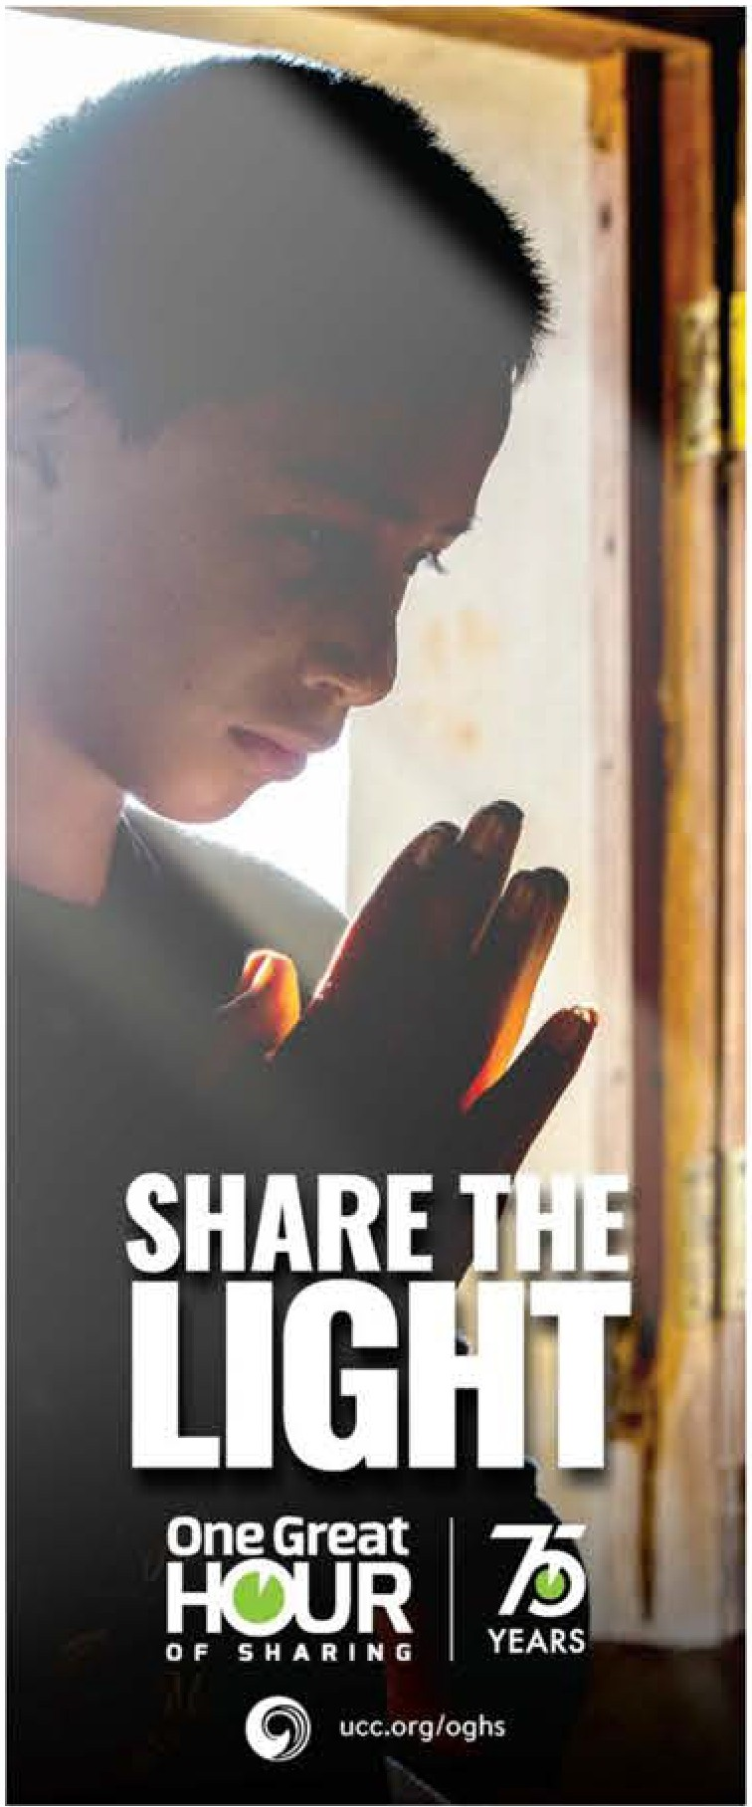
You're here to be light, bringing out the God-colors
WORSHIP RESOURCES
in the world.
Matthew 5:14-15 (The Message)

"This little light of mine, I'm gonna let It shine...Let it shine. let it shine, let it shine,_ "
If Jesus had a playlist of music, surely this familiar hymn would be among the Top Five.
Jesus teaches that faith calls for action. Sharing our light. as the diverse and colorful expression ot God's love here on earth. leads to making blankets. staffing food pantries, cooking meals, building houses and schools. signing petitions for worthy causes. and protesting injustices. A simple song with a simple message-our ght Is on a light stand. for all to see-shine and share. On any given day, light Is shining because we are there through our gitts to OGHS.
Your contributions make a difference. Your dollars count. Give generously.
Share the light.

exactly what my heart yearns to see. I vjew the kalejdoscope's jmage as a warm embrace - one more
colorful expression of God's love toward all creation.[ 4]
OneGreat

OF SHARING
HOUR
79

YEARS

Sharing our light, as the diverse and colorful expression of God's love here on earth, leads to making blankets, staffing food pantries, cooking meals, building houses and schools, signing petitions for worthy causes, and protesting injustices.

We also share the light through our contributions to One Great Hour of Sharing [OGHS]-supporting our siblings around the world after natural disasters; providing care and safety in places where war rages and poverty prevails; sharing techniques for sustainable agriculture, energy efficiency, and clean water; and advocating for the dignity of those who are marginalized.

Each of our playlists should include the song, "This Little Light of Mine." A simple song with a simple message-let your light shine, share in the kaleidoscope of care and love. Your light is on a light stand, for all to see-shine and share. On any given day, in any given place, in the midst of any given situation, light is shining because we are there through our gifts to OGHS. Your contributions make a difference. Your dollars count. Give generously. Share the light.

Order Additional OGHS Materials at www.uccresources.com
@ ucc.org/oghs

[I] Lift Every Voice and Sing II: An African American Hymnal (New York:
Church Publishing Incorporated, 1993), #221.
- https://www.merriam-webster.com/dictionary/kaleidoscope
- Named for the inventor of the kaleidoscope, David Brewster
- Cozy Baker, News Scope, spring, 2004; Cozx Baker - Brewster
KaleidoscoP-e Society_(brewstersocietx.com).

SERMON STARTER 8
•
SCRIPTURE COMMENTARY AND SERMON STARTER

An old adage declares, "If you know better, you do better." In his Sermon on the Mount, Jesus teaches his disciples and the gathered crowd what it means to be children of God.

By starting his discourse with the Beatitudes, Jesus declares that humanity was not living out God's intention for them. Jesus is struck by their conditions and circumstances of fear, anxiety, isolation, apathy, division, despair, oppression, injustice, and chaos. Jesus recognizes that throughout the land, there is a need for grace, mercy, justice, and compassion. They need light, direction, and guidance. Jesus makes a startling admission-God is transforming the land, right now, right here. Through Jesus, God lights a path forward toward shalom
-total well-being. God's grace is moving across the land, creating a ginormous household of diverse people who are children of God and siblings to one another.

Jesus also sets the bar for discipleship. The disciples are to live out their faith and commitment to God through concrete acts of service for others. They have been transformed from individuals into family, living for others.
Jesus says the disciples are light and as such, they are to shine, to share the light with others. Not to brag on themselves or bolster their egos-they engage in active service as a response to the gracious God who has gifted them with so much. Their acts reflect back to the Source of all there is-God! Jesus' message was for the Twelve, for the crowds gathered around them, and also for us! We are invited to join God's grand movement of transformation.

The world is as broken now as it was in Jesus' day. People are suffering, systems are failing the most vulnerable among us, safety nets are diminishing in number and effectiveness, needs are increasing. It can be so easy to get caught up in our own lives that we forget that our simple acts of illuminating the world around us with our love, compassion, and acts of service-however small it may seem to us-can make a difference. We know better and we do better.

As you prepare to preach and teach for the OGHS offering, consider these questions: what does sharing light look like in and for your congregation, your community, and in the world? How is God using you to share light? How has someone shared light for you?

As a congregational challenge, ask members to start a Share the Light journal
-write down instances where they see someone sharing light or when they have shared light. These can be posted on the church's social media platforms or in the newsletter. Light is shining everywhere if we take the time to notice.

Remind your congregation that we share our light whenever we offer an encouraging word, bake a casserole for a friend who is ill, tutor a child in an after-school program, staff a soup kitchen, volunteer to teach Sunday School, or advocate and support efforts to right an injustice.

We share our light when we contribute to the OGHS offering. Your gifts help families live more efficiently or to find safety in shelters instead of on the streets. Your gifts allow women to sell locally sourced produce and other food items to support their families. Your gifts allow women to create cooperatives so that they can do more together than they could do separately. Your gifts support places of hospitality to strangers who soon become friends. Your gifts support people recovering from trauma and much more.

We cannot be in all of the places that need help and we may never personally witness the results of our help, but through our generous tithes, offerings, and special gifts, we can illumine places with abundant God-colors and know that we have made a difference.

In the Sermon on the Mount, Jesus reminds us that we are the light of the world. We share that light when we do good for others. Discipleship from the inside out begins with generosity.

When the opportunity comes, let us shine and share. When another is in need, let us respond.
Let's go public, for we are Light-bearers. Generosity is our standard and Love is our ethic.

Let us not hide our light under a bucket-let our light shine for all to see. Let us share the light.
Rev. Barbara J. Essex

--e!!:!!11------r.i.e:a==== ===== The suggested Sunday for the OGHS Offering is March I 0, 2024.

9
CALL TO WORSHIP

THE LIGHT

CALL TO WORSHIP

One: Share the light
All: like a city on a hill.
Shine the light
for the world to see.
Be the light
so that our neighbors can find their way.
You are the light
and it will not be extinguished.
Do not hide your light.
We will share the light.

PRAYER OF INVOCATION

Your first word of creation, 0 God, was "Let there be light" and there was. Jesus came as the light of the world and then called us to become light-bearers in our lives. As we come to worship on this special day called One Great Hour of
Sharing, may we shine our light here in this place as well as in the world to which you have called us to live. It can be so easy to get so caught up in our own lives that we forget the simple act of illuminating the world around us with our love, compassion, acts of service, justice and advocacy and kind words to others. Show us the paths where we might follow in the footsteps of Jesus, in whose name we pray. Amen.
LITANY OR RESPONSIVE READING
One: "This little light of mine, All: I'm gonna let it shine." "Hide it under a bushel?"
"No! I'm gonna let it shine."
"You are the light of the world."
"A city set on a hill cannot be hidden."
When the opportunity comes,
I will shine.
When another is in need,
I will respond.
Let's go public.
Light-bearers we are. Generosity is our standard. Love is our ethic.
INVITATION TO COMMUNION
"May we be a shining light to the nations A shining light to the peoples of the earth
Till the whole world sees the glory of Your name. May Your pure light shine through us."
These lyrics were written by Chris Christensen, the son of a missionary, who lived on three continents before he entered college. After college, he went back and forth between Africa, Europe and North America. While in the US in the early 1980s on his way to a conference, he penned his "Song for the Nations."

Order Additional OGHS Materials at www.uccresources.com

Like many of us, Christensen would have seen many of the places where the One Great Hour of Sharing offering goes. Through the graciousness of generous people from around the world, the light of Christ shines through us as the hungry are fed, the unhoused find shelter and people are empowered to do more than they could have imagined. The light shines.

At this table, we share in the fellowship of one another and with Christ. We are filled again, so that we might go out and share with others. At the table, we hear Christ saying to us, "Share." Share the food. Share the bounty. Share the light. Share with the nations, the peoples, the world. Come, now, as Christ shares the best with us.

COMMUNION PRAYER

From the beginning of creation, God, you have brought forth light into the world. Your first act of creation was, "Let there be light," and there was light. In every way since that time, you have shared generous gifts with us and yet we did not always receive them.

We left the lush garden to toil in the world. We rebelled against your love and became greedy with the gifts you gave us. During the exodus, you sent manna and we wanted more. You called forth water from a rock and we still complained. You sent leaders, kings, judges, and prophets. All of them shared ways for us to be in relationship with you and each other and we ignored them. We chose our own path.

Eventually you sent Jesus, who called himself the light of the world and called us to join him in sharing the light with all we encounter. After his death and resurrection, you sent the Spirit to illuminate our lives so that we could continue to bear the light of Christ into the world for ages to come.

Sharing that light still today, we boldly proclaim this truth which we believe, live and proclaim:

Continue with the Sanctus (Holy, Holy, Holy) and the Great Thanksgiving as your tradition practices.
10

INVITATION TO OFFERING
CALL TO WORSHIP

"Rain-diamonds, this winter morning, embellish the tangle of unpruned pear-tree twigs; each solitaire, placed, it appears, with considered judgement, bears the light beneath the rifted clouds - the indivisible shared out in endless abundance."

English poet Denise Levertov reminds us that light is shared in endless abundance. Today, through our special offering to One Great Hour of Sharing, we have the opportunity to share light in endless abundance in places near and far.

Our gifts help families find safety in shelters instead of on the streets. Our gifts allow women to sell locally sourced produce and other food items to support their families. Our gifts allow other women to create cooperatives so that they can do more together than they could do separately. Our gifts support those who are recovering from trauma.

We cannot be in all of these places ourselves or even see them with our own eyes, but through our generous tithes, offerings, and special gifts, we can share abundant light. In that spirit, let us share now!

PRAYER OF DEDICATION

Generous God, we offer these gifts in the spirit of light and with a heart full of gratitude for what we've been given. These offerings are one way of showing our commitment to sharing with those who are in need, neighbors near and far, whom we are unlikely to meet. Let us not hide our light under a bucket but shine it for all to see. Bless the gifts, just as you have blessed us, with an extra measure of your grace. In Christ's name, Amen.

CHARGE & BENEDICTION

(Encourage those in your congregations to shine the lights on their cell phones during the benediction.)
One: You are the people called into God's own household.
All: We are children of light, living together,
Grounded in loving connection to each other and all creation.
We are co-creators with God,
Bringing peace, harmony, unity, compassion, care, love-shalom-right now.
We leave to share the light and love of Christ everywhere we go.

The suggested Sunday for the OGHS Offering is March I 0, 2024.

11
CHILDREN'S ACTIVITY

CHILDREN'S ACTIVITY

Would you rather?

SURVEY GAME: WOULD YOU RATHER?
In groups of 2, ask the following questions and ask the groups to share thoughts with one another based on questions like (you can add more should you like):
Would you rather:
- Know what's going to happen or be surprised?
- Eat a doughnut or a muffin?
- Sit in the front of the sanctuary or back?
- Listen to music or make a new friend?
- Dress up for worship or dress casually?
- Sit in worship with your friends or your family?
- Receive communion or serve communion?
- Spend time inside or outside?
- Share with a neighbor or share with a family member?

DISCUSS
We all have different things we like, different ways to do things, but all of us like to know that God loves us and that our church family loves us. We all want to know that we are welcome just as we are.
In the large group, talk to each other about what it feels like to be welcome. What does it feel like to not be welcome? What does it feel like to share something with another person?
Jesus encourages us to share with others, but in a very particular way. Let's look at this scripture and see if we can make sense of it together.
SCRIPTURE READING
Read the One Great Hour of Sharing focus text in these two versions:

MATTHEW 5:14-16 FROM THE MESSAGE PARAPHRASE:
14-16 "Here's another way to put it: You're here to be light, bringing out the God-colors in the world. God is not a secret to be kept. We're going public with this, as public as a city on a hill. If I make you light-bearers, you don't think
I'm going to hide you under a bucket, do you? I'm putting you on a light stand. Now that I've put you there on a hilltop, on a light stand-shine! Keep open house; be generous with your lives. By opening up to others, you'll prompt people to open up with God, this generous God in heaven."
MATTHEW 5:14-16 FROM THE INTERNATIONAL CHILDREN'S BIBLE:
14 "You are the light that gives light to the world. A city that is built on a hill cannot be hidden. 15 And people don't hide a light under a bowl. They put the light on a lampstand. Then the light shines for all the people in the house. 16 In the same way, you should be a light for other people. Live so that they will see the good things you do. Live so that they will praise your Father in heaven."

SONG
Sing "This Little Light of Mine" and teach the actions.There are lots of action videos on YouTube.

OBJECT LESSON
You will need the following supplies: battery-operated votive candles, bowls big enough to cover the candle. Have enough supplies for all the children participating.
Remind the children about the scripture passage - people don't hide light under a bowl.

Order Additional OGHS Materials at www.uccresources.com

Ask the children to light the candle and then go around the room and ask them to name something they are willing to share with another person. You might want to share examples such as love and happiness, or sharing their snack with a friend at school. Let them be creative. Share with them that what they are offering are actually GIFTS they are giving to others.
After they have a chance to share, ask the children to cover their candle and then ask them what happens to the gift (named above) they were going to share?
Give some time for responses.
Encourage them to keep their candles uncovered and lit while they work on their art project. They can also take the candles home with them as a reminder to "let their light shine."
ACTIVITY- COLLABORATIVE ART
You will need the following supplies: as many different kinds of art supplies as possible - paper, pipe cleaners, glitter, play-dough, markers, crayons, etc.
Invite the children to create a collaborative art project in which they show how they are connected to others and how they can share light with them.
Do not limit their ideas but encourage them to work together on the project. After it is created, display the art in a prominent place around the church.

Empowered to Share the Light (Youth Activity)
DISCUSS
Ask youth to share about a time when someone offered them a gift or shared something meaningful with them If they have trouble with ideas, you might share some ideas: a time when someone shared a compliment, a friend who helped with a difficult assignment, or something more tangible.
Discuss what it is like to receive a gift from another. How does it feel? Is it easy to be gracious and thankful? Or is it difficult? What is it like to give a gift to another?
12

GIFTED (EMPOWERED) TO SERVE
CHILDREN/YOUTH ACTIVITY
Each of us has been gifted by God to serve others. We are empowered to share the light. Ask youth either at your session or before to take a spiritual gifts inventory. There are many free surveys online; here is one: www.umcdisciRleshiR.org/sRiritual-gifts-inventory..
It is also available in Spanish. Another downloadable and printable version can be found here: www.urnedisciRleshiR.org/articl eslsRiritual-gifts-inventorY.-download.

DISCUSS
When the youth have their results, ask them to discuss:
- Were you surprised by any of your top gifts?
- Thinking about your top two gifts, how can those gifts help you share light with others?
- Jesus says we should not hide our lights from others. When you do not use your gifts, you are hiding your light. Which of your spiritual gifts have you been hiding? How could you begin sharing those with others?

CREATING EMOJIS
Materials: Cardboard cut into circles big enough to cover the face of youth, markers.
Either break the group into smaller groups of identical spiritual gifts or let them work separately. Ask them to create an Emoji which represents their spiritual gift.
Give them time to work on their Emojis and then ask them to share with the group when they are complete.
Ask them to share HOW the Emoji both depicts the spiritual gift and how they could share the light through their gift with others. For example, an Emoji with a speech bubble might depict the spiritual gift of faith sharing. An Emoji with a Band-Aid across it could depict the spiritual gift of healing.
Find a place in the church to display the Emojis and add a sticky note or some other way to explain how the Emoji represents a spiritual gift.
Conclude the session with prayer about encouraging the youth to share the light in as many places with as many people as they can.

-------------=============== =- The suggested Sunday for the OGHS Offering is March-I 0-, 2-02=4.---============================;::!. _-

13
CHILDREN'S ACTIVITY
INTERGENERATIONAL ACTIVITY

Empowered to Share the Light

This is based on the story of Bojana, found here:
htq s://cwsglobal.org/stories/bojanas-Rowerful-love/.

This activity is designed to help multiple generations consider what is important to them and how this is not the same across the world.
Materials: small paper bags, pens, small squares of paper
The Roma people in Hungary are often forgotten and left behind. Such is the s_tory of Bojana and her children. Thanks to the work of the Center for Youth Integration, they do not have to spend all of their time on the streets trying to come up with enough money to support their families.
INSTRUCTIONS
I. Give each person a paper bag, five squares of paper, and a pen.
- Ask each person to write their name on the bag.
- Then, invite participants to write down five things they cannot live without, one on each square.
- Ask each person to pass his or her bag clockwise.
- Upon receiving a bag, participants should pull out a piece of paper without looking and throw it in the center of the circle.
- Do this four times, until only one piece of paper remains in each bag.
- Return the bags to their original owners.
- Do not let the owners look inside the bag.
Ask the following questions, allowing for discussion between each one:
  - How did you feel having someone throw out a cherished item?
  - What is your fear when you look in the bag at what is left?
  - Would it feel better if your cherished item was intentionally selected or if your opinion was considered in the process?
Bojana and her family of IO live in a small one-bedroom home in an informal Roma settlement in Hungary where families often don't have proper access to electricity, heating, or running water. Bojana and her husband built the home using abandoned materials they found over the years.
We asked Bojana about access to electricity. She told us that the government has been shutting it off more often than usual and she fears that the settlement, along with the home she has built, could be demolished at any moment. She said, "Life in the settlement is catastrophic."
  - How do you think the Roma feel having to live so chaotically that they do not know what might happen to their possessions? .
  - How do you think Bojana's family feels knowing they might come home to their things gone?
After the discussion, participants can look in their bags to see what precious item survived migration and devastation.
The theme of this year's One Great Hour of Sharing is "Share the Light." Sometimes situations are so difficult we cannot imagine how we can share anything to overcome the situations others may find themselves living in.

However, it is important for us to realize that we can make a difference by sharing some of what others may need when their situations are as devastating as those assisted by One Great Hour of Sharing. Ask the group to consider how they might assist people in their own communities who may be living in situations where they could lose their possessions (the unhoused, foster children, etc.).
Connect with local programs for the unhoused or foster care agencies to see how they might be able to receive assistance or create cooperative projects. Plan a mission opportunity to impact this situation. In addition, encourage giving to One Great Hour of Sharing, which impacts Bojana and her family.
CONCLUSION
While we may live worlds apart, there are many similarities in human experiences. Connecting these experiences helps us think about how we can share the light wherever we are.

Order Additional OGHS Materials at www.uccresources.com

CHILDREN'S SERMON 14
-

CHILDREN'S SERMON

Based on the kaleidoscope image from the OGHS sermon starter written by Barbara Essex.

This can be adapted to your own words or followed as a script. The children's moment illustrates some of the ways that children can share the light by seeing that it looks different to every person. The script and design may be adjusted to fit your virtual or hybrid worship context.

THEME
One Great Hour of Sharing reminds us that we are all to "share the light" with others. There are many ways for us to know God's generosity in our lives and to share that with others. Sometimes, we just need to think about them in new ways.

MATERIALS NEEDED

    - An affirming listening ear, eager to engage children's ideas!
    - A kaleidoscope that can be passed around or individual ones for each child. Kaleidoscopes can be purchased at party stores or online.

SCRIPT SUGGESTION

I want to ask you a very serious question: Do you know how to share light with others?

Give time for responses.
It's kind of a hard question, isn't it?

How do we actually share light? Well, it may not seem natural to us, but Jesus asks us to do it. Let me share with you a scripture reading from Matthew's gospel: Matthew 5: 14-16 (Common English Bible)
14 You are the light of the world. A city on top of a hill can't be hidden. 15 Neither do people light a lamp and put it under a basket. Instead, they put it on top of a lamp stand, and it shines on all who are in the house. 16 In the same way, let your light shine before people, so they can see the good things you do and praise God who is in heaven. (CEB)

Give time for responses.
We can share our light when we help others, share an encouraging word or provide assistance through the One Great Hour of Sharing offering.

I would like to introduce you to a kaleidoscope. Do you know what one of these is? Have you ever looked through one?

First, let me show you the funny thing about how it works. If you look at it from the outside lens, it looks like you just have a bunch of pieces everywhere. Sometimes those pieces look broken! But here's the trick! If you look at it through the proper eye lens and twist it, all of those shattered pieces turn into beautiful shapes and a new picture.

Pass around the kaleidoscope, or pass out the individual ones to each child.
Before you looked into the kaleidoscope, could any of you imagine what the picture could look like?

Could you imagine how beautiful it would be?

Give time for responses.
As you twisted it, did you notice how the picture changed to a new shape? Did you have any idea beforehand what that shape would look like?

------==================- The suggested Sunday for the OGHS Offering is March-I 0-, 2-024=.
---============================-----

GIVE TIME FOR RESPONSES.

You see, each of you saw something just a little bit different when you looked inside that kaleidoscope. You saw a unique image. All of those shattered pieces turn into beautiful shapes and a new picture-just as our acts of service do.

Well, that is very much like each of you. Your uniqueness is your beauty and you can each share the light in your own unique way. But the important thing is this - share your light. Don't hide it, as the old song says, "Hide it under a bushel? NO!" Shine it for the world to see and do it in the way that only you can do!

Give the OGHS banks to children and families or arrange for them to be given
out at an appropriate time.

This special bank can help you help others by doing good and sharing with them. At home, I'd like you to think about all the times each day someone shares light with you. Maybe it's at school or when you are playing with your siblings. And with your family, maybe each night at dinner, or when you have breakfast, think and pray together about how you want to make a difference. Maybe you want to put in a dollar for every time someone shares something with you, either at home or at school.

Or maybe you want to count all the times you've shared something with another person and add an amount of money each time. I bet you can think of a lot of creative ways to help. It's a way of being mindful of all that we have, being grateful, and helping others.

Share any details about when your community will be receiving the offering, and when and how they should return the banks.
Can we pray a blessing together over these banks and over the offering we'll receive with them? What do we hope God will do?
Allow for their prayer requests. All prayers are welcome!
15

Very good! Let's pray:
CHILDREN'S SERMON

If you are comfortable doing so, incorporate the specific requests and wording offered by the children in your prayer with them.
Or you may wish to use this prayer:

"Dear Lord, thank you for loving us so much and showing us how we can love others.

The offerings we will put in these banks we know will change someone's life. We can love those we will never even meet sharing light with them through our gifts. With thankful hearts, we pray. Amen."

OFFERING REMINDER

Would you like to share the light of Christ with others in your own community and around the world? Would you like to help a skilled tailor in Indonesia who finds new life through sewing? Would you like to help a mother in Romania find safe shelter for her children when homelessness is an ever-present reality? Help women farmers in Indonesia and much more? You will have the opportunity to do just that as next week [or two weeks, three weeks, or on Sunday ], we will receive a special offering for One Great Hour of Sharing.

Your generous gifts each year to One Great Hour of Sharing help our church and the churches we work with make a difference in the lives of people around the world. In the bible verse we read earlier, Jesus reminds us that we are the light of the world. We share that light when we do good for others. Following Jesus in our lives begins with generosity, and that can begin with you.

Rev. Derrek Belase

Order Additional OGHS Materials at www.uccresources.com

16
SHARE THE

MISSION MOMENT

"TAKE A CLOSER LOOK" NARRATIVE:
DON PEDRO AND HIS FAMILY SHARE THE LIGHT IN COMMUNITY

Don Pedro Antonio Maldonado lives in the countryside of Honduras where he works on his crops and coffee plantations. In 2019, when the pandemic lockdown happened, it was difficult for Don Pedro and his family to access food and supplies needed to maintain their harvests. His wife even suggested she leave for the U.S. to find employment and help make ends meet. Despite the challenges they were facing, Don Pedro and his wife decided they would hold onto their deep faith and stay together in Honduras.

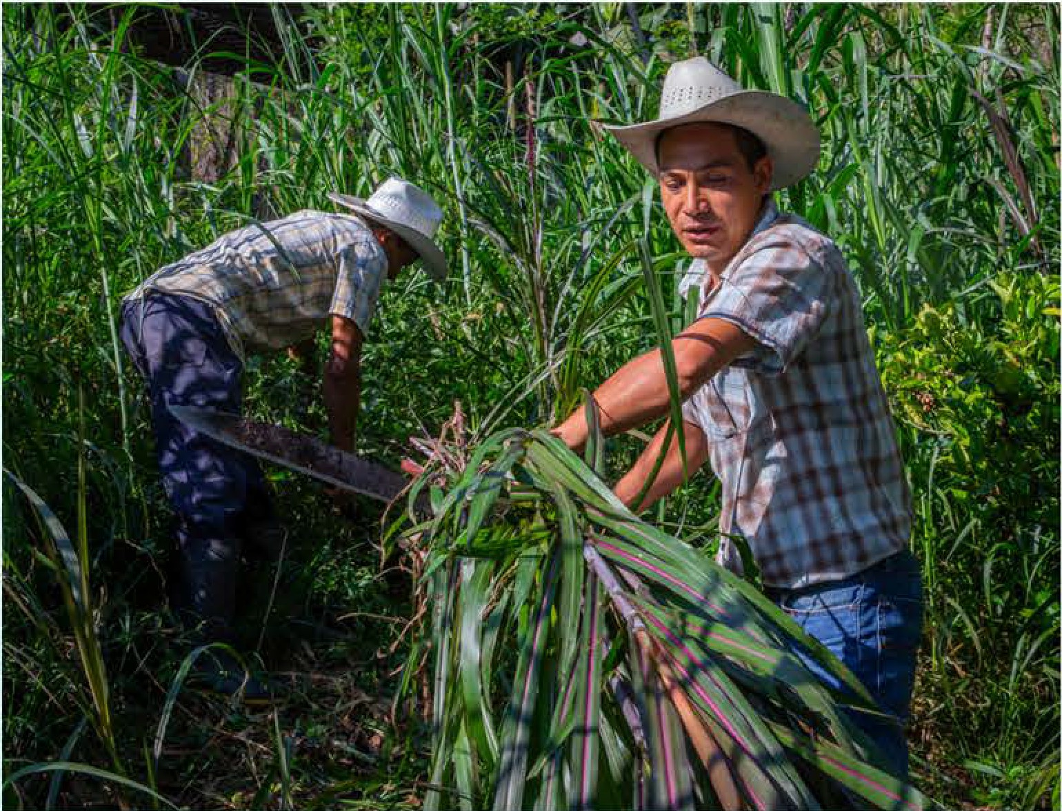
Following their decision, they received the blessing they had been hoping for when Church World Service (CWS) and Honduran partner, the Mennonite Social Action Commission, provided funding assistance from One Great Hour of Sharing (OGHS), allowing Pedro to participate in a food security program. Pedro received chickens, a piglet, sheep, and a cow.

He also learned how to start a vegetable garden. Today, he is an expert in animal care, fertilization, and vegetation.

Don Pedro shares his knowledge by inviting his neighbors to his home to teach them what he learned from the training.

He added that since joining the program, his family has made a good income that will allow them to maintain a happy life together in their country.
He says, "I teach them by doing, actually doing the job, and not giving them theory... so they see that if I can do it, our community ... which faces limitations ... can do it, too. It's my best accomplishment. I feel complete when I receive support and I have the opportunity to share it."
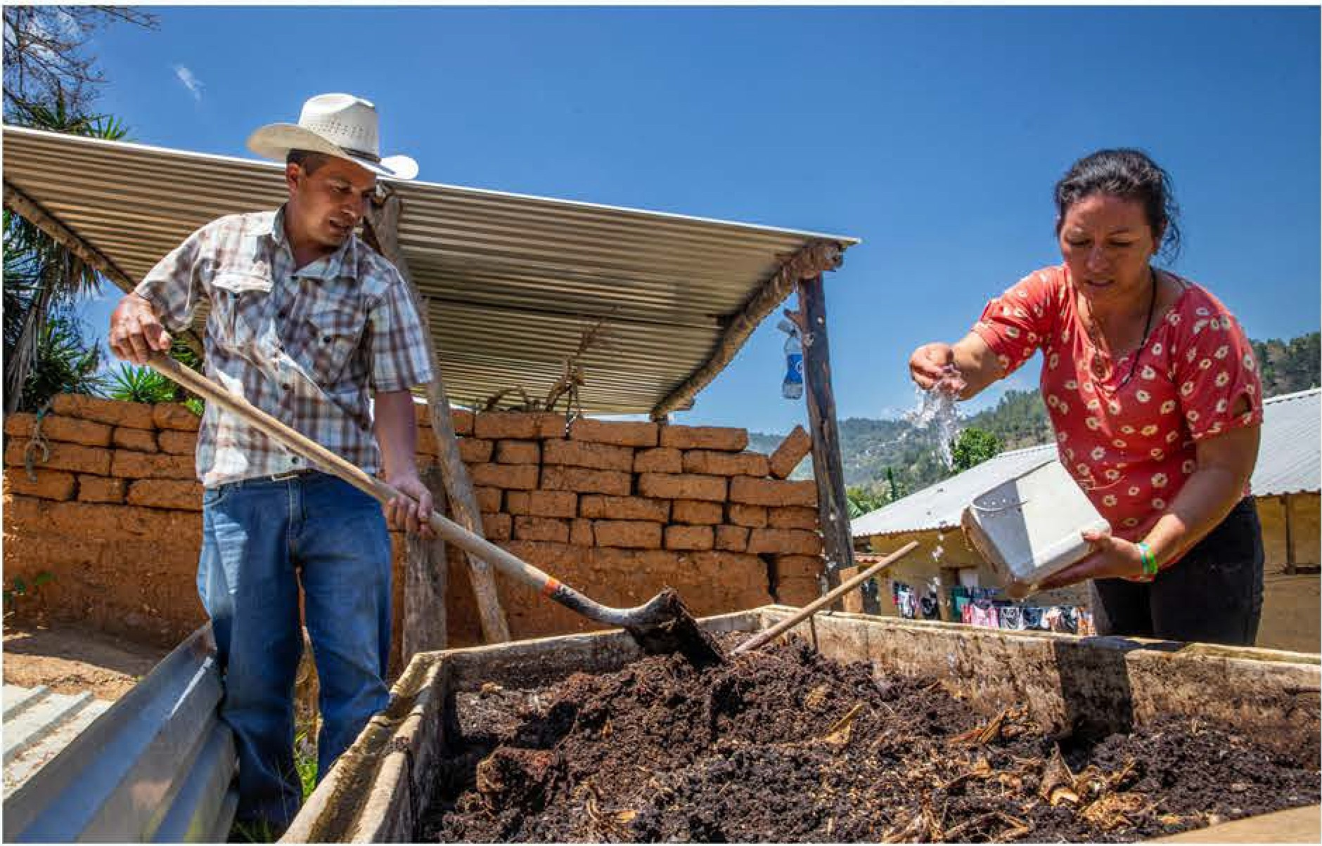
Don Pedro and his wife. OGHS recipient for 2024

Don Pedro credits all of his success to God. His gratitude and desire to share these blessings makes him a blessing to the rest of his community and a guiding light, illuminating the path toward a better tomorrow. His family can stay planted where they are and share the light in their community.

Your contributions to OGHS makes Don Pedro's good work possible. He shares the light of Christ-revealing God-colors in the world.

-------------================= ------=-===========================-=---
The suggested Sunday for the OGHS Offering is March I 0, 2024.

17
SHARE THE

MISSION MOMENT

"WELCOMING NEIGHBORS: REFUGEES AND MIGRANTS"

The United Nations High Commission on Refugees reports that there are currently almost I IO million people forcibly displaced from their homes. This figure includes at least 36.4 million refugees, in addition to another 6 million Palestinians. It is the highest number of displaced in recorded human history.

Most often, we think of displaced persons as those who have fled wars, violence, or persecution, but there are many other reasons for migration, such as lack of economic opportunity, lack of access to natural resources like water, food, and energy, and climate change.

In the Middle East and Europe, One Great Hour of Sharing supports programs of partners in Morocco, Italy, Greece, Turkey, Lebanon, and Palestine which responds to the needs of those who have been forced from their homes. The Evangelical Church in Morocco is a church that is predominantly made up of people from more than 15 African countries.

It has opened its doors through its International Mutual Aid Committee (CEI) to provide basic immediate needs for new arrivals, who have come to Morocco from many of the same African countries as its members.

The migrants in Morocco have experienced much hardship before arriving there, such as human trafficking and other forms of exploitation. They are desperate to pass through the country to Europe, to rest and remain, worn out from their experience, or simply wish to return home. They arrive in need of physical and mental health care, and spiritual care.

The CEI attempts to address these needs, living out Jesus' teaching that, "You shall love your neighbor as yourself' (Mark 12:31). It offers care for newborn children and their mothers, medical assistance, vocational training, microloans for entrepreneurial projects, and scholarships for study.

In these ways, people who are in the greatest of need are able to enjoy something of the fullness of life, as the Evangelical Church in Morocco welcomes, loves, and cares for the most vulnerable of people.

Dr. Peter E. Makari, Ph.D., Global Relations Minister, Middle East and Europe, Global Ministries of the Christian Church (Disciples of Christ) and United Church of Christ
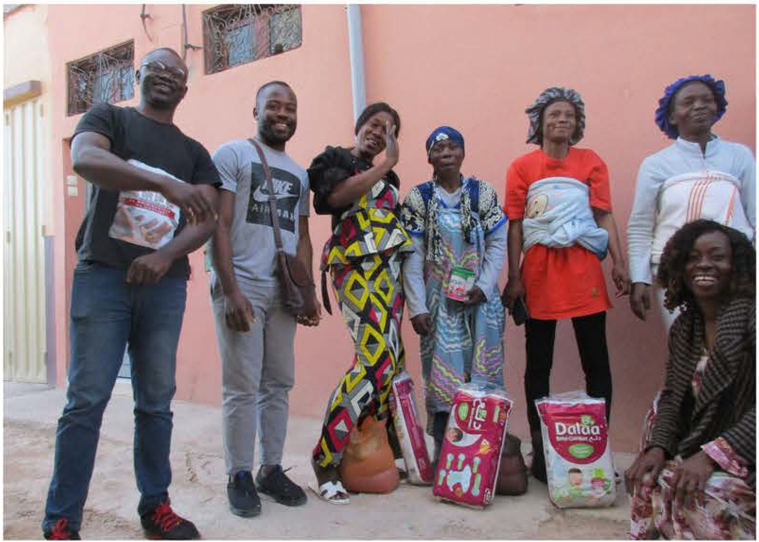
Migrant beneficiaries with the CE/ team, near Agadir, Morocco

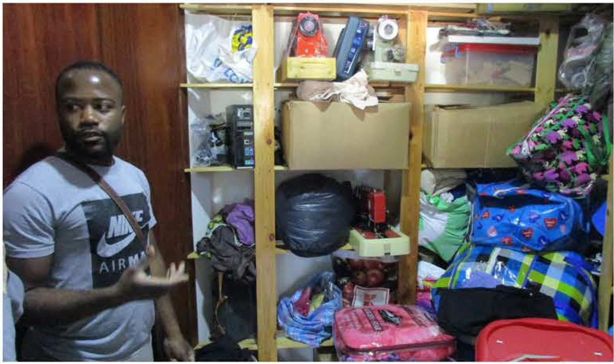
Local CE/ coordinator in Agadir, Morocco

Order Additional OGHS Materials at www.uccresources.com

18
SHARE THE

MISSION MOMENT

LOMANA NA VULAGI ECO-FARM & TRAINING CENTRE, FIJI

If you walk up the path that weaves through the lush vegetation, you come to a field dotted with seedlings freshly planted in the rich, volcanic soil. In the distance, a voice echoes out "Cow! Cow!" Follow the voice and the landscape opens into a glorious scene of rolling hills under a bright blue sky. Cows low as they lumber from beneath patches of shade trees toward the feed left by the field worker calling them.

These seedlings and cows are just the first step toward a grand vision the Pacific Conference of Churches (PCC) has to develop the innovative Lomana Na Vulagi Eco-Farm & Training Centre. Once completed, Lomana Na Vulagi, meaning "Love the Stranger," will contain orchards and crops, a piggery, apiary and poultry house, farmhouses and a retreat center.

It was the height of the pandemic in 2021 when the PCC bought these fifty undeveloped acres. Border closures had been difficult even for larger islands like Fiji.

Having grown to rely on imports, now isolated Pasifika communities began to look to more self-sufficient practices and traditional foods like cassava and kura fruit.

The PCC saw a need and an opportunity to promote local farming to increase food security and develop a model of sustainability based on indigenous knowledge, culture, and environmental stewardship. Off the grid, the farm will use solar power and produce its own bioenergy.

Planting trees will provide carbon offsets. Member churches throughout the Pacific, as well as groups from youth to specialists, will be able to visit, learn, and share Pasifika solutions to ecological challenges like climate change.

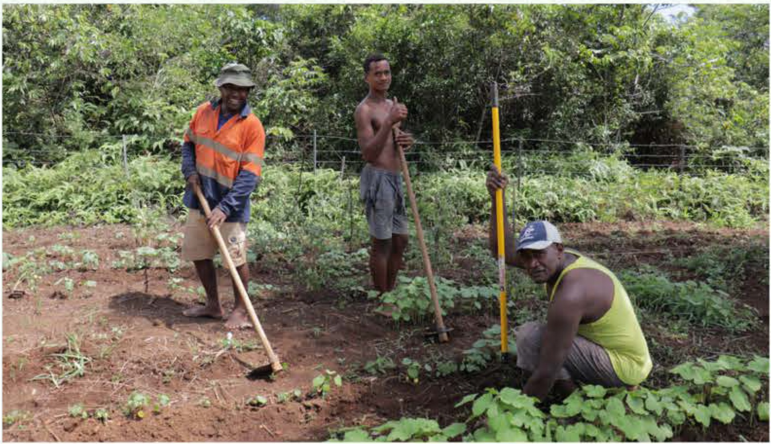
Workers from the Lamana Na Vulagi Eco-Farm &
Training Centre, Fiji

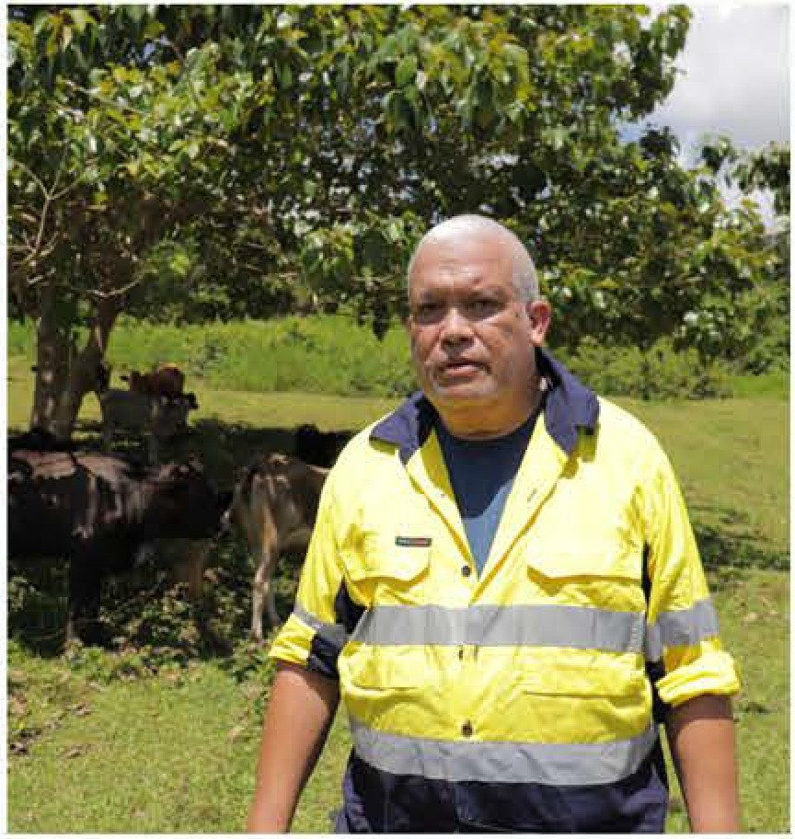
NETANI RIKA, Development and Communications Manager for PCC Lamana Na Vulagi Eco-Farm &
Training Centre, Fiji

The PCC believes strengthening the capacity and agency of Pasifika communities not only makes them more resilient in the face of both natural threats and exploitation from powerful nations, but the Vulagi Farm is rooted in the conviction that renewing the land and the indigenous spirit of the Pasifika is vital to the future of island peoples and their way of life.

Lamana Na Vulagi Eco-Farm & Training Centre, Fiji

Derek Duncan, Global Relations Minister, East Asia & Pacific, Global Ministries of the Christian Church (Disciples of Christ) and United Church of Christ

-------------=============== =- The suggested Sunday for the OGHS Offering is March-I 0-, 2-02=4.---============================;::!. _-

19
SHARE THE
TOP GIVING CHURCHES BASE.DON 2022 DOLLARS

California, Nevada Northern
The Community Church of Sebastopol, UCC Sebastopol, CA
California, Nevada Southern Neighborhood Church UCC Palos Verdes Estates, CA
Mission Hills UCC San Diego, CA
Claremont United Church of Christ Claremont, CA
First Congregational UCC Long Beach, CA

Central Atlantic
Rock Spring Congregational UCC Arlington, VA
Evangelical Reformed Church Frederick, MD
Glen Ridge Congregational UCC Glen Ridge, NJ
Little River UCC Annandale, VA Central Pacific
Bethel Congregational UCC Beaverton, OR

Order Additional OGHS Materials at www.uccresources.com

Florida
Cocoa Beach Community Church UCC Cocoa Beach, Fl

Hawaii
Waiokeola Congregational Church UCC Honolulu, HI

Heartland
Richfield United Church of Christ Richfield, OH
The Bath Church UCC Akron, OH
First Congregational Church UCC of Columbus Columbus, OH
First Congregational Church of Tallmadge Tallmadge, OH

Illinois
Saint John's UCC Mokena, IL
First Congregational UCC Crystal Lake, IL
Indiana-Kentucky First United Church Bloomington, IN
Top Givers: $3500-$28,000

Iowa
Eastgate Congregational
ucc
Fall City, WA
First Church of Christ Congregational, Glastonbury Glastonbury, CT
First Congregational UCC
Eau Claire, WI
Rock Spring
Congregational UCC
Arlington, VA
First Congregational
ucc
Colorado Springs, CO
First Congregational
ucc
Baraboo, WI
--------
Plymouth Congregational UCC Des Moines, IA
The Congregational Church UCC Grinnell, IA
Kansas-Oklahoma Plymouth Congregational UCC Lawrence, KS

20
SHARE THE
TOP GIVING CHURCHES BASED ON 2022 DOLLARS

Maine
First Congregational UCC Camden, ME
Michigan Plymouth UCC Grand Rapids, Ml
United Church of Christ Midland, Ml
Ada Congregational UCC Ada, Ml

Minnesota
First United Church of Christ Northfield, MN

Missouri Mid-South
Saint John UCC Saint Charles, MO New Hampshire
The Church of Christ At Dartmouth UCC Hanover, NH

Pacific Northwest
Eastgate Congregational UCC Fall City, WA
University Congregational UCC Seattle, WA
United Church in University Place University Place, WA

Penn Central
Church of the Apostles UCC Lancaster, PA
Trinity UCC
East Petersburg, PA Pennsylvania Southeast Heidelberg UCC Schwenksville, PA Pleasantville UCC Chalfont, PA

Rocky Mountain
First Congregational UCC Colorado Springs, CO
First United Church of Arvada UCC Arvada, CO

Southeast
Pleasant Hill Community Church UCC Pleasant Hill, TN
Central Congregational UCC Atlanta, GA

Southwest
Church of the Palms UCC Sun City, AZ

Southern New England
First Church of Christ Congregational, Glastonbury
Glastonbury, CT
First Congregational Church of Old Lyme Old Lyme, CT

Vermont
The Congregational Church of Middlebury, UCC
Middlebury, VT

Wisconsin
First Congregational UCC Eau Claire, WI
First Congregational UCC Baraboo, WI
First Congregational UCC Watertown, WI
United Church of Christ, Mc Farland, WI
Orchard Ridge UCC Madison, WI

-----------============ ==- The suggested Sunday for the OGHS Offering is March-I 0-, 2-02=4.- ,;========================-:!.

21
TOP GIVING CHURCHES
TOP GIVING CHURCHES BASE.DON 2022 PE.R CAPITA

California, Nevada Southern
Neighborhood Church UCC

Florida
Cocoa Beach Community Church UCC
Top Givers: over $2000.00

Palos Verdes Estates, CA Mission Hills UCC
San Diego,CA
Community Church of Poway Poway, CA
Church of the Foothills UCC Santa Ana, CA
Plymouth Congregational UCC Paso Robles, CA

Central Atlantic
Evangelical Reformed Church
Cocoa Beach, FL

Hawaii
Waiokeola Congregational Church UCC Honolulu, HI

Heartland
Richfield United Church of Christ Richfield, OH

Illinois
Hope United Church of Christ Moline, IL

Indiana-Kentucky
United Church in University Place
University Place, WA
First United Church UCC
Belvidere, WI
First Congregational UCC
Arvada, CO
United Church of Christ
Mc Farland, WI
First Congregational UCC Watertown, WI Congregational UCC Buena Vista, CO

Frederick, MD
United Christian Parish Reston, VA
New Ark Church UCC Newark, DE
Rock Spring Congregational UCC Arlington, VA

Central Pacific
Bethel Congregational UCC Beaverton, OR

Order Additional OGHS Materials at www.uccresources.com
First United Church Bloomington, IN
First Congregational UCC Indianapolis, IN

Iowa
United Church of Christ - Congregational
Grinnell, IA

Maine
First Congregational UCC Camden, ME

Michigan
Saint Andrew's UCC Dexter, Ml
First Congregational UCC Alpena, Ml
Plymouth UCC Grand Rapids, Ml

Minnesota
Union Congregational UCC Saint Louis Park, MN Missouri Mid-South
Christ Church, UCC (Maplewood) Maplewood, MO
Kirkwood UCC Kirkwood, MO Ivy Chapel UCC Chesterfield, MO

TOP GIVING CHURCHES BASED ON 2022 PE.R CAPITA

Pacific Northwest |  | Pennsylvania Southeast | Southern | Southwest
United Church in University | Place | Trinity Christian UCC | High Country UCC | Church of the Palms UCC
University Place, WA |  | Harleysville, PA | Vilas, NC | Sun City, AZ
Northshore UCC |  | Heidelberg UCC | South Dakota | Vermont
Woodinville, WA |  | Schwenksville, PA | South Park UCC | Second Congregational UCC
Shalom UCC, Richland |  | Rocky Mountain | Rapid City, SD | Bennington, VT
Richland, WA |  | Congregational UCC | Southern New England | Wisconsin
Magnolia UCC |  | Buena Vista, CO | First Church of Christ | First Congregational UCC
Seattle, WA |  | First United Church of Arvada UCC | Congregational, Glastonbury | Baraboo, WI
Penn Central |  | Arvada, CO | Glastonbury, CT | United Church of Christ
Hamilton Park UCC  Lancaster, PA |  | First Congregational UCC  Colorado Springs, CO | Congregational Church of Harvard  ucc | Mc Farland, WI  First Congregational UCC
Church of the Apostles UCC |  | Southeast | Harvard, MA | Watertown, WI
Lancaster, PA |  | First United Church UCC | United Congregational Church | First Congregational UCC
Trinity UCC |  | Belvidere, TN | Worcester, MA | Eau Claire, WI
East Petersburg, PA |  | Pleasant Hill Community Church  ucc
 |  | Pleasant Hill, TN

23
SHARE THE
ADDITIONAL RESOURCES
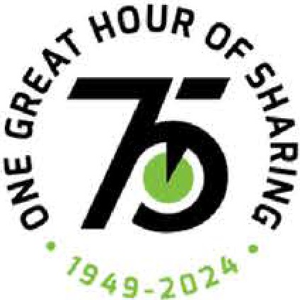
one Great
R
OF SHARING

Additional print resources can be ordered online - www.uccresources.com Electronic resources can be found online - www.ucc.org/oghs resources Share the Light Promotional Video

OGHS DONATIONS
Please mail your church's gift to your Association or Conference.
All gifts will then be sent to the United Church of Christ, at our new address United Church of Christ
PO BOX 71957
Cleveland, Ohio 44194
Please mark "One Great Hour of Sharing" clearly on your check or money order.

GET CONNECTED WITH OGHS SOCIAL MEDIA
Follow us on Facebook at https://www.facebook.com/onegreathourofsharingucc and Twitter @OGHS_at_UCC

Contact us by email oghs@ucc.org
Contributors to this resource: Rev. Barbara Essex and Derrek Belase 1300 East 9th Street, Suite I I 00, Cleveland, OH 441 14

Order Additional OGHS Materials at www.uccresources.com

