SHARE THE LIGHT

MISSION MOMENT
“TAKE A CLOSER LOOK” NARRATIVE:
DON PEDRO AND HIS FAMILY SHARE THE LIGHT IN COMMUNITY

Don Pedro Antonio Maldonado lives in the countryside of Honduras where he works on his crops and coffee plantations. In 2019, when the pandemic lockdown happened, it was difficult for Don Pedro and his family to access food and supplies needed to maintain their harvests. His wife even suggested she leave for the U.S. to find employment and help make ends meet. Despite the challenges they were facing, Don Pedro and his wife decided they would hold onto their deep faith and stay together in Honduras.

Following their decision, they received the blessing they had been hoping for when Church World Service (CWS) and Honduran partner, the Mennonite Social Action Commission, provided funding assistance from One Great Hour of Sharing (OGHS), allowing Pedro to participate in a food security program. Pedro received chickens, a piglet, sheep, and a cow.

He also learned how to start a vegetable garden. Today, he is an expert in animal care, fertilization, and vegetation. Don Pedro shares his knowledge by inviting his neighbors to his home to teach them what he learned from the training. He added that since joining the program, his family has made a good income that will allow them to maintain a happy life together in their country.

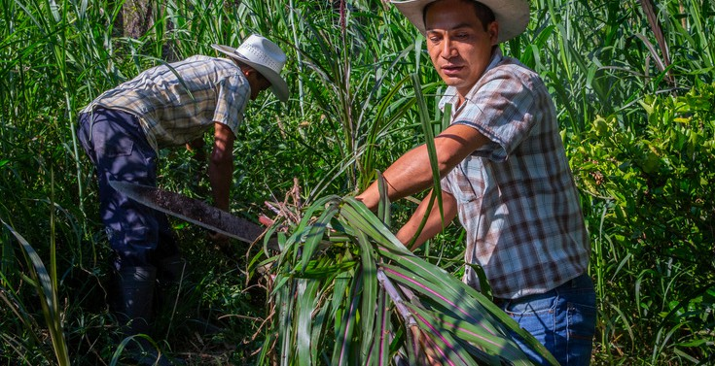

Don Pedro and his wife. OGHS recipient for 2024
He says, “I teach them by doing, actually doing the job, and not giving them theory… so they see that if I can do it, our community… which faces limitations… can do it, too. It’s my best accomplishment. I feel complete when I receive support and I have the opportunity to share it.”
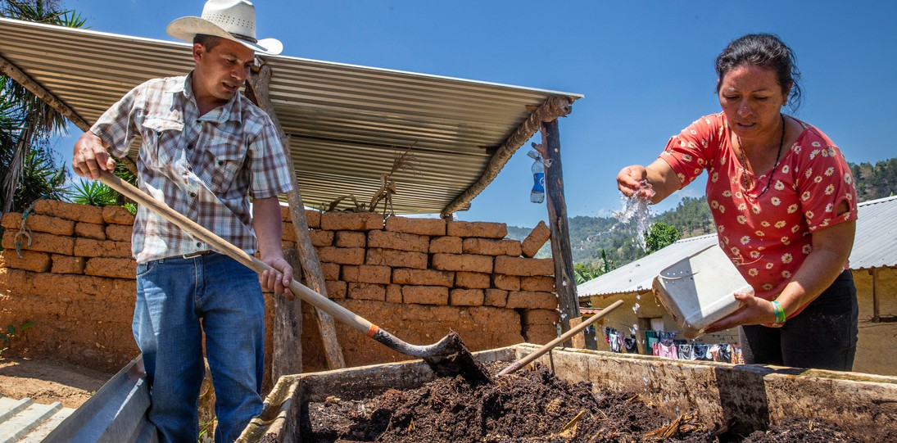
Don Pedro credits all of his success to God. His gratitude and desire to share these blessings makes him a blessing to the rest of his community and a guiding light, illuminating the path toward a better tomorrow. His family can stay planted where they are and share the light in their community.

Your contributions to OGHS makes Don Pedro’s good work possible. He shares the light of Christ—revealing God-colors in the world.

SHARE THE LIGHT

MISSION MOMENT
“WELCOMING NEIGHBORS: REFUGEES AND MIGRANTS”
The United Nations High Commission on Refugees reports that there are currently almost 110 million people forcibly displaced from their homes. This figure includes at least 36.4 million refugees, in addition to another 6 million Palestinians. It is the highest number of displaced in recorded human history.

Most often, we think of displaced persons as those who have fled wars, violence, or persecution, but there are many other reasons for migration, such as lack of economic opportunity, lack of access to natural resources like water, food, and energy, and climate change. In the Middle East and Europe, One Great Hour of Sharing supports programs of partners in Morocco, Italy, Greece, Turkey, Lebanon, and Palestine that respond to the needs of those who have been forced from their homes. The Evangelical Church in Morocco is a church that is predominantly made up of people from more than 15 African countries.

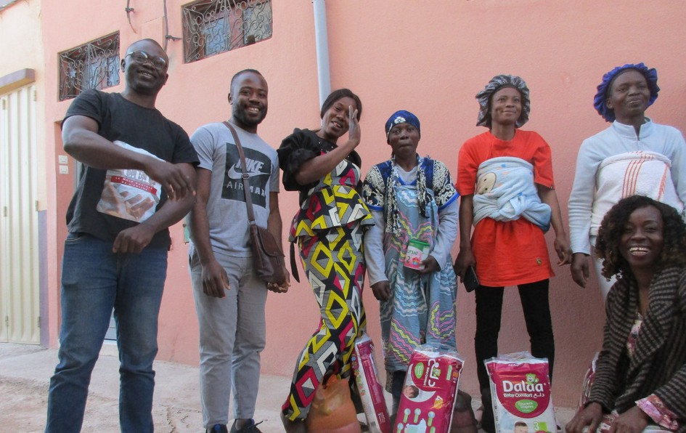
It has opened its doors through its International Mutual Aid Committee (CEI) to provide basic immediate needs for new arrivals, who have come to Morocco from many of the same African countries as its members.

The migrants in Morocco have experienced much hardship before arriving there, such as human trafficking and other forms of exploitation. They are desperate to pass through the country to Europe, to rest and remain, worn out from their experience, or simply wish to return home. They arrive in need of physical, mental health, and spiritual care.

Migrant beneficiaries with the CEI team,
near Agadir, Morocco
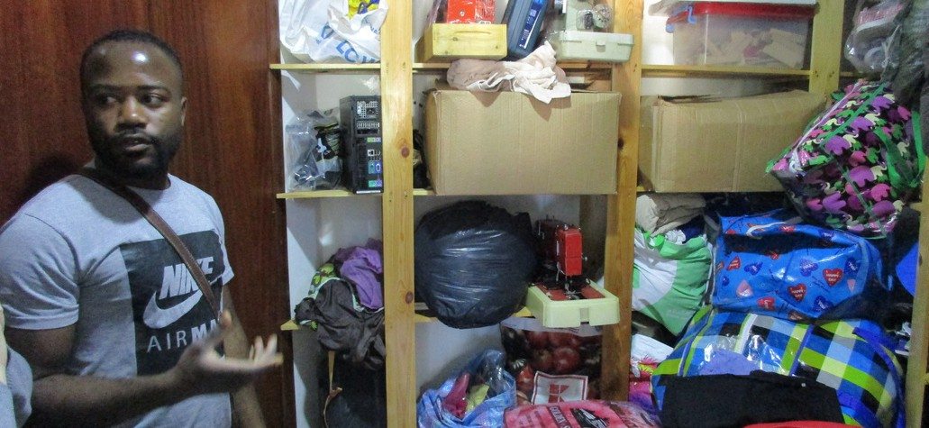
Local CEI coordinator in Agadir, Morocco

CEI attempts to address these needs, living out Jesus’ teaching that, “You shall love your neighbor as yourself” (Mark 12:31). It offers care for newborn children and their mothers, medical assistance, vocational training, micro-loans for entrepreneurial projects, and scholarships for study.

In these ways, people who are in the greatest of need are able to enjoy something of the fullness of life, as the Evangelical Church in Morocco welcomes, loves, and cares for the most vulnerable of people.

Dr. Peter E. Makari, Ph.D., Global Relations Minister, Middle East and Europe, Global Ministries of the Christian Church (Disciples of Christ) and United Church of Christ

SHARE THE LIGHT

MISSION MOMENT
LOMANA NA VULAGI ECO-FARM & TRAINING CENTRE, FIJI
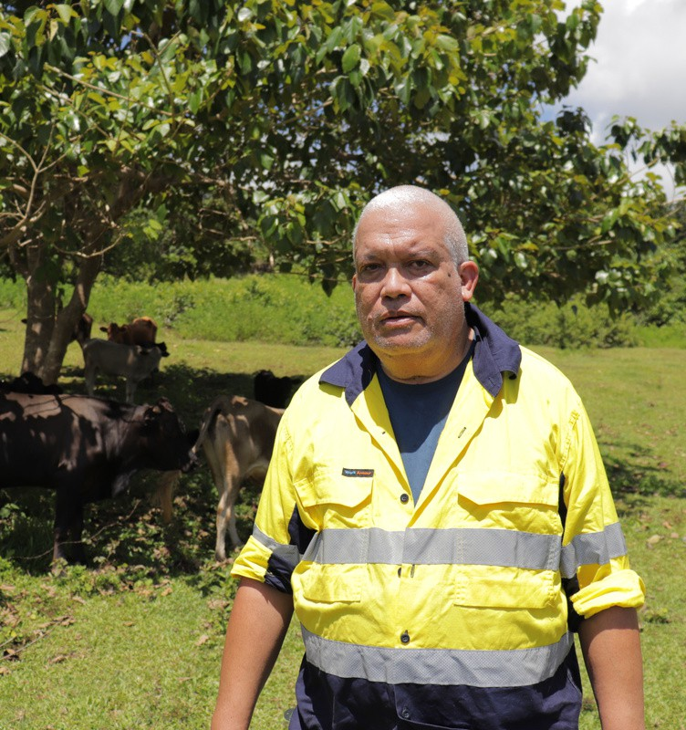
If you walk up the path that weaves through the lush vegetation, you come to a field dotted with seedlings freshly planted in the rich, volcanic soil. In the distance, a voice echoes out “Cow! Cow!” Follow the voice and the landscape opens into a glorious scene of rolling hills under a bright blue sky. Cows low as they lumber from beneath patches of shade trees toward the feed left by the field worker calling them. These seedlings and cows are just the first step toward a grand vision the Pacific Conference of Churches (PCC) has to

NETANI RIKA, Development and Communications Manager for PCC Lomana Na Vulagi Eco-Farm &
Training Centre, Fiji
develop the innovative Lomana Na Vulagi Eco-Farm & Training Centre. Once completed, Lomana Na Vulagi, meaning “Love the Stranger,” will contain orchards and crops, a piggery, apiary and poultry house, farmhouses and a retreat center.

At the height of the pandemic in 2021, PCC bought these fifty undeveloped acres. Border closures had been difficult even for larger islands like Fiji.

Having grown to rely on imports, now isolated Pasifika communities began to look to more self-sufficient practices and traditional foods like cassava and kura fruit.

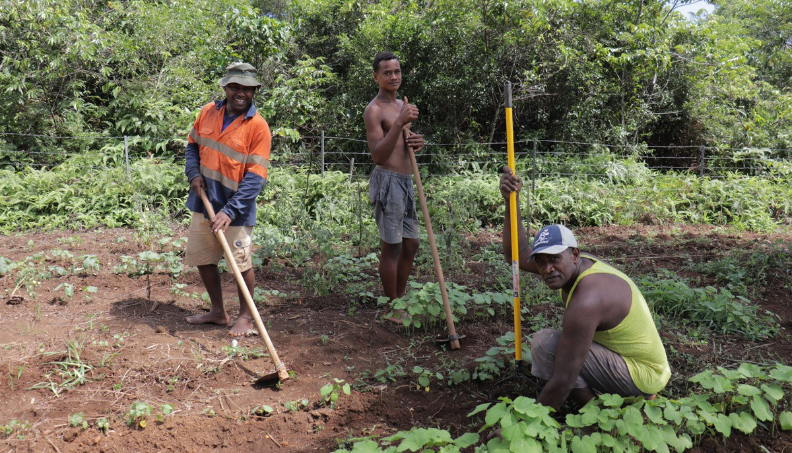
Workers from the Lomana Na Vulagi Eco-Farm &
Training Centre, Fiji

The PCC saw a need and an opportunity to promote local farming to increase food security and develop a model of sustainability based on indigenous knowledge, culture, and environmental stewardship. Off the grid, the farm will use solar power and produce its own bioenergy.

Planting trees will provide carbon offsets. Member churches throughout the Pacific, as well as groups from youth to specialists, will be able to visit, learn, and share Pasifika solutions to ecological challenges like climate change.

The PCC believes strengthening the capacity and agency of Pasifika communities not only makes them more resilient in the face of both natural threats and exploitation from powerful nations, but the Vulagi Farm is rooted in the conviction that renewing the land and the indigenous spirit of the Pasifika is vital to the future of island peoples and their way of life.

Derek Duncan, Global Relations Minister, East Asia & Pacific, Global Ministries of the Christian Church (Disciples of Christ) and United
Church of Christ

SHARE THE LIGHT

MISSION MOMENT
ANTI-HUMAN TRAFFICKING MINISTRY OF THE DIOCESE OF DURGAPUR OF THE CHURCH OF NORTH INDIA
Back in 2006, the Diocese of Durgapur of the Church of North India, began addressing human trafficking, which is an urgent problem that necessitated a faith response and embarked on an effort to confront it.

Over the years since, this effort grew into a persistent program titled Anti- Human Trafficking Ministries. The Diocese of Durgapur is situated in the state of West Bengal and is at the border region of India and Bangladesh where border crossings without necessary documentation is a common feature. There at the border human traffickers exploit people with the lure of better life and livelihoods across the border.

The Anti-Human Trafficking Ministry (AHTM) of the Diocese of Durgapur began as an initiative of the women in the church, long before this issue was precisely identified.
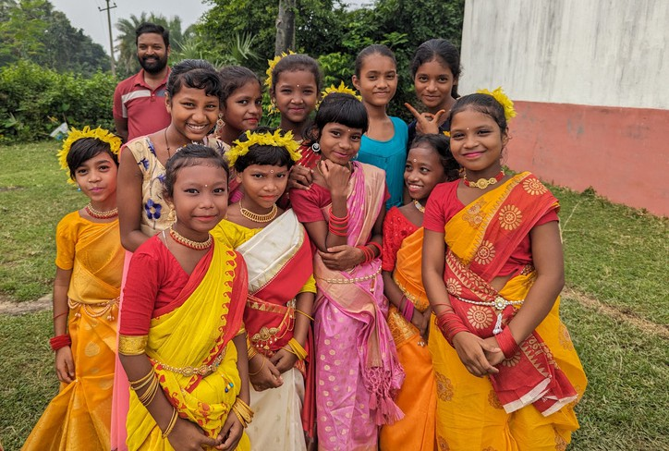
Women in the diocese felt that children who are vulnerable to be trafficked need a safe space to equip themselves with education and training in various trades and life-skills, so they would have different and better possibilities in their lives.

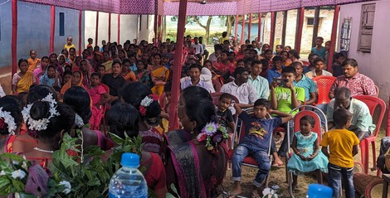
In the following years, the AHTM program grew into a network of child development centers and residential homes where children receive a different environment, and hopefully the abilities to navigate the world as confident and capable individuals.

Anti-Human Trafficking Education Session and Cultural Event organized by the Anti-Human Trafficking Ministry of the Diocese of Durgapur of the Church of North India

Dr. Sarosh Koshy, Global Relations Minister, Southern Asia, Global Ministries of the Christian Church (Disciples of Christ) and United Church of Christ

Every year, thousands of people receive information and training in identifying cases of human trafficking and on how to address them and take the cases to governmental agencies and authorities. This sustained effort has kept hundreds of children every year from being trafficked.

SHARE THE LIGHT

MISSION MOMENT
INYATHI MISSION FARM
ZIMBABWE SYNOD OF THE UNITED CONGREGATIONAL CHURCH IN SOUTHERN AFRICA (UCCSA)
The UCCSA Zimbabwe Synod serves communities predominantly in the south- western part of the country affected by genocide in the 1980s. That experience left communities and members of the church hurt, brokenhearted, and traumatized. The trauma experienced by victims and survivors, especially women and youth, has resulted in poverty, hunger, disillusionment, and substance abuse. The church takes the gospel into public space, to transform society. One of the “public spaces” that the church uses is Inyathi Farm. At their farm, they carry out agricultural initiatives including animal husbandry and horticulture aimed at fulfilling the church’s missional role of addressing socioeconomic issues, needs, and pain within and outside the church. For communities in the Makhaza Nkala region, which includes the farm, the Inyathi Farm project provides employment, economic sustainability, food security, and independence through agriculture.
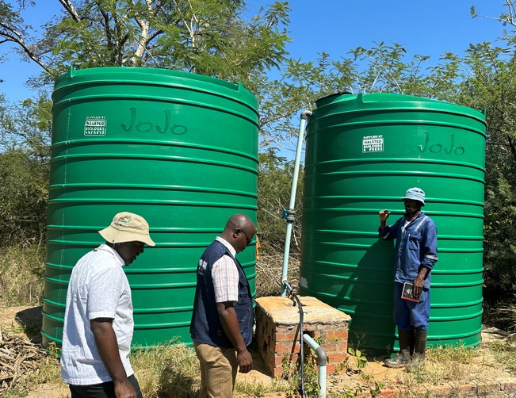
The community can now purchase produce within the community rather than traveling long distances to buy from markets 60 km away.
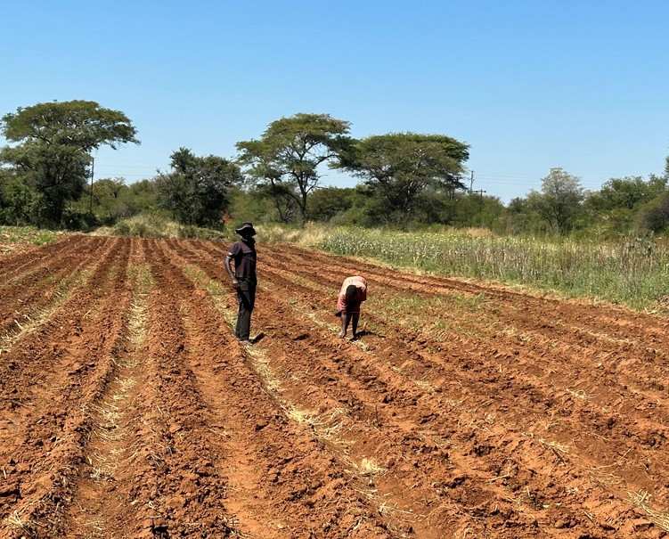
Sehliselo Khumalo, who was born near Inyathi Farm, states, “The farm is helping because my work with the farm makes me get something to put in my pocket (an expression of receiving money) because people come here and buy sweet potatoes, cabbage, and maize cobs to feed their families. It helps the community especially during drought seasons.” Elizabeth Sibanda, states, “As community members, we find the Inyathi Farm very helpful. There was little water in the past, but the farm now has large water containers and now waters a big area. As a result, our community is able to get buckets of maize that will feed our children. The farm once had one employee but now we see the farm has an influx of employees from our local community

Workers from the Inyathi Farm in Zimbabwe
and children are now able to continue their education.”

The Inyathi Farm project creates life-transforming opportunities and a sense of renewed hope in the life of the Church and community. “The youth, community members, and church members get employment at the farm,” states Mr. Marko Tshabalala, Inyathi Farm caretaker. We pray for continued blessings as the church continues to take the ‘Gospel to the public space.’ This work builds a bond among communities nearby and improves the lives and well-being of individuals and families.
Kahala Cannon, Global Relations Minister, Africa, Global Ministries of the Christian Church (Disciples of Christ) and United Church of Christ

