The Association of Religion Data Archives (ARDA) provides high-quality data on religion and communities in America to pastors, leaders, and researchers. The generosity of several foundations and universities makes this resource available for free. Previously, the same information came from MissionInsite at a cost to Conferences and the national setting. The UCC Local Church Profile references both the ARDA and MissionInsite, and these instructions help you find all the information you need for your profile from the free ARDA site.
Demographic information can help you reflect on several questions crucial to your profile.
- “Who Is God Calling Us to Become” asks the search committee to describe how God is calling you to reach out to address the emerging challenges and opportunities of your community and congregation.
- “Who is Our Neighbor” invites the search committee to reflect on the ARDA or MissionInsite data
- Comment on your congregation’s MissionInsite report with data for your neighborhood(s) or area. What trends and opportunities are shown?
- Point people to look at population trends
- Look at educational levels
- Frequency of moves in a community
- Ownership of homes
- Family structure
- How do your congregation’s internal demographics compare or contrast to a) the neighborhoods adjacent to your church, and b) other neighborhoods with which your church connects?
- How are the demographics of the community currently shaping ministry, or not?
Create Report
To access the ARDA tools for reflecting on these questions, begin by creating a profile of the neighborhood for your congregation.
- Visit www.thearda.com
- Click on the “Congregations” tab from the horizontal bar at the top of the screen (see red circle on image below).
- A menu will open up with an option to “Profile Your Community” on the right. Click on the red “Your” underneath the photo. Enter the zip code of your congregation and click on the button labeled “Create Profile.”
- On the interactive GIS maps page, you will want to do several things:
- Enter the radius that you want to use for your report. The ARDA defaults to a 2-mile radius and this will work well for most congregations. However, you may want to increase this radius if your congregation is in a rural area or decrease it if you are in an urban one. In thinking about the radius, reflect on how far you would drive in your community to get to a grocery store. That can serve as a rule of thumb for how far people will ideally drive for their church. Remember: we are not looking to make a demographic map of where current members come from but instead to create a map of where your potential future church members may come from. Choose a radius that will include the most likely neighborhoods of potential visitors to your congregation.
- Select your congregation on the map. The displayed map will shift to center your congregation.
- Click on the button labeled “Profile,” which is located on the blue bar to the right on the list under step 4.
- These steps created a demographic report for your congregation. You can further customize the report using the menu to the left to unclicking what community profile sections you want to see and/or by clicking the display charts option. After making your selections, click on the “update report” button to see the refreshed report.

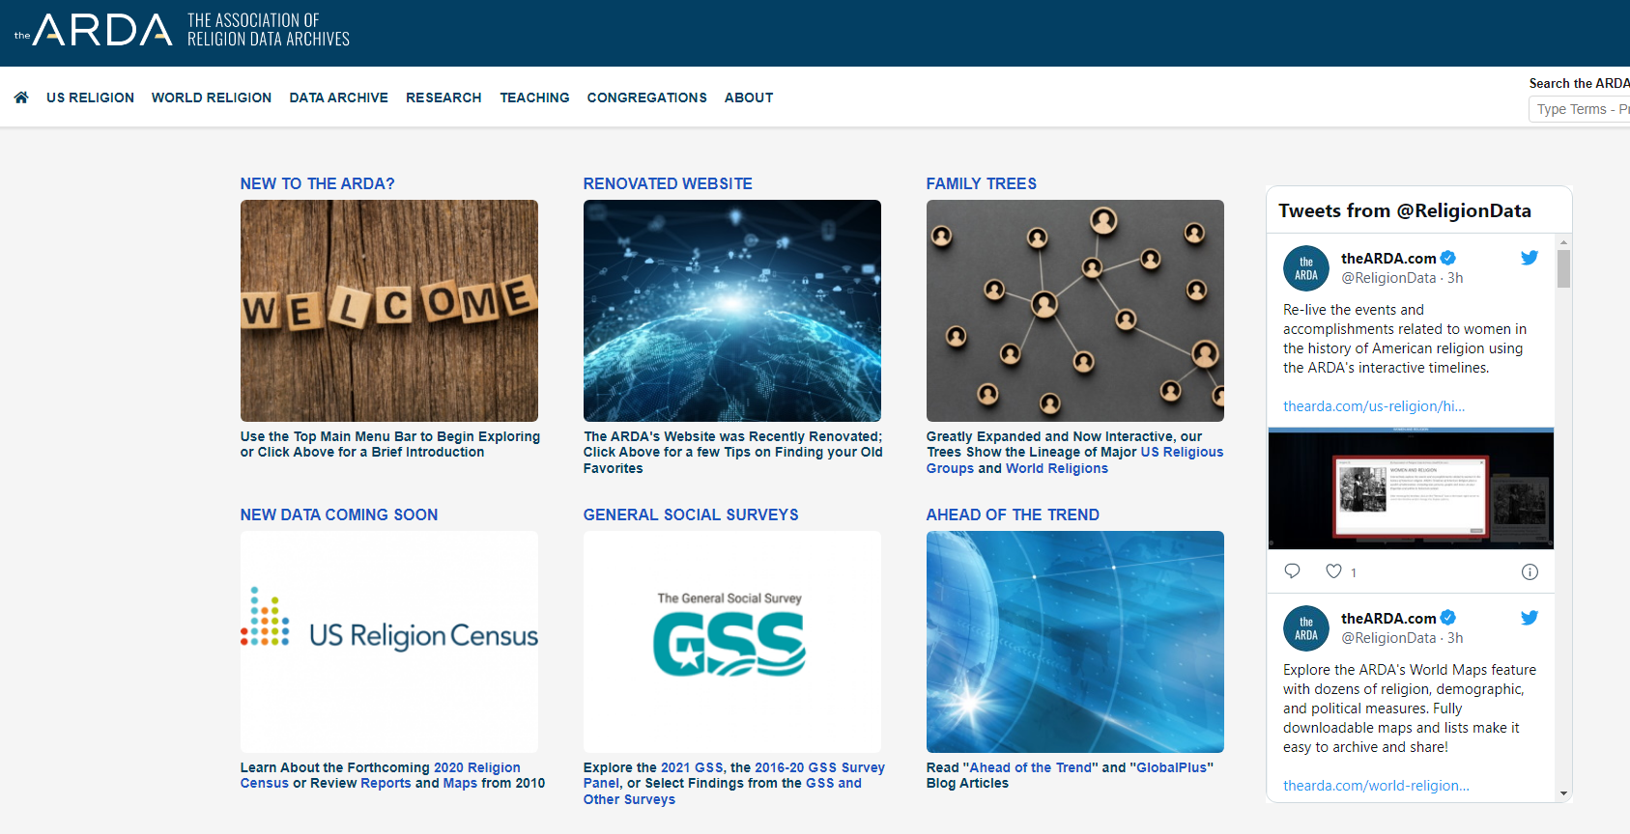

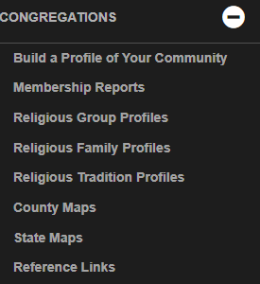

Reflection

Initially, ask yourself questions as you review the graphs and data tables of the neighborhood around your congregation?
- What surprises you?
- What opinions about your neighborhood do you see confirmed in the data?
- Do any opportunities for mission stand out?

One search committee, looking at the report, was surprised by the high percentage of people with college or advanced degrees the church’s neighborhood.

Spend time more time with the report by noticing which demographics are changing in your community.
- What areas show increasing numbers of people? What areas show decreasing numbers of people?
- What are the demographics of the people in these areas?
- How far do people drive to work?
- Is there a census tract in your neighborhood that shows an increasing number of new households?

One search committee noticed that a particular census tract to the southwest of the church showed increasing numbers of people moving into the area. The committee wondered how they could reach out to the new neighbors in this part of town. Another noticed that many of the people living near the congregation were Millennials without children in the home and Boomers with grown children; both were moving into the area around the church to live in condos and apartments. The committee began to wonder if their new childless neighbors might need a dog park.

Compare what you see in the demographic report of your neighborhood to the demographic profile of your congregation.
- How does your congregation compare to the age, race, and educational level of your neighborhood?
- Does your congregation have more or fewer households with children living at home than the neighborhood?
- Looking at the demographics, on a scale of 1 to 4, would you say that your congregation is very in sync with the neighborhood (a 1) or not very in sync with the neighborhood (a 4)?
- Who in your circle of connection (not church attendees) could you interview to better understand the top demographic groups in your neighborhood? That is, who could help you better understand the needs of the neighbors outside of your congregation?
- Which community leaders (Chamber of Commerce, Rotary president, social service agency executive) could you talk with you about the social, spiritual, and practical needs of your non-church neighbors?

Answer Sections “Who Is God Calling Us to Become” and “Who Is Our Neighbor” on the Profile

“Who is God Calling Us to Become”

Based on your reflection on your demographic profile and using the intel you gained from conversations with people outside of your congregation, write a paragraph or two summarizing how God is calling you to reach out to address the emerging challenges and opportunities of your community and congregation.

“Who Is our Neighbor” – ARDA or MissionInsite Reflection

This is an opportunity to say a bit more about the demographics of the neighborhood around your congregation. You can turn any chart into a jpeg to include on supplemental pages of your report by clicking on the download button (see image below – green triangle) and then putting the image into a Word document. Be sure to note the trends in the wider community and how your congregation mirrors or differs from them.
- Population trends (see Age/Gender Report and Race/Ethnicity Report)
- Educational level (see Education Report)
- Frequency of moves (under Housing Report see “Where did person live, one year ago?” data)
- Home ownership (under Housing Report see “Housing Occupancy” data)
- Family structure (see Family Report)

Be sure to address in a paragraph or two how the demographics of the community currently shaping ministry or how you hope to address them in the future.

