Pentecost – May 28 (rev. 5/15/23)
May 28, 2023
Pentecost Sunday
John 7: 37 – 39 | “Flow Out from Within”

Passing of the Peace (Speaking of Jewish and Samoan Diaspora)

Welcome to the last Sunday of Asian American, Native Hawaiian, and Pacific Islander Heritage Month! However, in the Church, today is Pentecost Sunday, a celebration of the Holy Spirit, affectionately thought of as “the birthday of the Church”. It is a day when we recount how our faith ancestors though scattered throughout the world, were all represented in Jerusalem and able to hear the apostles speaking in the tongues of their new homelands.

There are approximately 70 Samoan Churches affiliated with the United Church of Christ. We know firsthand what it means for our people to be dispersed around the world as the Samoan population is dispersed throughout the whole Pacific including Hawaii, New Zealand, Australia, and the USA. The initial migration of Samoans to the United States was driven by the U.S. Navy (military movement) shortly after WWII, particularly settling in Hawaii and then in Southern California. Of course, the migration then established local gatherings that gave birth to the beginnings of the indigenous congregations.

Would you believe that of the approximate total Samoan population of 700,000, over two-thirds live outside the Samoan Islands? So, as Jews might have opportunity to reassemble in Jerusalem for important festivals like Pentecost (Shavuot), we Samoan sometimes, if we are fortunate, may also have opportunity (or obligation) re-assemble back in Samoa for special occasions.

This morning, we invite you to greet one another by “speaking in tongues”; that is, with the simple Samoan greeting “Talofa!” or even more politely “Talofa lava!” Sidenote: The word talofa comes from an old Samoan phrase, “si o ta alofa” which means, “my love for you”.

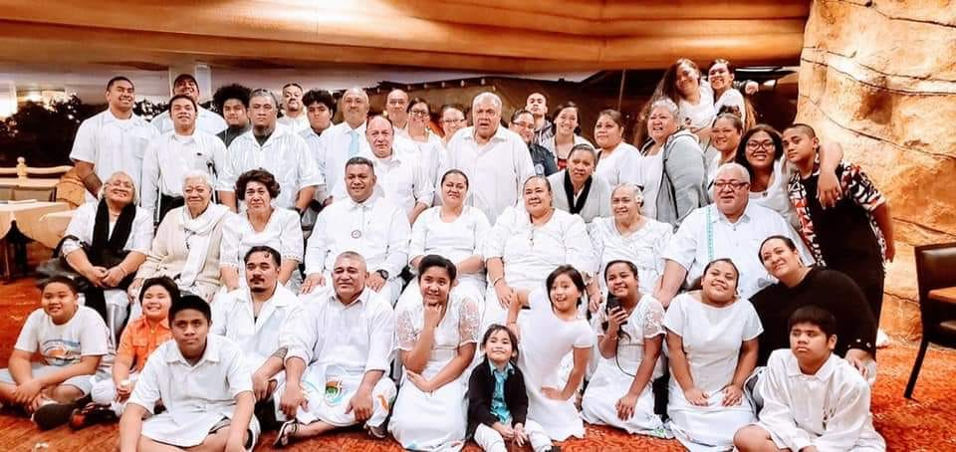
“Talofa!” from Faaaliga o le Alofa “FOLA” Church in Las Vegas

Call to Worship

One: When the day of Pentecost had come, the disciples were all together in one place.
Many: Today, followers of the Way gather in many places,
One: From Jerusalem to Galilee, from Pago Pago to Apia.
Many: From Rome to Arabia, from Las Vegas to Cleveland.
One: God’s Spirit still blows like a mighty wind
Many: Breathing new life into the sails of our canoes.
One: God’s Spirit still burns like tongues of flame
Many: Dancing over the heads of our Toa* [TOH-ah] (brave ones).
One: God’s Spirit still flows like currents of living water
Many: Connecting hearts and islands of all believers.
One: Praise God! Viia le Atua! [vee-EE-ah leh ah-TOO-ah]
Many: Viia le Atua! Praise God!
All: Let us worship God, from whom all life’s blessings flow!

* Cultural note: Toa – defined as ‘brave one(s)’
In ancient Samoa, warriors may demonstrate prowess and bravery through artfully twirling, throwing and catching, and dancing with war clubs: these exhibitions were known as Ailao. At night, twirling of lit torches may have been added to the ritual. This developed into the modern Siva Ailao Afi (fire knife dance) that is performed in many Polynesian cultures.

Invocation

O Holy Spirit, come and blow through this gathering space as Mighty Wind as you did with the apostles at the beginning of the Church. Pour your Spirit upon us all, both colonized and colonizer, of all ages, all genders, to speak your words, see your vision, dream your dreams toward your great and glorious day when everyone who calls on the name of the Lord shall be saved. Flow like rivers of living water from the hearts of believers through the songs of praise, words of worship, and prayers of devotion. Amen!
Prayer for Transformation
Dear God, le Atua e (leh ah-TOO-ah eh) God of oceans and land and all life contained therein. You created this world by the power of your word. By your own hands and breath, you formed humankind in every conceivable shade of brown. You gave us islands and continents as a gift and charged us to be the stewards of what you have made.
Creator God, we have failed you and abused your gift to us. We have offended you and defiled your creation, including seeing fellow human beings as being less than created in your very image. Forgive us for betraying your trust. Forgive us for our greed and arrogance.
Hear the cries of islands drowning in the rising seas, oceans that rise with the melting of the ice.
Hear the cries of our world in distress through storm and drought.
God of Life, heal your wounded earth. Embolden us to choose the path that leads to life. so that we may renew your Shalom in land, sea, and sky. This we ask in the name of the one who came that we way have life in abundance, your Son, our Savior Jesus the Christ. Amen.

Words of Grace
Le alofa o le Atua (leh ah-LOW-fah oh leh ah-TOO-ah), God’s love does not belong to one person or group of people. God’s love and forgiveness is available to all, even those who do not ask for it. You can also be agents of God’s love and healing, so let us strive to receive and give this gift of God’s restoration with Creation and with each other. Be God’s love and healing for people and planet. Amen.

Pastoral Prayer
Creator God, we give thanks for the amazing diversity of people and cultures living on the islands and continents of your beautiful earth, for rocks and trees, for skies and seas. We give thanks for the colors of creation and seas teeming with life. May we see the vastness of oceans as what connects us rather than what separates us, one with another.
We pray for those adversely affected by earthquakes, volcanoes and hurricanes, those dealing with the legacy of past nuclear weapons testing and with careless waste management polluting the land, water, and air. We pray wisdom and compassion for leaders in their governance – especially in preserving indigenous cultures –which by intention or ignorance, often keep people impoverished, hungry, lacking sufficient education or meaningful employment.
O God, as we see rising tides of hate, especially against people of color, save our shores from the weapons of death. Protect us from that which denies our young ones love and freedom. Let each child swim and breathe the fresh air that is filled with your Holy Spirit. Bless all who stand as makers of peace and breakers of hate, as we dare to dream that all the peoples of the world may live happily as one. We pray in the name of Jesus Christ, Prince of Peace. Amen.
Invitation to Generosity (Call for the Offering)
At the birth of the Church, all who believed were together and had all things in common: they would sell their possessions and goods and distribute the proceeds to all, as any had need. The work of le Agaga Paia (leh Ah-NGA-nga Pah-EE-ah), the Holy Spirit, flows like living water from the hearts of believers. Shall our confidence in the mission of our congregation and the wider church also overflow freely with the generosity of the faithful? May each of our families give without measure so that the larger family of faith may be a vessel of Good News to the world!

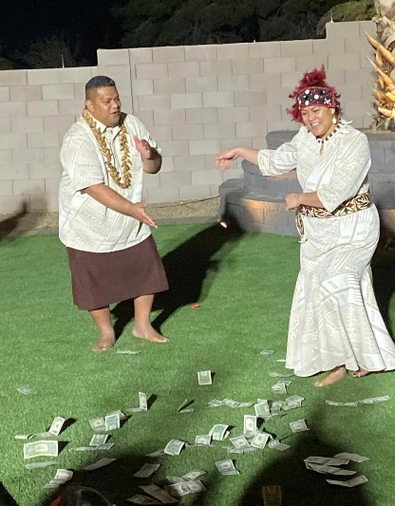
Cultural Note: On special occasions, traditional Samoan money dance may be used as a gift to the church.

Prayer of Thanksgiving and Dedication
Heavenly God, even as the first believers did in the early church, we lay our gifts at the feet of the apostles. May these gifts support the ministry of our congregation as well as strengthen the wider United Church of Christ and ecclesial partner, the Congregational Christian Church of American Samoa, as well as the whole of the Samoan ecclesial family here and everywhere. Give our leaders gifts of discernment for wisest possible use of these resources which we dedicate to you today. Blessing and honor, glory and power be unto you! Amen.

Benediction
Dear Sisters and Brothers, God’s Holy Spirit goes with you, blows with you, and flows with you.
So let us be as Vai Ola, Living Water, flowing from within this worship service out to a thirsty world. Amene.

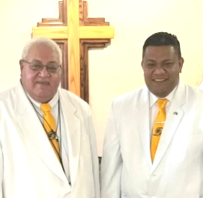
Flow Out from Within: Service Prayers for Pentecost Sunday was written by Rev. Mikey Kelemete, Senior Pastor of Faaaliga o le Alofa (Vision of Grace) Church in Las Vegas, Nevada, affiliated with both the Congregational Christian Church of American Samoa (Ekalesia Faapotopotoga Kerisiano Amerika Samoa) and the United Church of Christ and Rev. Samuelu “Sam” Tialavea, Associate Pastor of Faaaliga o le Alofa. Pastor Sam also serves as secretary for United Samoan Ministries of the UCC and in the Southern California Nevada Conference as Vice-Moderator for the Eastern Association as well as secretary for SCN Pacific Islander and Asian American Ministries. Would you like to see what worship in a Samoan church in the USA looks like? Visit us on facebook: (20+) FAAALIGA O LE ALOFA - VISION OF GRACE CHURCH in Las Vegas, NV USA | Facebook

Editor Note:
Speaking of Vai Ola, if you are using the image of “living water” (John 7:38) this Pentecost Sunday, you may find more helpful reflections in the Hawai’i Conference UCC February 2023 edition of “The Friend” newsletter with several Hawai’i Conference UCC leaders’ eco-justice reflections on “Ola i ka Wai” (“Water is Life”). 1c51b0_d1e9eda1e71f476b99d3d46f96d35410.pdf (hcucc.org)

