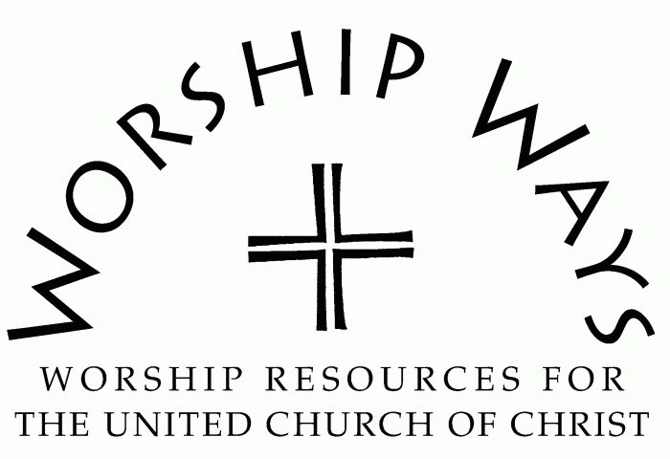

Sunday, April 23, 2023
Third Sunday in Easter
“While You Walk”

Note: For PAAM/API worship services [From Chinese Immigrant perspective (Cantonese dialect) when Chinese words/phrases are used]

CALL TO WORSHIP

One: Come! Come! Come!

All: 来! 来! 来! (Lai! Lai! Lai!)

One: Come! Let us worship our God who listens to us…
All: Whatever language we speak!

One: Come! Let us worship our God who understands us…
All: Whatever story we live and share!

One: Come! Let us worship our God who loves us…
All: Just as we are!

INVOCATION
Holy One, God of many names,

Be with us while we walk our Road to Emmaus…
Be with us as we share a simple ordinary meal with you – like jook*…or naw mai fan**
Rejoice with us as we recognize you more clearly with each tasty mouthful of familiar food…that you are alive and real in our midst!

May we open our hearts along with our eyes…to the resurrected Jesus during this hour of worship and beyond…that we become your Easter People of today…embracing all colors, nations, and races. Amen!

* jook = congee, Chinese rice porridge – served with condiments in some Chinese churches often for breakfast after Easter Sunrise Services
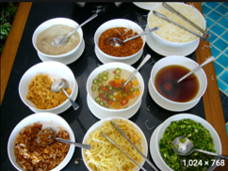

** naw mai fan = Chinese sticky rice with lop cheong (Chinese sausage), dong goo (aka shiitake mushrooms, hai mai (dried shrimp), and green onions: a comfort food in many Chinese homes and popular pot luck dish in Chinese churches.
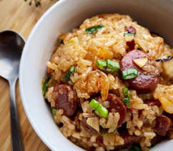

PRAYER OF CONFESSION
God of Surprises, God of Resurrection, God of Unity,

We are still celebrating Easter! And in our excitement…especially as we begin to emerge from being buried in Covid fears…we can be blind to what is happening around us. AND we are still unsure about how to live out the message of resurrection.

We know that the lives of our loved ones, our AAPI brothers and sisters, are dealing with the reality of increased Anti-Asian violence and attacks. We know this is not the oneness in you that you call us to be. Give us the courage to fully open ourselves to you and to follow you that we become your hands, feet, love and presence while we walk with you in your world. Amen.

ASSURANCE OF GRACE
With our confession…we are assured of God’s grace…whoever we are…whatever our story…whereever we find ourselves…whatever language we speak…whoever our family and loved ones are…God loves us… Praise be to God!

PRAYER OF DEDICATION
God of Yesterday, Today and Tomorrow,

Along with these offerings we bring our hope that you continue to open our eyes to Jesus just as you did for the travelers on the road to Emmaus. Help us to see all of creation – the world and all who live in it - through your eyes. Help us to see and act, listen and pray, feel and respond to your larger vision of what can be. Help us to grow in you…may our eyes be Easter eyes to recognize Jesus wherever we are, whoever we are, whoever we are with. Amen.

In Case these aren’t referenced elsewhere:
MUSIC LINKS
1. Youtube link to “Great is Your Faithfulness” by NCNC choir (multi-language), directed by Rev. Michael Ellard
https://www.youtube.com/watch?v=y6fiyI9764g

2. Youtube link to “Together We Are One” by PAAM choir, directed by Rev. Michael Ellard (lyrics by PAAM’s Dick Hom)
https://www.youtube.com/watch?v=LlfMd8iznWg

WORSHIP LINKS – (excerpts can be used for church worship)
• PAAM Thursdays for the Soul (041521)
https://www.youtube.com/watch?v=lKsiph3bnCM

• Youtube Link to Monday Night (aka “PAAM Worship”, General Synod 32 (062419)
https://www.youtube.com/watch?v=KNxhS06yX6c&feature=youtu.be

A LITANY TO HONOR AND AFFIRM PACIFIC ISLANDER & ASIAN AMERICAN MINISTRIES, UCC
By Rev. Tom Fujita, for PAAM – several decades ago
Right: For creating this world into which we are born, and for giving us the opportunity to live our lives to the fullest…
All: We give you thanks, O God our Creator.

Left: For leading peoples of diverse countries and cultures to this country called America…
All: We give thanks, O God of the heavens and the earth!

Right: For the opportunities and responsibilities that come to us being a country of diversity…
All: We give thanks, O God, who created diversity!

Left: For the struggles and sacrifices of our immigrant ancestors who toiled so hard that succeeding generations might have a better life…
All: We give you thanks, O God of integrity and history!

Right: For the gifts, faith, culture, and religious traditions of Chinese, Japanese, Korean, Filipino, Taiwanese, Hawaiian, Samoan, Micronesian and all other Pacific Islander and Asian peoples…
All: We give you thanks, O God of all!

Left: For failing to appreciate fully the traditions and heritages from which we come and for failing to respond and be sensitive to people especially from Asia and the Pacific Islands;

All: To you we confess our sins of omissions, O God of struggle!
O God, we commit ourselves to:

Right: Care for the suffering of all God’s people, especially for our neighbors of Asian and Pacific Island descent;

Left: Strive for a deeper spirituality as exemplified by the first generation of our Christian ancestors;

Right: Live for peace which comes from a dedication to live with justice;

Left: Appreciate that true Christian harmony comes through a positive identity based upon pride in God’s gift to us, our heritages both ethnic and Christian; and

Right: Sharing our unique talents in the concerns of others, all for the glory of your universal plan.

All: Amen.

While You Walk: Service Prayers for the Third Sunday of Easter were written by The Rev. Sharon Lee Mei-Shem MacArthur (PSR 2001)
Born and raised in Stockton CA by Immigrant parents from China via Hong Kong, with English as second language; UCC pastor recently retired after serving in churches in Northern California and Hawaii as senior pastor and intentional interim pastor; currently serving as Moderator of National PAAM, UCC Manual on Church Writing Group; lives in Hercules CA with Nowell, husband of 58 years.

