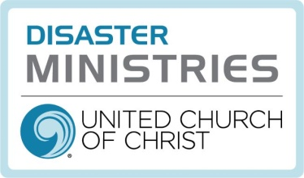

Conference Disaster Coordinators (CDC) and Emotional and Spiritual Care Team (ESCT) Directory December 2022

Mission Statement
“Responding to the call of our faith, UCC Disaster Ministries supports holistic community recovery, by engaging supporters, volunteers and partners to focus on preparedness, emergency relief and long-term recovery”

United Church of Christ
Cleveland, Ohio
https://www.ucc.org/what-we-do/wider-church-ministries/global-hope/disaster/

Central Atlantic
(DC, DE,MD, NJ, WV, VA)
Jerrold L. Foltz, CDC
Centreville, VA
jfoltzva@gmail.com
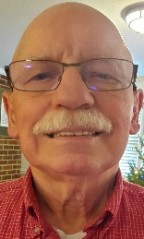

Central Pacific
(OR, So. ID, So.WA)
Kim Vogel, CDC
Hood River, OR
UCCkimvogel@gmail.com
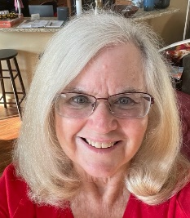

Florida
Alan Coe, CDC
Naples, FL
revalcoe@gmail.com
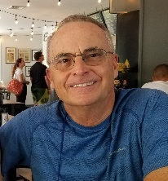

Hawaii
Danny Tengan, CDC
Honolulu, HI
dstengan@gmail.com
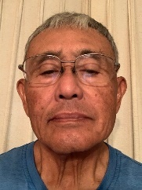

Gordon Marchant, ESCT
Honolulu, HI
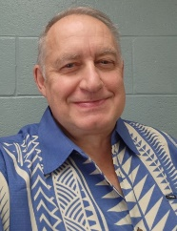

Heartland
(OH, No. KY, WV)
Kevin Gehres, CDC
Wren, Ohio
gehreskb@gmail.com
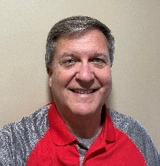

Illinois North Central
Roger Dart, CDC
Deerfield, IL
disaster@ilucc.org
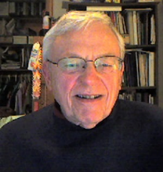

Illinois North Central
Scott Hagedorn, CDT
hagedorn51@comcast.net
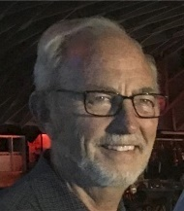

Illinois South
Priscilla Self, CDC
Nashville, IL
pjj48@hotmail.com
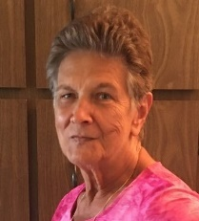

Indiana-Kentucky
Greg Denk, CDC
Greenwood, IN
gdenk5258@att.net
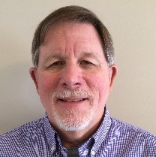

Iowa
Brice Hughes, CDC
Burlington, IA
bricehughes@hotmail.com
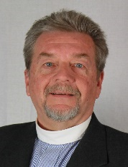

Kansas-Oklahoma
Kelly Hansen, CDC
Prairie Village, KS
kellyahanseninkc@gmail.com
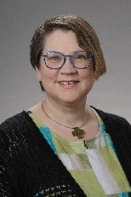

Kansas-Oklahoma
Laura Woods, CDC
Oklahoma City, OK
lauraeliwoods@gmail.com
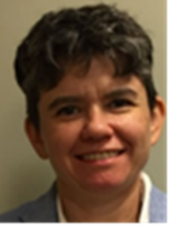

Maine
Estelle Margarones, CDC
South Portland, ME
disasters@ucc.org
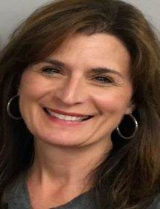

Michigan
Lillian Daniel, CM
Detroit, MI
lillian@michucc.org
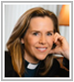

Michigan
Judith Booker, POC
Detroit, MI
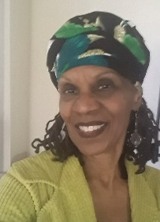

Minnesota
Cris Phillips, CDC
Minneapolis, MN
Sonoma566995@hotmail.com
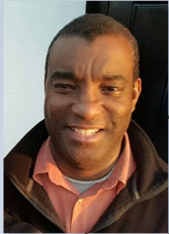
Missouri Mid-South
(MO, AK)
Rev. Mary Nelson, CM mary@mmsucc.org

Montana-Northern Wyoming
Marc Ian Stewart. CM
Billings, MT
marc@mnwcucc.org

Pam Peterson, CDC
Red Lodge MT
Pam Peterson pastorpampeterson@gmail.com

Joshua Rau, CDC
Sidney and Savage MT
joshuawrau@gmail.com
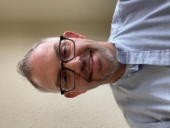

Nebraska
Coral Parmenter, CDC
Thedford, NE
coralparmenter@gmail.com
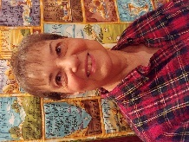

New Hampshire
Daniel Adam, CDC
Newport, NH
Danieladam.scc@gmail.com
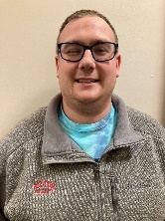

New York
Sue Frost, CDC
Binghamton, NY
sfrost@uccny.org

Emotional and Spiritual Care Team Coordinator
Martha Jacobs, ESCT
Yonkers, NY
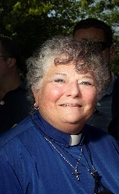

Northern California-Nevada
Davena Jones ACM, CDC
Concord, CA
davena@ncncucc.org
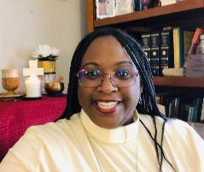

Northern Plains (ND)
Darla Schafe, CDC
Flasher, ND
randar@westriv.com
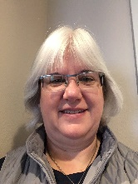

Pacific Northwest
(AK, WA, No. ID)
Seattle, WA
Arlene Hobson, Executive Administrator
arlene@pncucc.org

Pennsylvania Central
Bill and Ellen Matten, CDCs
Boalsburg, PA
ellen.matten@gmail.com
beathomemd@comcast.net
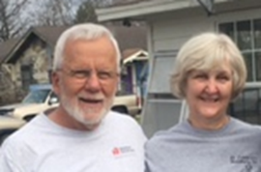

Pennsylvania Northeast
Steve Hummel, CDC
Bloomsburg, PA
revstevehummel@gmail.com
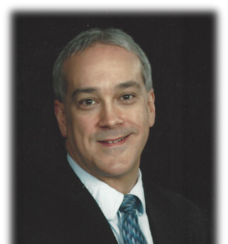

Pennsylvania Southeast
Karl Jones, CDC
Douglasville, PA
kjones275@comcast.net
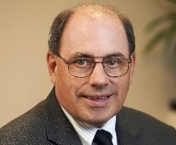

Jennifer Smith, ESCT
Norristown PA
ergojenny@aol.com
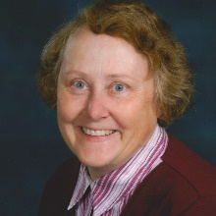

Pennsylvania West
Ryan Lucas, CDC
Vandergrift, PA
ryanplucas@gmail.com
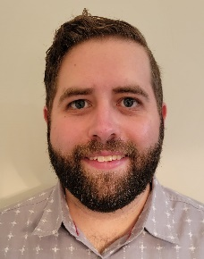

Rocky Mountain
(CO, WY, E. NV, UT)
Beth Whipkey, CDC, ESCT
Eden, UT
majorinsight@gmail.com
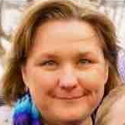

South Central
(LA, So. MS, TX)
Mona S. Lopez, CDC, ESCT
Humble, TX
revmona@gmail.com
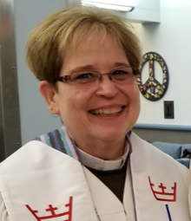

South Central
(LA, So. MS TX)
Phillip Hodson CM, CDC
Sccm@sccucc.org
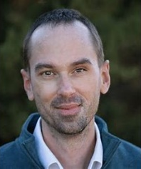

South Dakota

Southeast
(AL, GA, MS, SC, TN)
Rev. Kim Wood CM, CDC
kwood@secucc.org
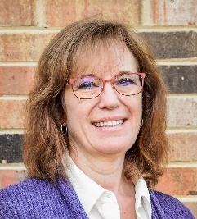

Southeast (TN)
JRae Rice-Cranford, CDC
Waverly TN pastorjrae@gmail.com
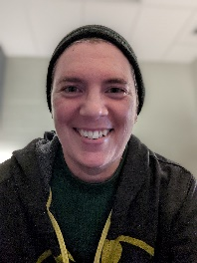

Southern
(NC, S VA)
Eddie Weathers ACM, CDC
Eddie.weathers@yahoo.com
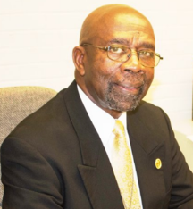

Rob Edwards, ESCT
Virginia Beach, VA
pastor@baysidechristianchurch.com
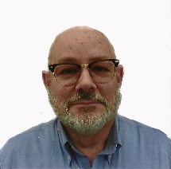
Southern California-Nevada
Virginia Arroyo
Administrative Assistant
arroyo@scncucc.org
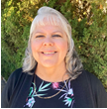

Southern New England
(CT, MA, RI)
Fred Meade, CDC, ESCT
Pocasset, MA
fredmeade@aol.com
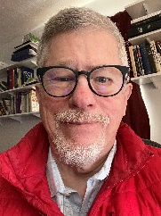

Southern New England
(CT, MA, RI)
Philomena Hare, CDC
Hyannis, MA
Philomena.hare@gmail.com
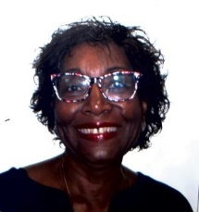

Jeffrey Gallagher, ESCT
Tolland, CT
jgallagher@ucctolland.org
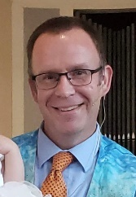
Southwest
(AZ, NM, El Paso TX)
Southwest Arizona
Gloria Smith, CDC
Phoenix, AZ
gsmithrev@aol.com
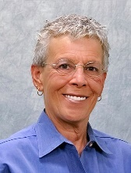

Southwest
NM, El Paso TX
Tom Davis, CDC
Albuquerque, NM
thdavis353@gmail.com
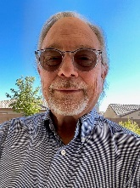

Vermont
Greg Briggs, CDC, ESCT pastor.greg.briggs@gmail.com
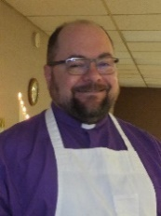

Wisconsin
Christina Schoenwetter, CDC
Sun Prairie, WI
chris_schoeny@hotmail.com
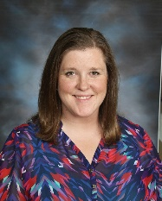
NATIONAL STAFF
Karen Georgia Thompson
Associate General Minister for
Wider Church Ministries
thompsonk@ucc.org

Joshua Baird
Team Leader
Global H.O.P.E.
bairdj@ucc.org

Lesli Remaly
Global H.O.P.E.
Minister for Disaster Response and Recovery
Remalyl@ucc.org
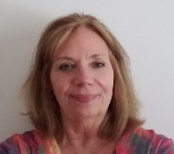

Elena Larssen
Global H.O.P.E.
Minister for Volunteer Engagement
Larssene@ucc.org

Irene Willis Hassan
Global H.O.P.E.
Minister for Refugee and Migration
hassani@ucc.org
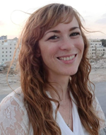

Craig Hoffman
Global H.O.P.E.
Program Assistant
Hoffmanc@ucc.org
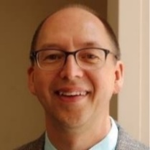

Global H.O.P.E.
Communication Specialist
Position Open

