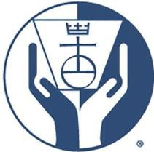
UNITED CHURCH OF CHRIST
CORNERSTONE FUND

Position Openings
November 14, 2022

{To view the position description, select Ctrl and Click on keyboard and point to the title or visit Career Opportunities - United Church of Christ (ucc.org)}

Investment Portfolio Specialist Extended Close: December 16, 2022

