Living Psalms Book
Psalms in the form of words and art, reborn in the specific contexts of our world, privileging the voices of historically marginalized communities and those acting in solidarity with them.

Living Psalm 80—Advent 4 C
(Restore us, O God)

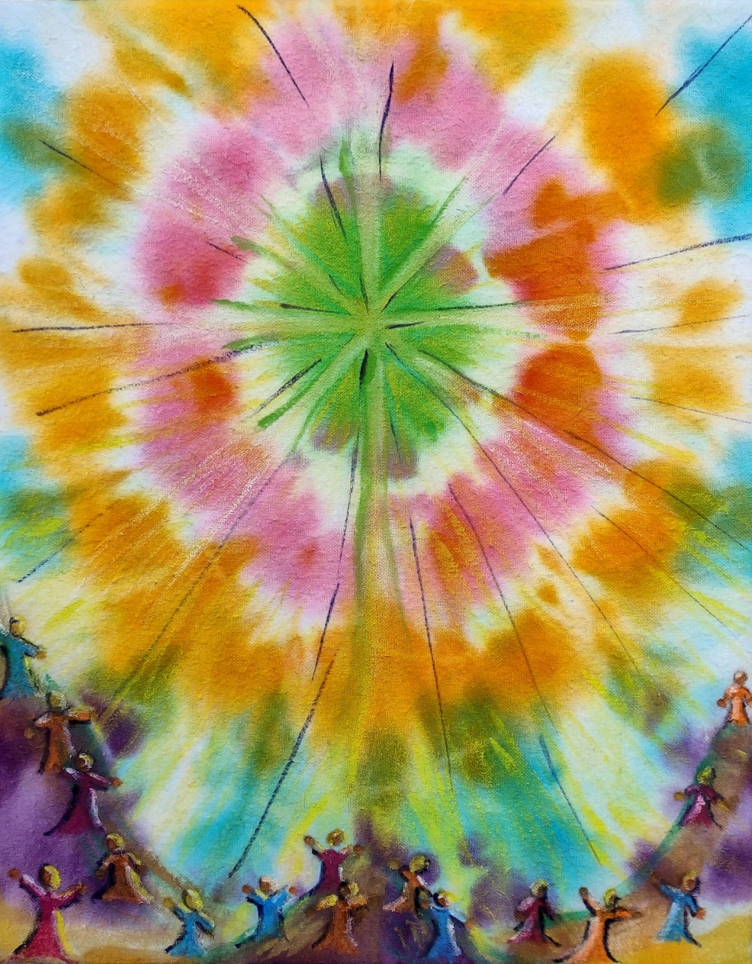

Living Psalm 80—Restore us O God--for Advent 4 C was created by Erin Beardemphl.
.
Living Psalms Book is created by UCC Witness & Worship Artists’ Group, a Network of UCC connected artists, activists and ministers bridging the worship and liturgy of the local church with witness and action in the community. Editor, Maren Tirabassi.

Logo is detail from Living Psalm 80 by Sophia Beardemphl, Redwoods, CA. Recovering from significant bullying, Sophia, age nine, read Psalm 80 and thought of brokenness that needs mending. She drew this broken and mended bowl.

© Copyright 2021 Erin Beardemphl., Permission granted to reproduce or adapt this material for use in services of worship or church education. All publishing rights reserved.

