2022 Conference Disaster Coordinators
(States included)
Conference Disaster Coordinator/or POC
Location
Email address

Central Atlantic
(DC, DE,MD, NJ, WV, VA)
Jerrold L. Foltz
Centreville, VA
jfoltzva@gmail.com
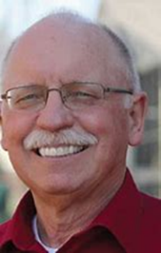

Central Pacific
(OR, So. ID, So.WA)
Kim Vogel
Hood River, OR
UCCkimvogel@gmail.com
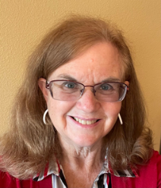

Florida
Alan Coe
Naples, FL
revalcoe@gmail.com
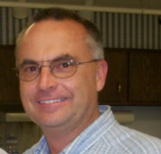

Hawaii
Danny Tengan
Honolulu, HI
dstengan@gmail.com

Heartland
(OH, No. KY, WV)
Kevin Gehres
Wren, Ohio
gehreskb@gmail.com
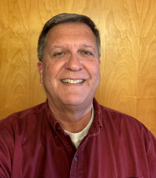

Illinois North Central
Roger Dart
Deerfield, IL
dart.rc@gmail.com
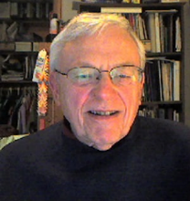

Illinois South
Priscilla Self
Nashville, IL
pjj48@hotmail.com
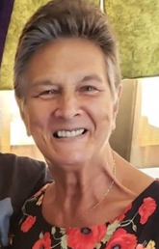
Indiana-Kentucky
Greg Denk
Greenwood, IN
gdenk5258@att.net
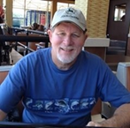

Iowa
Brice Hughes
Burlington, IA
bricehughes@hotmail.com
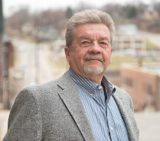

Kansas-Oklahoma
Kelly Hansen
Prairie Village, KS
kellyahanseninkc@gmail.com
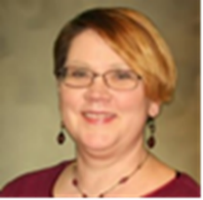

Kansas-Oklahoma
Laura Woods
Oklahoma City, OK
lauraeliwoods@gmail.com
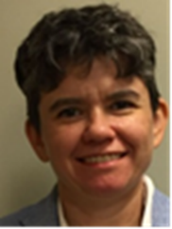

Maine
Jonna Jensen
Augusta, ME
jjensen@maineucc.org
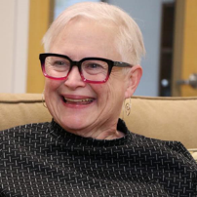

Michigan
Judith Booker
Detroit, MI
jgarnell46@yahoo.com
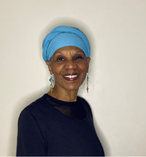
Michigan
Roslyn Bouier
Detroit, MI
Supporting
bouierr@yahoo.com

Minnesota
Cris Phillips
Minneapolis, MN
Sonoma566995@hotmail.com
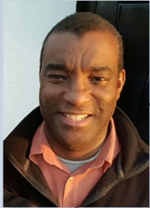

Missouri Mid-South
(MO, AK)
Rev. Mary Nelson mary@mmsucc.org

Montana-Northern Wyoming
Marc Ian Stewart
Billings, MT
marc@mnwcucc.org

Nebraska
Coral Parmenter
Thedford, NE
coralparmenter@gmail.com
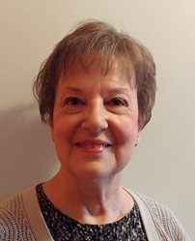

New Hampshire
Gordon Rankin
grankin@nhcucc.org
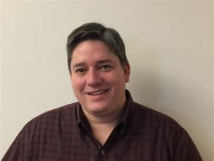

New York
Sue Frost
Binghamton, NY
sfrost@uccny.org
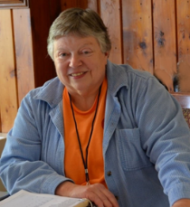

Northern California-Nevada
Davena Jones
Concord, CA
davena@ncncucc.org
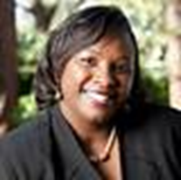

Northern Plains
(ND)
Darla Schafer
Flasher, ND
randar@westriv.com
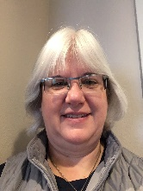

Northern Plains
(ND)
Kayla Henke
Washburn, ND
kay_schaf@yahoo.com
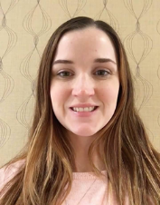
Pacific Northwest
(AK, WA, No. ID)
Mike Denton
Seattle, WA
revdenton@gmail.com
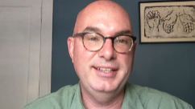

Pennsylvania Central
Bill and Ellen Matten
Boalsburg, PA
ellen.matten@gmail.com
beathomemd@comcast.net
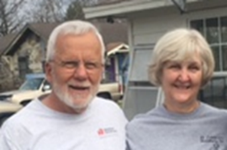

Pennsylvania Northeast and Pennsylvania Southeast
Karl Jones
Douglasville, PA
kjones275@comcast.net
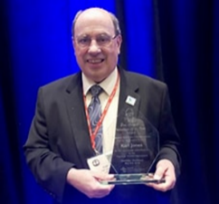

Pennsylvania West
Ryan Lucas
Vandergrift, PA
ryanplucas@gmail.com
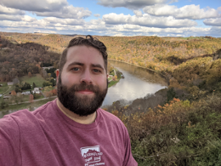

Rocky Mountain
(CO, WY, E. NV, UT)
Beth Whipkey
Eden, UT
majorinsight@gmail.com
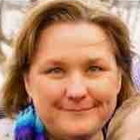

South Central
(LA, So. MS, TX)
Mona S. Lopez
Humble, TX
revmona@gmail.com
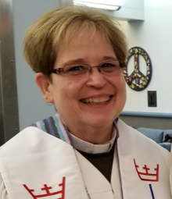

South Central
(LA, So. MS TX)
Phillip Hodson
Sccm@sccucc.org
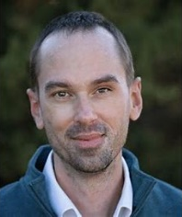

South Dakota
Samantha Houser
Sioux Falls, SD
samantha@ucctcm.org

Southeast
(AL, GA, MS, SC, TN)
Doug Borko
Pleasant Hill, TN
nz2w@nz2w.com
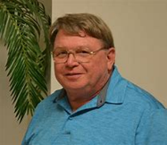

Southeast (TN)
JRae Rice-Cranford
Waverly TN pastorjrae@gmail.com
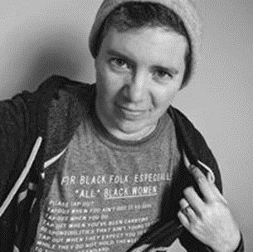

Southern
(NC, S VA)
Eddie Weathers
Eddie.weathers@yahoo.com
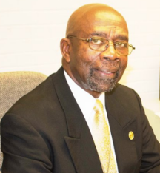

Southern California-Nevada
Rudy Van Graan
Associate Conference Minister
vangraan@scncucc.org
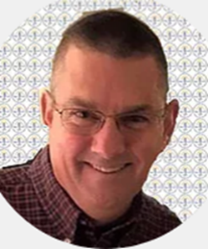

Southern New England
(CT, MA, RI)
Fred Meade
fredmeade@aol.com
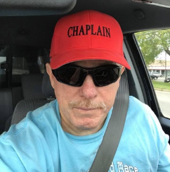

Southwest
(AZ, NM El Paso TX)
Bill Lyons
Phoenix, AZ
blyons@uccswc.org
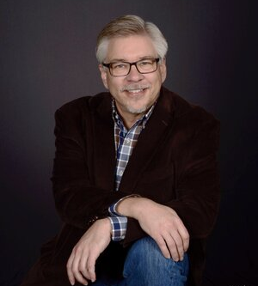

Vermont
Lynn Bujnak
vtcarrs@gmail.com
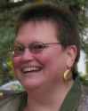

Wisconsin
Chris Schoenwetter
Sun Prairie, WI
chris_schoeny@hotmail.com
NATIONAL STAFF
Karen Georgia Thompson
Associate General Minister for
Wider Church Ministries
thompsonk@ucc.org

Joshua Baird
Team Leader
Global H.O.P.E.
bairdj@ucc.org

Lesli Remaly
Global H.O.P.E.
Minister for Disaster Response and Recovery
Remalyl@ucc.org

Elena Larssen
Global H.O.P.E.
Minister for Volunteer Engagement
Larssene@ucc.org

Irene Willis Hassan
Global H.O.P.E.
Minister for Refugee and Migration
hassani@ucc.org
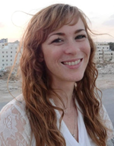

Craig Hoffman
Global H.O.P.E.
Program Assistant
Hoffmanc@ucc.org
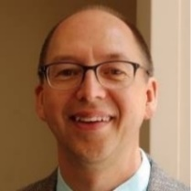

Carol Fouke-Mpoyo
Global H.O.P.E.
Communication Specialist
New York, NY
Fouke-mpoyoc@ucc.org
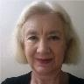

Conference
Disaster Coordinators
Directory
January
2022

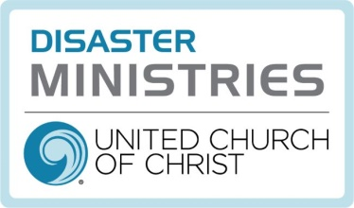

Mission Statement
“Responding to the call of our faith, UCC Disaster Ministries supports holistic community recovery, by engaging supporters, volunteers and partners to focus on preparedness, emergency relief and long-term recovery”
United Church of Christ
Cleveland, Ohio
https://www.ucc.org/what-we-do/wider-church-ministries/global-hope/disaster/

