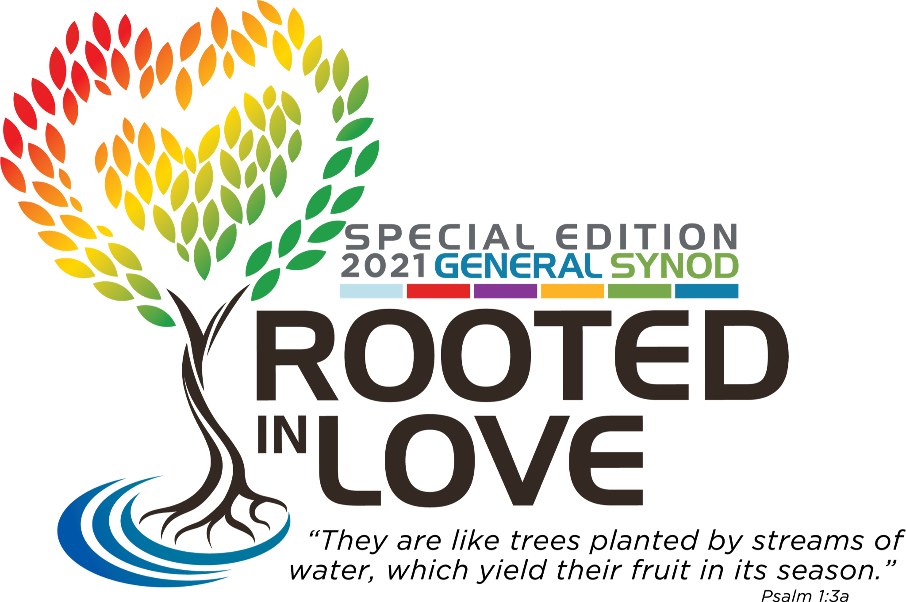

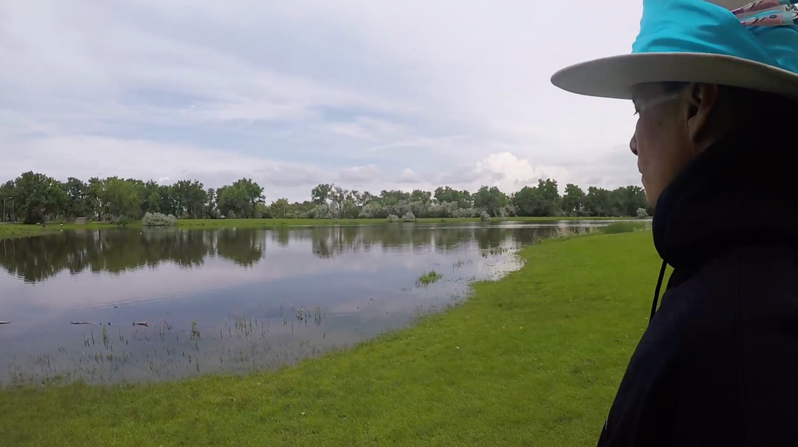

Image Description: A Native man in a black hoodie and a traditional hat wrapped with blue silk looks over a pond surrounded by lush green grass and trees.

GENERAL SYNOD MIDWEEK WORSHIP
JULY 14, 2021

RESILIENCE ⇌ WATER ⇌ SUMMER 2020 UPRISINGS

WELCOME TO WORSHIP!

-Support your body (be comfortable, have space to move)
-Engage your senses (dedicate a space, fill it with meaning and beauty)
-Watch and listen in High Definition if you are able
-Interact or respond through social media using #UCCSynod

This service includes a water ritual. To participate you will need:
-a bowl
-a pitcher with water
-a smaller bowl with flower or rose petals (optional)
-a little container with oil (optional)
-a hand towel

PRELUDE MUSIC:
One Brick by Fran McKendree and Brian McLaren
By the Stream by Christopher Grundy

UCC WELCOME: Rev. Dr. Karen Georgia Thompson
Rev. Dr. John Dorhauer
Rev. Traci Blackmon

NATIVE RESILIENCE PRAYER:
Miracle by Christian Parish Takes the Gun of the Apsáalooke Nation, a.k.a.
Supaman, featuring Maimouna Youssef

PRAYER OF LAMENTATION:
Street Kyrie by Joel and Aimee Pakan

Kyrie Eleison, another way of sayin’ I can’t breathe; we can’t breathe.
Christe Eleison, another way to plead, Momma, momma, come for me.

We must confess today. We have gone astray.
We must confess today. We have gone astray.

"Thoughts and prayers” as healing as blank stares
at white washed ceilings.
We come to the street, to pray with our feet.
Walking prayer as a posture that laments all we’ve lost here
Through raised fists and chanting, say their names,
stop the lynching.

We must confess today. We have gone astray.
We must confess today. We have gone astray.
We cry justice today, Christ, come now we pray

LITANY OF RESILIENCE: Rev. Julian DeShazier
Resilience tastes like dumplings your grandmother brought from the motherland; like mofongo and poi and branch lettuce; like cornbread, and tomato and okra gumbo and no part of the pig left behind; like recipes measured not in ounces but in this much and that much; it tastes like love, bitter and sweet and forever.
Happy are those whose delight is in the wisdom of God. They are like trees planted by streams of water, resilient, resourceful, generative.
Resilience feels like days that last an hour too long, and the deep breath during; like the oak tree and the reed, flowing, rooted and strong; like disappointment and commitment - “how could they?” and “why won’t they?” and “now we must!”; like skinned knees and good sleep; it feels like being torn and being healed.
Happy are those whose delight is in the wisdom of God. They are like trees planted by streams of water, resilient, resourceful, generative.
Resilience sounds like the kick and the snare, the conga and the djembe and the tambourine; like “hell no, we won’t go!” and “Ni una mas!” and This is My Story, This is My Song; it sounds like a whisper, a still small voice, a gentle stream, a howling wind.
Happy are those whose delight is in the wisdom of God. They are like trees planted by streams of water, resilient, resourceful, generative.
Resilience looks like ancestors; like children playing and people riding the bus with masks on; like virtual worships and family calls; like deep, dark colors; like a seat for everyone at the table; it feels like finally finding a place where I can show up, and being safe. As we come together as the body of Christ in this worship, we bring with us the many senses that will help us make sense of resilience, and God, and self, and our many neighbors across this world today.
Happy are those whose delight is in the wisdom of God. They are like trees planted by streams of water, resilient, resourceful, generative.

HYMN: Step By Step, words: Traditional Labor Movement Song
music by Pete Seeger, arr. by Sweet Honey In the Rock

Step by step the longest march,
can be won, can be won
Many stones to form an arch,
singly none, singly none
And by union what we will, can be accomplished still
Drops of water turn a mill,
singly none, singly none

PSALM 1 INTERPRETATION: J.Kwest

SERMON: Rev. Michelle Higgins

SERMON RESPONSE: When the Cameras All Stop
By Rev. Julian DeShazier, a.k.a. J.Kwest

CALL TO THE OFFERING: Rev. Dr. Monica Dawkins-Smith
Today’s offering supports Thursdays In Black, an ongoing campaign to end violence against women. Text UCCTIB to 41444 to donate or give at www.generalsynod.org/worship-offerings/.

OFFERTORY: I’m Surrounded by Mia McClain

WATER RITUAL: Rev. Nancy Rosas and JaQuan Beachem

Blessed be God, whose steadfast love endures forever
Blessed be God, whose steadfast love endures forever

We are like trees planted by streams of water, resilient through all the
seasons of life, bearing fruits, generating life.

Christ be with you.
And also with you.
Let us pray...

God be with you.
And also with you.
Let us give thanks to God.
It is right to give God thanks and praise.
Let us pray...

HYMN: Queen's Prayer (Ke Aloha O Ka Haku)
written by Queen Lili`uokalani
arranged by John McCreary and John Alexander
We Shall Overcome, arr. by Shelton Ridge Love

O kou aloha no Aia I ka la ni
A o kou oi a io He he mo le le ho i

Kou no ho mi hi ana
A pa ahoa ia
O O eku u la ma
Kou n ani ko u ko o

No lai la e ka Ha ku
Ma la lo kou e he u
Ko ma kou ma lu hi a
A mau loa a ku no

We shall overcome (3x) someday
O deep in my heart, I do believe we shall overcome someday

We shall live in peace (3x) someday
O deep in my heart, I do believe we shall overcome someday

We’ll walk hand in hand (3x) someday
O deep in my heart, I do believe we shall overcome

We are not afraid (3x) today
O deep in my heart, I do believe we shall overcome someday

God will see us through (3x) someday
O deep in my heart, I do believe we shall overcome someday
We shall overcome someday

Queen's Prayer English Translation from The New Century Hymnal: Your love is in heaven and your truth so perfect. I live in sorrow imprisoned; you are my light, your glory my support. Behold not with malevolence the sins of humankind, but forgive and cleanse. And so, Lord, beneath your wings be our peace forever more.

BENEDICTION: Rev. Michele Higgins

CELEBRATION SENDING MUSIC:
‘Til Love Comes by Tracy Howe

About the People In This Worship Service:

Rev. Michelle Higgins is a community organizer grounded in Black liberation traditions and is Senior Pastor at St John’s Church (The Beloved Community) UCC in St Louis, MO.

Rev. Julian DeShazier is Senior Pastor of University Church in Chicago, IL and an Emmy Award-winning hip-hop artist known as J.Kwest.

Rev. Nancy Rosas is an immigrant, an educator and community activist, and currently serving as Pastor of Pilgrim St Luke’s UCC of Buffalo, NY.

JaQuan Beachem is an artist, creative leader, member of Spring Glen Church of Hamden, CT and a recent graduate of Yale Divinity School.

Christian Takes the Gun Parish, a.k.a. Supaman is an Apsáalooke hip-hop artist and fancy dancer who lives on the Crow Reservation in Montana and has dedicated his life to empowering and spreading a message of hope, pride and resilience through his original art form.
Rev. Mia McClain is a performer and composer, ordained in the United Church of Christ and serving as Associate Minister of Faith Formation and Community Outreach at Myers Park Baptist Church in Charlotte, North Carolina.

Rev. Dr. Monica Dawkins-Smith was born and raised in Jamaica, loves gardening and is Executive Associate for Wider Church Ministries at the United Church of Christ.

Rev. Dr. Karen Georgia A. Thompson is a Jamaican born poet and Associate General Minister and Co-Executive for Global Ministries, Wider Church Ministries and Operations. She served as the General Synod Administrator for this 33rd General Synod, Rooted in Love.

Rev. Dr. John Dorhauer loves baseball, music and poetry and is General Minister and President of the United Church of Christ.

Rev. Traci Blackmon is an influential speaker and preacher, an Auburn Seminary Senior Fellow and the Associate General Minister, Justice and Local Church Ministries at the United Church of Christ.

Bryan Johnson is Executive Director of Worship and Arts at Trinity United Church of Christ, Chicago, IL and served as the Music Director for this 33rd General Synod, Rooted in Love.

Rev. Tracy Howe is a songwriter and music producer, a liturgical activist and the Minister of Community and Congregational Engagement, Justice and Local Church Ministries at the United Church of Christ. She served as the Worship Director for this 33rd General Synod, Rooted in Love.

This service was written by Rev. Nancy Rosas and JaQuan Beachem.

33rd General Synod Worship Working Group, Writers and Service Architects:
Rev. Tracy Howe (Synod Worship Director)
Rev. Phiwa Langeni and Rev. Susan Blain, Soil; JaQuan Beachem and Rev. Nancy Rosas, Water; Rev. Mia McClain and Rev. Dave Sigmund, Air

Worship Band:
Bryan Johnson (Synod Music Director), Piano, Keyboards
Alfred Golden, Tenor, Alexandra Hill, Violin, Andra Moran, Soprano,
Angela Walton, Soprano, Christopher A. Joyner, Tenor, Jo Deen Davis, Organ,
Dr. Keith Hampton, Baritone, Lamar Jones, Bass, Nicole Serrano, Acoustic and Electric Guitar, Nikkieli, DeMone, Tenor, Plu Harmon, Drums, Queen McClain, Alto,
Sharon Mason, Alto, Teniya Mackey, Alto, Rev. Vickie D. Johnson, Soprano, Warnell Berry Jr., Bass

Queen's Prayer (Ke Aloha O Ka Haku) and We Shall Overcome Choir Members:
Alice Metzloff, Carol Sanders, Daniel Wright, David Chase, Debbie Gline Allen, Don Jones, Elizabeth Graham, Elizabeth Mooney, Elizabeth Nelson, Ellen Killam, Emily Perl, Fred Heidrich, George Bowman, Gloria Bordeaux, Irene Ikeda, J.R. Cannaday, Jean Gilbertson, Jennifer Bertoni, Jill Frey, Jim Fisher, John Pottmeyer, Cinda Pottmeyer,Amber Pottmeyer, Karl Vercouteren, Kevin Groppe, Kimberly Wood, Linda Stoll, Monty Bieber, Rebecca Poos, Nicole Loser, Paul Clay ,Peggy Ludlow, Penny Phillips, Robert Veiga, Sandy Soho, Sherri ingvarsson, Susan Stewart, Tara Tetreault,Torie Front

Videographers:
Rev. Jason Chesnut, ANKOSfilms (Synod Video Editor)
Anne Dunlap, Bob Lormor, Elijah Moss, Gabrielle Muller, Miles Dela Cruz, Stephen Powell, Elmwood Media, Tony Carpenter, Wes Cobb, West Art Video

Sound Editors:
Aaron Strumpel, Thirsty Dirt Studio (Synod Sound Editor)
David Wilton, Coalesce Studio, Mastering Engineer

ASL Interpreters:
Brenda Terry, Kyla Wilkenfeld, Mara Bassani-SantaMaria

Artists and Works in Order of Appearance:

Water ©2021 Aaron Strumpel. All publishing rights reserved. Permission granted to reproduce and stream for use in services of worship or church education.
One Brick ©2021 Fran McKendree and Brian McLaren. All publishing rights reserved. Permission granted to reproduce and stream for use in services of worship or church education.

By the Stream ©2021 Christopher Grundy. All publishing rights reserved. Permission granted to reproduce and stream for use in services of worship or church education.

Miracle ©2021 Supaman. Written and Performed by supaman, featuring Maimouna Youssef. Directed by Jihan Hafiz. Gratitude and acknowledgement to the people of Wishtoyo Chumash Village, L.A. Dancers and the Graff Lab, Montana Dancers and Singers, People of Gaza, People of Tijuana, Ocetisakowin, Kathleen Newton, Jesse Freeston, Jonathan Klett, Roddy Hafiz and Lea Friebel, MST, Reaja ou Sera Morta, Ney Matagrosso. All publishing rights reserved.
Permission granted to reproduce and stream for use in services of worship or church education.

Street Kyrie ©2021 Joel Pakan & Aimee Pakan. All publishing rights reserved. Permission granted to reproduce and stream for use in services of worship or church education.
Step by Step, 19th Century labor union organizing song. Lyrics in Public Domain. Tune © 1985 Pete Seeger. All rights reserved. Arrangement ©1985 Ysaye Barnwell. All rights reserved. Performed under PerformMusic license 7631, and streamed under WorshipCast license 7631.
“Resilience Is Like,” “Psalm 1” and “When the Cameras All Stop” ©2021 Julian DeShazier, a.k.a J.Kwest. Written and performed by Julian DeShazier. All publishing rights reserved. Permission granted to reproduce and stream for use in services of worship or church education.

I’m Surrounded ©2021 Mia McClain. Written and performed by Mia McClain, accompanied by Dawn Anthony and Adrienne Williams. Filmed by Wes Cobb, West Art Video. Edited by Jason Chesnut, ANKOS films. All publishing rights reserved. Permission granted to reproduce and stream for use in services of worship or church education.

Ke Aloha O Ka Haku “The Queen’s Prayer,” words and music by Queen Liliuokalani. Text and Tune in Public Domain. Arrangement © John Alexander and John McCreary. All Rights reserved. Permission given to reproduce and stream for use in services of worship or church education.

We Shall Overcome, Words in Public Domain; Tune, Traditional; Arrangement ©Shelton Ridge Love. All rights reserved. Streamed under CCLI # 11417377.

‘Til Love Comes, ©2019 Tracy Howe. Song written and performed by Tracy Howe. Video featuring Alex Wispelwey. Storyboard by Tracy Howe. Filmed and edited by Jason Chesnut, ANKOS films. All publishing rights reserved. Permission granted to reproduce and stream for use in services of worship or church education.

Rooted In Love Worship Banners and Stoles by Sew[i]ng Creations, Jennifer and Christine Ng. https://www.sewingcreations.net/about

