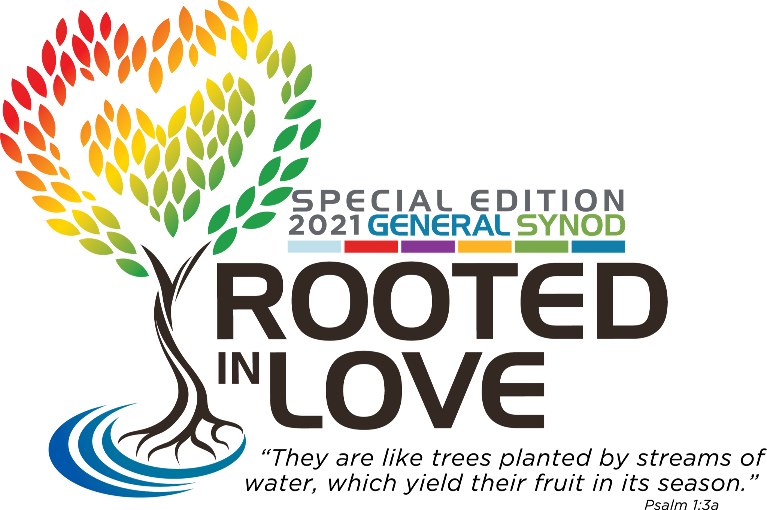

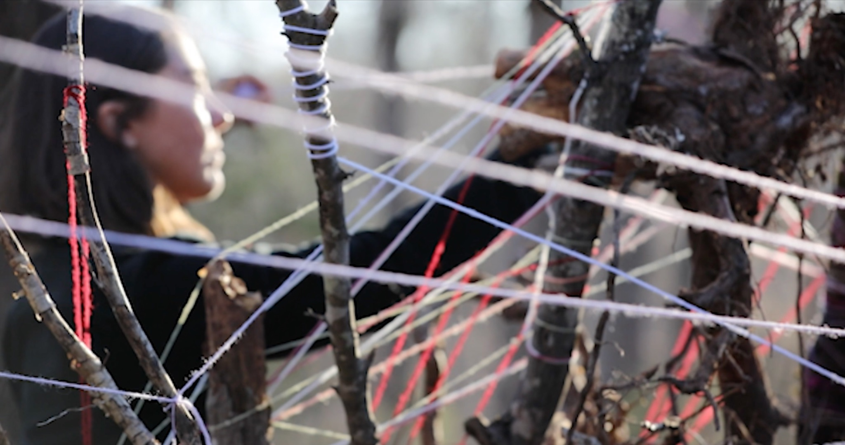
Image Description: A woman weaves colorful yarn through a very large system of tree roots, unearthed from old and felled trees.

GENERAL SYNOD OPENING WORSHIP
JULY 11, 2021

ROOTEDNESS ⇌ SOIL ⇌ RURAL & ENVIRONMENTAL ISSUES

WELCOME TO WORSHIP!

-Support your body (be comfortable, have space to move)
-Engage your senses (dedicate a space, fill it with meaning and beauty)
-Watch and listen in High Definition if you are able
-Interact or respond through social media using #UCCSynod

PRELUDE MUSIC:
Rooted In Love by Natalia Serna (La Muna)
The Soil by David Benjamin Blower

UCC WELCOME: Rev. Dr. Karen Georgia Thompson
Rev. Dr. John Dorhauer
Rev. Traci Blackmon

NATIVE PRAYER FOR LAND AND HUMANITY:
Warriors Prayer by Christian Parish Takes the Gun of the Apsáalooke
Nation, a.k.a. Supaman

HYMN: Break Up Your Fallow Ground by Tom Wuest, arr. By Bryan Johnson

Break up your fallow ground, break up your fallow ground
And sow not among thorns my child, break up your fallow ground

When the work of day is done, when the work of the day is done
Lay down your tool and rest my child, when the work of day is done

Through the shadows of the night, through the shadows of the night
God will keep watch over us, through the shadows of the night
God will keep watch over us through the shadows of the night
Lay down your toll and rest my child,when the work of day is done

GATHERING & GREETING: Rev. Phiwa Langeni
We invite you as you desire and are able, to participate in real-time by using the General Synod hashtag #UCCSynod to share prayers, respond to what moves you, and contribute to shaping this sacred space we’re creating together.

INVOCATION: Holy Fool Arts

Holy be the ground that bears good fruit
Hands bless the soil as we summon the root (chanted)

Dance your clay back to the old way
Holy be the ground that bears good fruit
Dance your clay back to the old way
Hands bless the soil as we summon the root (4x)

Dance your clay back to the old way
Through the groaning earth becoming replanted
Close to the ground, remember the sound
That sings your soul back to its enchantment

Leaf and branch waiting for the chance
To send sunlight back down to the root bed
Mulch and rot, the wet and the hot,
Composting the poisons inside your head
Composting the poisons inside your head

PRAYER OF CONFESSION: Holy Fool Arts

Because we fail to perceive Earth as a living, interrelated system, and persist in thinking society is primarily made up of separate individuals, separate nations, with separate destinies, we remember that … The struggle of the people and the struggle of the Earth are one.

Because some are granted privilege and power, while whole people groups are treated as disposable, and because we convert earth’s gifts into single use plastic, exporting northern waste to southern countries and impoverished communities herein, we declare that... The struggle of the people and the struggle of the Earth are one.

Because we and our neighbors have degraded fertile Earth into landfills, wetlands into shopping malls, and running rivers into silted floodplains, we call out… The struggle of the people and the struggle of the Earth are one.

Because we deem the earth and certain workers as “essential”, yet allow for their rights to be negotiable, and their lives expendable, we cry out… The struggle of the people and the struggle of the Earth are one.

Because many of the original inhabitants of this land offered life saving hospitality to early settlers, receiving in return condemnation encoded in policies of displacement, genocide and ongoing dispossession... The struggle of the people and the struggle of the Earth are one.

Because we often fail to honor the beauty of social and natural diversity as monocrop industrial agriculture deprives us of valuable biological diversity, and forced assimilation strips communities of connection to their many ancestral lifeways and stories, we shout… The struggle of the people and the struggle of the Earth are one.

Because the Movement for Black Lives is met with tear gas and militarized police, the Water Protectors are met with attack dogs and water hoses, and farmers globally are pummelled by state violence, we know that... The struggle of the people and the struggle of the Earth are one.

Because state warfare turns children into collateral damage and extractive industries make sacred sites and drinking water into sacrifice zones for industry profits, we cry… The struggle of the people and the struggle of the Earth are one.

Because our economic system promotes addiction, is dependent upon oppression, and endangers human existence by exploiting Earth’s cycles, we call out... The struggle of the people and the struggle of the Earth are one.

Because pride gets placed in racist symbols and military might, and the American dream of “the good life” ignores environmental impact and promotes patriarchy, we call out… The struggle of the people and the struggle of the Earth are one.

Because we have grown alienated from the natural world, unable to hear her voice, to savor her gifts and to grieve the damage, and because we grow numb to the suffering of our brothers and sisters, too overwhelmed to hear their stories, we cry… The struggle of the people and the struggle of the Earth are one.

AN ASSURANCE OF GRACE: Holy Fool Arts

HYMN: Rooted and Grounded in Love by Amy Sens

In these changing times, in these shifting days,
challenged by new circumstance
God we turn to you, ground of all our ways:
Bear us up and hold us fast

Refrain: Through the storm may howl and the wind may roar
Your love enfolds us evermore.
Like a tree that’s planted by the water
We’re grounded and rooted in your love.

Like the mystery of living things,
new life springs at our feet.
From a stump of loss comes another shoot
growing up into a tree.[Refrain]

When your realm draws near, in the coming hours,
when your love has healed the world
Then our voices rise with a joyful power,
singing songs of hope revealed.[Refrain]
SHARING GOD’S PEACE: Rev. Phiwa Langeni
You are invited to share God’s peace with a neighbor, a pet, a huggable plant, or deep peace within yourself. As you desire and are able, consider sending a text message to someone, using the General Synod hashtag #UCCSynod, or writing a quick note you can mail later.

SHARING GOD’S PEACE: Rev. Phiwa Langeni

SCRIPTURE READING: Psalm 1 read in Zulu, Rev. Phiwa Langeni

SERMON: Faith, Justice and Love Matter, by Rev. Dr. Benjamin Chavis

SERMON RESPONSE: Lord, Don’t Move My Mountain
By Holy Fool Arts

CALL TO THE OFFERING: Rev. Dr. Velda Love
Today’s offering supports the racial justice ministry of the United Church of Christ. Text UCCRJ to 41444 to donate or give at www.generalsynod.org/worship-offerings/.

OFFERTORY: May Your Roots Go Down Deep by Jean Lucas

BENEDICTION: Rev. Dr. Benjamin Chavis

HYMN: Great Is Your Faithfulness
music by William M. Runyan, words by Thomas O. Chisholm
Great is your faithfulness, O God, Creator,
With you no shadow of turning we see.
You do not change, your compassions they fail not;
All of your goodness forever will be.
Refrain:
Great is your faithfulness!
Great is your faithfulness!
Morning by morning new mercies I see;
All I have needed your hand has provided,
Great is your faithfulness, God, unto me!
Summer and winter, and springtime and harvest,
Sun, moon, and stars in their courses above,
Join with all nature in manifold witness
To your great faithfulness, mercy, and love. [Refrain]
Pardon for sin and a peace so enduring,
Your own dear presence to cheer and to guide.
Strength for today and bright hope for tomorrow,
Blessings all mine with ten thousand beside.[Refrain]

CELEBRATION SENDING MUSIC:
Let’s Do the Work by Kevon Carter, arr. By Bryan Johnson
Benediction by Abby Madden

About the People In This Worship Service:

Rev. Dr. Benjamin Chavis is Civil Rights leader, scholar, poet and educator, a long- time leader for environmental and racial justice in the United Church of Christ and beyond.

Rev. Phiwa Langeni is a church planter, fashion designer, and Ambassador for Innovation and Engagement, Center for Analytics, Research and Development, and Data (CARDD) at the United Church of Christ.

Tevyn East and Jay Beck are founders of Holy Fool Arts, a theatrical production company that uses the transformative power of dance, drumming, theater, story-telling, song, circus arts and spoken word to inspire communities across North America to live in right relationship with the Earth.

Natalia Serna, known as La Muna, is a Colombia-American musician and sociologist whose music animates the work of social justice across Mexico, Guatemala, and the United States.

Christian Takes the Gun Parish, a.k.a. Supaman is an Apsáalooke hip-hop artist and fancy dancer who lives on the Crow Reservation in Montana and has dedicated his life to empowering and spreading a message of hope, pride and resilience through his original art form.

Rev. Amy Sens is a church-start pastor and musician who creates biblically rooted, progressive hymns in the bluegrass-Americana tradition.

Rev. Dr. Velda Love is an educator specializing in African based pedagogy and the Minister for Racial Justice in Justice and Local Church Ministries at the United Church of Christ.

Rev. Dr. Karen Georgia A. Thompson is a Jamaican born poet and Associate General Minister and Co-Executive for Global Ministries, Wider Church Ministries and Operations. She served as the General Synod Administrator for this 33rd General Synod, Rooted in Love.

Rev. Dr. John Dorhauer loves baseball, music and poetry and is General Minister and President of the United Church of Christ.

Rev. Traci Blackmon is an influential speaker and preacher, an Auburn Seminary Senior Fellow and the Associate General Minister, Justice and Local Church Ministries at the United Church of Christ.

Bryan Johnson is Executive Director of Worship and Arts at Trinity United Church of Christ, Chicago, IL and served as the Music Director for this 33rd General Synod, Rooted in Love.

Rev. Tracy Howe is a songwriter and music producer, a liturgical activist and the Minister of Community and Congregational Engagement, Justice and Local Church Ministries at the United Church of Christ. She served as the Worship Director for this 33rd General Synod, Rooted in Love.

This service was written by Rev. Phiwa Langeni and Rev. Susan Blain.

33rd General Synod Worship Working Group, Writers and Service Architects:
Rev. Tracy Howe (Synod Worship Director)
Rev. Phiwa Langeni and Rev. Susan Blain, Soil; JaQuan Beachem and Rev. Nancy Rosas, Water; Rev. Mia McClain and Rev. Dave Sigmund, Air

Worship Band:
Bryan Johnson (Synod Music Director), Piano, Keyboards
Aaron Strumpel, Trumpet, Alfred Golden, Tenor, Alexandra Hill, Violin, Andra Moran, Soprano, Angela Walton, Soprano, Christopher A. Joyner, Tenor, Jo Deen Davis, Organ, Dr. Keith Hampton, Baritone, Lamar Jones, Bass, Nicole Serrano, Acoustic and Electric Guitar, Nikkieli, DeMone, Tenor, Plu Harmon, Drums, Queen McClain, Alto, Sharon Mason, Alto, Teniya Mackey, Alto, Rev. Vickie D. Johnson, Soprano, Warnell Berry Jr., Bass

Break Up Your Fallow Ground Choir Members:
Allan Henden, Amy Sens, Angela Garner, Arthur Wille, Barb Palmer, Barbara Joellenbeck, Cathy Wille, Chad Savage, Cheryl Chase, Chris Copley, Claire Klein, Dorothy Cresswell, Dusty Miller, Gregory Swanson, Heidi Willis, Ivy Tillman,J acob Brenton, Jane Killough, Janice Bauer, Jeffrey Clouser, Joan Puls, John Zollweg, Juanita Edington, Kevin Murphy, Laurel Thurman, Laurie Otten, Marsha Stevens, Mary Beers, Michael Bryant, Pamela Stallings, Patti Fleer, Phil Haslanger, Rebecca Maccini, Ruth Shaver, Samantha Houser, Samuel Maruthoti, Sue Jones, Wendy Lukaszewski

Great Is Your Faithfulness Choir Members:
Angela Wheeler, Anne Sprague, Beatrice Brooks, Beverly Byrd, Carole Mastin, Charlene Parks, Charlotte A. Blackman, Charnett Brown, Cheryl Toles, Claudia Walker, Constance Y Williams, Curtis Jackson, David Scheufler, Deborah Jones, Hattie Tucker, Ivy H. Jackson, Janice Scheufler, Jared Deane, Jennifer Bertoni, John Sledge, Keith Hampton, Linda McDaniel, Lisa Marie Moreno, Lurlene Burchett, Lynn Warren, Marica Bullock, Mary Wilkes, Connie Detjen, Dale Bertlett, David Stow, Dennis Keefe, Ed Smith, Elizabeth Clarke, Emily Bieber-Harris, Jacqueline Smith, JoAnn Hubbard, Katelyn King, Marv Dunn, Mary Ann Larzalere, Marya Peters, Melanie Baker, Monty Bieber, Nancy Bieber, Pam Sisson, Peggy Dunn, Patricia A Owens, Peter Richards, Peter Thomas, Prudence Richards, Rhonda Pope, Sandra Saunders, Sandra Bibb, Shirley Fleming, Shirley Millet, Becky Dion, Ellen Buxton, Kathleen McDonald, Kristi Falkner, Laura Ouimette, Nancy Bent, Pam Harrington, Sue Bechtold, Susan O’Neil, Wendy Rothschild, Art Baldwin, Bill Boring, Carter Bentley, David Fish, Dix Fulton, Jim Bechtold, Debi Wallingford, Pam Boring, Sally Lawrence, Virginia Daugherty, Randy Wallingford, Sam Bent, Stephen O’Bent, Thomas Bandy, Tracy Cureton, Velena Brooks, Wayne Baskerville, Tia Baskerville, Wendy Wilson, Yukio Phillips

Videographers:
Rev. Jason Chesnut, ANKOSfilms (Synod Video Editor)
Brian Keith; Bob Lormor; Jarrett Heatherly, Heat and Sand Productions; Katie Simbala, Kap2ure Creative Co.; Miles Dela Cruz; Marthame Sanders, Heat and Sand Productions; Tony Carpenter

Sound Editors:
Aaron Strumpel, Thirsty Dirt Studio (Synod Sound Editor)
David Wilton, Coalesce Studio, Mastering Engineer

ASL Interpreters:
Brenda Terry, Kyla Wilkenfeld, Mara Bassani-SantaMaria

Artists and Works in Order of Appearance:

Soil ©2021 Aaron Strumpel. All publishing rights reserved. Permission granted to reproduce and stream for use in services of worship or church education.

Rooted in Love ©2021 La Muna (Natalia Serna). Written and performed by Natalia Serna, accompanied by Rito Antonio Palma. All publishing rights reserved. Permission granted to reproduce and stream for use in services of worship or church education.

The Soil ©2021 David Benjamin Blower. Written and performed by David Benjamin Blower. All publishing rights reserved. Permission granted to reproduce and stream for use in services of worship or church education.

Warriors Prayer ©2017 Supaman. Written by Supaman and Nakoa Heavy Runner and performed by Supaman. All publishing rights reserved. Permission granted to reproduce and stream for use in services of worship or church education.

Break Up Your Fallow Ground ©2021 Tom Wuest. All publishing rights reserved. Permission granted to reproduce and stream for use in services of worship or church education.

Invocation: Root Summons ©2021 Holy Fool Arts, poetry and lyrics by Jay Beck, musical performance by Jay Beck, Tevyn East and Samuel Lockridge. Confession: The Struggle of the People and the Struggle of the Earth are One ©2021 Holy Fool Arts, written by Tevyn East and Sarah Nahar, music by Samuel Lockridge. Assurance of Grace: Jubilee Jamboree Funk Note Song ©2021 Holy Fool Arts, written by Dr. James W. Perkinson, music by Samuel Lockridge and Jay Beck. Lord, Don’t Move My Mountain ©2021 Holy Fool Arts, written by Jay Beck, performed by Jay Beck, Tevyn East, Samuel Lockridge, additional trumpet recording by Aaron Strumpel.
All publishing rights reserved. Permission granted to reproduce and stream for use in services of worship or church education.
Storyboard and Performance: Tevyn East and Jay Beck
Set Director: Zap McConnell
Assistant Director: Sam Lockridge
Director of Photography: Jarrett Heatherly, Heat and Sand Productions
Sound Director: Marthame Sanders, Heat and Sand Productions
Video Editor: Jason Chesnut, ANKOSfilms
Storyboard: Tevyn East and Jay Beck
Sound Editor: Aaron Strumpel
Craft Services: Daniel East
Equipment Rentals: Heat and Sand Productions

When the Walls Come Crashing Down ©2012 Samuel Lockridge. Written and performed by Samuel Lockridge. All publishing rights reserved. Permission granted to reproduce and stream for use in services of worship or church education.

Rooted and Grounded in Love ©2021 Amy Sens. Written and performed by Amy Sens, accompanied by Alex Lacquement and Luke Chohany. All publishing rights reserved. Permission granted to reproduce and stream for use in services of worship or church education.

Great is Your Faithfulness, text: Thomas O. Chisholm; Tune William Runyan. © 1951 Hope Publishing Company. All rights reserved. Reproduced under ONE LICENSE #A-719582.

Let’s Do the Work ©2021 Kevon Carter. All publishing rights reserved. Permission granted to reproduce and stream for use in services of worship or church education.

Benediction ©2021 Abby Madden. All publishing rights reserved. Permission granted to reproduce and stream for use in services of worship or church education.

Rooted In Love Worship Banners and Stoles by Sew[i]ng Creations, Jennifer and Christine Ng. https://www.sewingcreations.net/about

