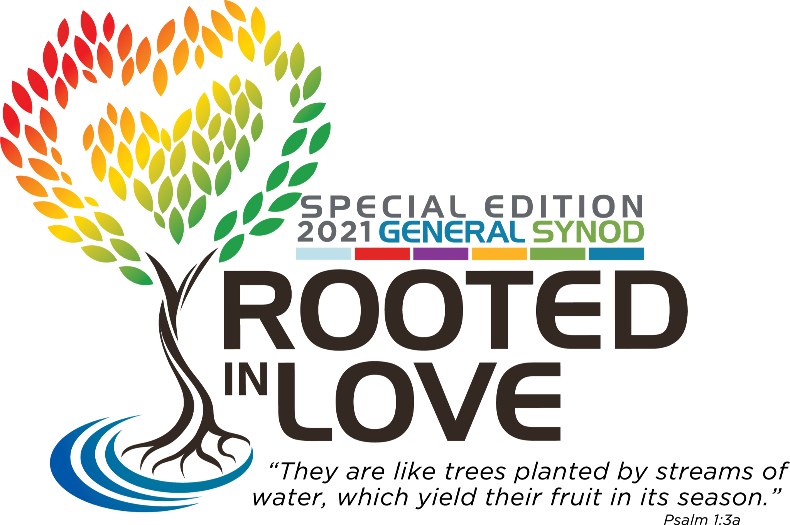

GENERAL SYNOD CLOSING WORSHIP
JULY 18, 2021

RESURRECTION ⇌ AIR ⇌ COVID19 PANDEMIC

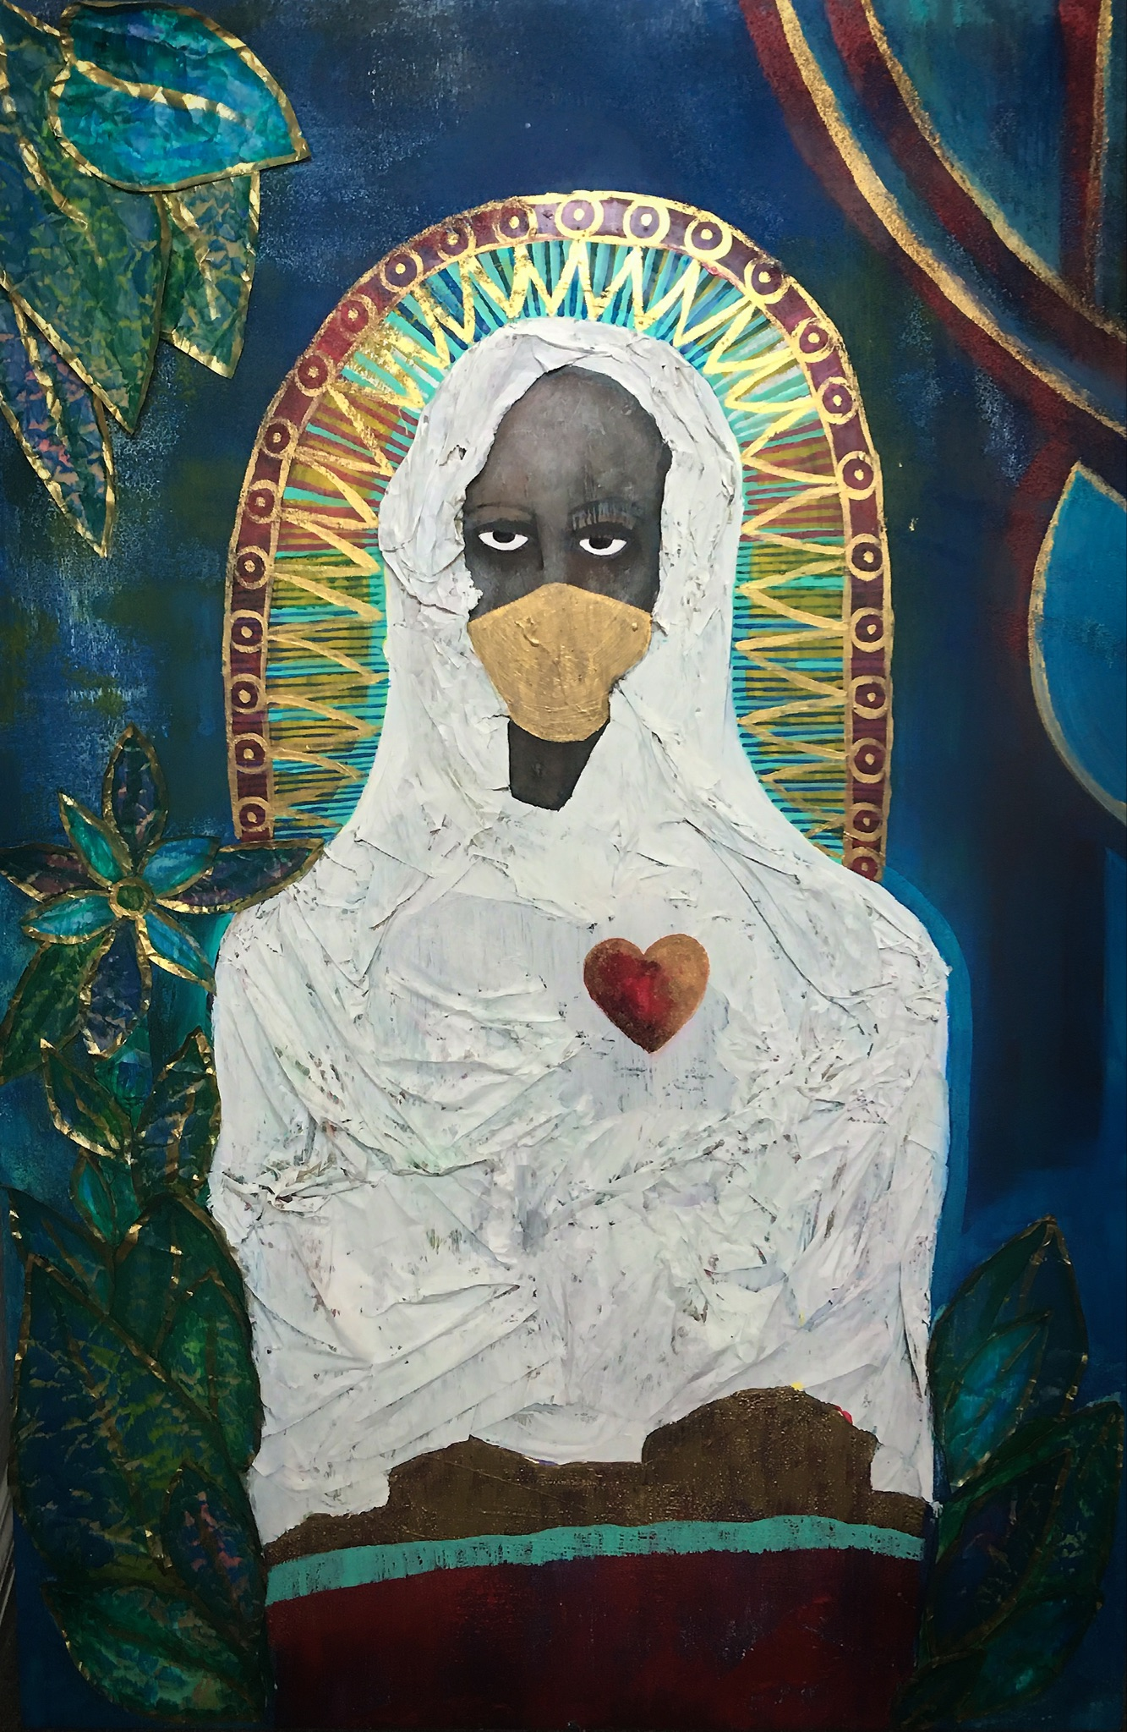
Our Lady of Covid by Shannon Kearse-High
Mixed Media - Paper and acrylic on canvas.

Image Description:
Modeled in the style of Christian Saints and Mary the Mother of Christ, this "Lady of Covid" is clothed in white "fabric" made out of tissue paper. It covers a dark red robe that has a light blue stripe painted across the bottom. She is standing in front of a vibrant blue background, surrounded by large green paper leaves that have been outlined with gold paint. A gold, red, and green halo outlines her head and red and gold lines are also painted in the top right corner of the canvas. Her dark grey face is partially covered by a face mask that has been painted gold. Her dark eyes stare straight ahead. There is a heart on the left side of her chest that has been painted red and gold.

WELCOME TO WORSHIP!

-Support your body (be comfortable, have space to move)
-Engage your senses (dedicate a space, fill it with meaning and beauty)
-Watch and listen in High Definition if you are able
-Interact or respond through social media using #UCCSynod

This service includes the celebration of Holy Communion. We invite you to set a table in your worship space with a plate and cup, and use bread and juice, or chips and water, whatever you have on hand!

PRELUDE MUSIC:
Rooted In Love by Ken Medema
Bring Us Peace by Michelle Hecht
Breathe On Me Breath of God
words by Edwin Hatch, tune by Robert Jackson, arr. by Bryan Johnson

UCC WELCOME: Rev. Dr. Karen Georgia Thompson
Rev. Dr. John Dorhauer
Rev. Traci Blackmon

NATIVE PRAYERS THROUGH A PANDEMIC:
Pt. I The Lodge by William Snell of the Apsáalooke Nation
Pt. II Lighting of the TeePees by the Rocky Mountain Tribal Council

HYMN: Sing a New World Into Being
words by Mary Louise Bringle, tune by Ludwig van Beethoven

Sing a new world into being. Sound a bold and hopeful theme.
Find a tune for silent yearnings. Lend your voice and dare to dream:
Dream a church where all who worship find their lives and loves belong.
Sing a new world into being. Sing as Christ inspires your song!

Sing a new world into being where each gender, class and race
Brings its rainbow gifts and colors to God’s limitless embrace:
Where the lines that once divided form instead the ties that bind.
Sing a new world into being: risk transforming heart and mind.

Sing a new world into being where the homeless find a home,
Where no children ever hunger but are filled in God’s Shalom:
Where all people work for justice, where all hate and vengeance cease.
Sing a new world into being: raise the harmonies of peace.

Sing a new world into being, join the ancient prophets’ cry
For a time of health and plenty, when all tears have been wiped dry:
When compassion flows like waters, pouring balm for all who grieve,
Sing a new world into being: live the promise you believe!

BREATH RITUAL: Rev. Vahisha Hasan
Throughout the service we will use this regulating breath.
You will have 16 beats each time.
4 beats to get ready. 4 beats to breathe in. 4 beats to hold. 4 beats to exhale.

CALL TO WORSHIP: Rev. Mia McClain
How can I call out?
Our very breath has betrayed us
Endangering those we love
Necessitating distance
Masks over lips
Is there a call that would rise without words?
You are as near as our breath
No you are nearer!
You hold us closer than our own trepidation
When we fear to breathe the air
You meet us here, where we are
You meet us here
How can we gather?
Our fellowship has let illness spread
For survival we moved apart
Out of love we have isolated
Distance between friends
Is there a gathering without going?
*breathe: 4 beats to get ready, 4 to inhale, 4 to hold, 4 to exhale
There is when we are already gathered by you God
And we declare we are gathered in you!
Together, in this distance you hold us closer
than perhaps we have ever been
You meet us here, where we are
You meet us here
We are already gathered in you God
You meet the weary chaplains who have held hands
through countless latex gloves
Our mourning and still resilient Marshallese communities
counting and mourning their loved ones who have died
Our siblings with disabilities wondering if crisis medical care rationing
will become a death sentence for their community.
You meet us here
We are already gathered in you God
You meet those who rise up in the streets still
With masks and extra care because justice cannot wait
You meet our Native elders who paint the names of children
on tear-stained rocks
and erect teepees as signs of hope for the world
You meet the Asian and Pacific Islander communities
as hate crimes against them surge
You meet us here
We are already gathered in you God
You meet our church elders isolated in homes by vulnerability this year
You meet our children caught between online learning
and exhausted parents and caretakers
doing their best to keep them safe and learning
You meet those who are working everyday and need a break
and those who have lost everything because this economic system paused
with no safety net
You meet us here
We are already gathered in you God
You will be worshiped most Holy God, who so loves us you embody your love
in intimate presence that is known, fully, and beautifully
And in everything God, the United Church of Christ is here,
because everyone of its members is gathered and hemmed in you
And as siblings, people have cared for one another, cried with one another,
laughed with one another and continued to declare the Good News
of your Love and Justice in the world
so you will be praised today Creator God!
You meet us here
We are already gathered in you God
Let all who have any measure of breath come and worship God!
Let the rocks and creation cry out in Praise
The Living God is the embodiment of justice and love, beauty and peace
And God has not forsaken us!
You meet us here
We are already gathered in you God!
*breathe: 4 beats to get ready, 4 to inhale, 4 to hold, 4 to exhalee

CONTEMPORARY TESTIMONY: barely breathing
by Karen Georgia Thompson and Keon Heywood
*breathe: 4 beats to get ready, 4 to inhale, 4 to hold, 4 to exhale

SERMON: Rev. Dr. Karen Georgia Thompson

SERMON RESPONSE: Lady of Covid
By Shannon Kearse-High

HOLY COMMUNION:

God Will Meet You At Your Table by Mia McClain

Wherever you are on this journey
And whoever you may be
Whether you’re near or far
In your house or in your car
There’s a table for you and for me
Whatever your soil gives life to
However your rivers may run
There’s a sacred story
And it’s full of God’s glory
At a table where we can be one

God is still moving
And guiding
And speaking
And cooking up feast even when we’re apart

Chorus:
God will meet your at your table
Wherever that may be
God will show up at the crossroads of faith and ingenuity
May this seed grow the body
The river pour the cup
Whatever you bring is more than enough
And God will meet you there

Whatever the road you travel
Whenever the journey takes place
Might a stranger appear asking questions
Would you share in a moment of grace

God’s still appearing as stranger,
Unusual neighbors, and those who are last, who are least

Would you invite them to pull up a chair at your table
And share in the holy feast

Chorus:
God will meet your at your table
Wherever that may be
God will show up at the crossroads of faith and ingenuity
May this seed grow the body
The river pour the cup
Whatever you bring is more than enough
And God will meet you there

God will meet you there (2x)
Love will meet you there
Grace/Peace/Hope

Communion Prayer

God be with you
And also with you
We lift up our hearts and give thanks to God who meets us where we are.

Let us pray:
Holy and loving God, we offer thanks for this day—
for the beauty of the earth, for your love and care for every creature, for this table that is before us. We offer gratitude for the virtual community that surrounds this table, and for the many tables and faces we cannot see that make up this ceremonial banquet montage. We rejoice that you call the entire human family to this marvelous mosaic.

In between the mundane and the miraculous—the sipping of our morning coffee, the buttering of bread—we encounter your divine presence ever so delicately. You meet us there—here—in our gardens and in our chapels, in between our fervent faith and our unbelief. Even when we foolishly ignore the prophets telling of your wondrous and miraculous love, you do not abandon us. Instead, you find new ways of meeting us, over and over again, until your presence is made known. For that, we give you praise. We offer prayers for those without tables to gather around, without food to eat, without beverage to quench their thirst. Communion and community are for them too. Meet them where they are, Righteous One, and we’ll remind each other to do the same. Meet us as we pray the words that Jesus taught us, saying:

JESUS PRAYER (Disciple’s Prayer by M. Barclay/enfleshed)

Our Creator, Parent, Mother of us all,
who dwells within and beyond,
Sacred is your name.
May your holy vision for collective flourishing
come to fruition among us.
May your dreams of justice, love, compassion,
and connection be enfleshed on earth.
Provide us today with what we need to be nourished in body, soul, and heart.
Forgive us for the harm we cause as we seek to forgive those who have harmed us.
Lead us away from everything that destroys and liberate us from the hands of evil.
For you are the ultimate source of hope.
You are the ultimate source of healing.
Your power-with exceeds all power-over.
Your presence incites eternal wonder.
All praise to you, our comfort and strength.
Amen.

Words of Institution

Memorial Acclamation
Christ has died, Christ is risen, Christ will come again (2x)

Breaking of Bread/Pouring of Cup

Call to Supper

Agnus Dei
Lamb of God have mercy on us
Heal the world and grant us peace (2x)

Sharing of the Elements

God Will Meet You At Your Table (cont.)

As we gather at our tables
As we listen to your word
Help us know your wondrous presence
Let our hearts and minds be stirred

Turn our worship into witness
In the sacrament of life
Send us forth to love and serve you
bringing peace where there is strife

Chorus+
God will meet your at your table
Wherever that may be
God will show up at the crossroads of faith and ingenuity
God will meet your at your table (4x)
May this seed grow the body
The river pour the cup
Whatever you have is more than enough
And God will meet you there, right where you are
God will me you there
And God will meet you there, come as you are
God will meet you there
*breathe: 4 beats to get ready, 4 to inhale, 4 to hold, 4 to exhale

CALL TO THE OFFERING: Cheryl Williams
Today’s offering supports the Annual Fund of the United Church of Christ. Text UCCGS to 41444 to donate or give at www.generalsynod.org/worship-offerings/.

OFFERTORY: In God’s Hands by Tracy Howe
Featuring the General Synod Children’s Choir

TESTIMONY OF RESURRECTION: Breath of Heaven
choreographed and performed by Adrienne Hurd accompanied by Dione McClain-Freeney

BENEDICTION: Rev. Dr. Karen Georgia Thompson
*breathe: 4 beats to get ready, 4 to inhale, 4 to hold, 4 to exhale
HYMN: Rooted and Grounded in Love
by Amanda Udis-Kessler, arr. by Bryan Johnson
In a time of disease, we are called to be healers embodying Love’s holy care.
We follow the healer who tended the suffering, restoring the wounded,
our work and our prayer.
We are joyful and strong as our faith is revealed
in the richest abundance of fruit that we yield.
Chorus
We are rooted and grounded in love.
Like a tree by the river, we’re planted so deep.
We are rooted and grounded in love
with each gift that we bring and each promise we keep.
As we birth a new world where we all have enough,
we are rooted and grounded in love.

In a time of distrust, we are called to be teachers
embodying Love’s holy grace.
We follow the teacher who welcomed the stranger,
enlarging Love’s realm with each sacred embrace.
We are joyful and strong as our faith is revealed
in the richest abundance of fruit that we yield.

Chorus
We are rooted and grounded in love.
Like a tree by the river, we’re planted so deep.
We are rooted and grounded in love
with each gift that we bring and each promise we keep.
As we birth a new world where we all have enough,
we are rooted and grounded in love.

In a time of despair, we are called to be prophets,
proclaiming all people as one.
We follow the prophet who cried out for justice,
our lives offered up so Love’s will can be done.
We are joyful and strong as our faith is revealed
in the richest abundance of fruit that we yield.

Chorus
We are rooted and grounded in love.
Like a tree by the river, we’re planted so deep.
We are rooted and grounded in love
with each gift that we bring and each promise we keep.
As we birth a new world where we all have enough,
we are rooted and grounded in love.

CELEBRATION SENDING MUSIC:
Light of God by Patrick Henderson, arr. By Bryan Johnson
I’m Surrounded by Mia McClain
Let’s Do the Work by Kevon Carter, arr. By Bryan Johnson
Rooted In Love by Natalia Serna (La Muna)

About the People In This Worship Service:

Rev. Dr. Karen Georgia A. Thompson is a Jamaican born poet and Associate General Minister and Co-Executive for Global Ministries, Wider Church Ministries and Operations. She served as the General Synod Administrator for this 33rd General Synod, Rooted in Love.

Rev. Mia McClain is a performer and composer, ordained in the United Church of Christ and serving as Associate Minister of Faith Formation and Community Outreach at Myers Park Baptist Church in Charlotte, North Carolina.

Rev. Vahisha Hasan is a faith-rooted organizer moving at the intersections of faith, social justice, and mental health. She is the Executive Director of Movement in Faith.

William Snell is a member of the Apsáalooke Nation and Executive Director of the Pretty Shield Foundation. His record for erecting a teepee is just under 14 minutes.

Shannon Kearse-High, MDiv, MAST is the Owner of Root & Soil Sacred Space Design, LLC. She intends for her artwork to inspire others to illustrate their life experiences with intentionality and authenticity, giving voice to the dark places where light often echoes.

Cheryl Williams, MPA, CFRE, is passionate about philanthropy and strategic development, and is the Chief Strategy Officer for the United Church of Christ.

Rev. Dr. John Dorhauer loves baseball, music and poetry and is General Minister and President of the United Church of Christ.

Rev. Traci Blackmon loves to cook, is an influential speaker and preacher, an Auburn Seminary Senior Fellow and the Associate General Minister, Justice and Local Church Ministries at the United Church of Christ.

Bryan Johnson is Executive Director of Worship and Arts at Trinity United Church of Christ, Chicago, IL and served as the Music Director for this 33rd General Synod, Rooted in Love.

Rev. Tracy Howe is a songwriter and music producer, a liturgical activist and the Minister of Community and Congregational Engagement, Justice and Local Church Ministries at the United Church of Christ. She served as the Worship Director for this 33rd General Synod, Rooted in Love.

This service was written by Rev. Tracy Howe, Rev. Mia McClain and Rev. Dave Sigmund.

3rd General Synod Worship Working Group, Writers and Service Architects:
Rev. Tracy Howe (Synod Worship Director)
Rev. Phiwa Langeni and Rev. Susan Blain, Soil; JaQuan Beachem and Rev. Nancy Rosas, Water; Rev. Mia McClain and Rev. Dave Sigmund, Air

Worship Band:
Bryan Johnson (Synod Music Director), Piano, Keyboards, Aaron Strumpel, Trumpet, Alfred Golden, Tenor, Alexandra Hill, Violin, Andra Moran, Soprano, Angela Walton, Soprano, Christopher A. Joyner, Tenor, Jo Deen Davis, Organ, Dr. Keith Hampton, Baritone, Lamar Jones, Bass, Nicole Serrano, Acoustic and Electric Guitar, Nikkieli, DeMone, Tenor, Plu Harmon, Drums, Queen McClain, Alto, Sharon Mason, Alto, Teniya Mackey, Alto, Rev. Vickie D. Johnson, Soprano, Warnell Berry Jr., Bass

Sing a New World Into Being Choir:
Angela Garner, Cathy Gunstone, Christy Watson, Craig Jackson, Crystol Lee, Daniel Johnson, Deborah Ehrlichman, Elizabeth Mooney, Erin Johnson, Fred Heidrich, Jacque Brandon, Jennifer Gray, Karen Levell, Kathy Young, Kay Murakami, Kelly Brandon, Ken Johnson, Laura Wilcox, Nancy White, Andrea Allington, Andrew Jackson, Anette Bebermeyer, Dottie Brinker, Frankie Jo Hogan, Hank Anderson, Joline Logan, Ken Tucker, Patti Fleer, Phil Butler, Ruth Wood, Ann Clemmons, Carol Klein, Carol Luckenbach, Daniel Brodsky, Eileen McCann, Heather Crawford, Julie Abbott, Kate Davis, Keith Luckenbach, Kyle Hetrick, Laura Prohaska, Mary I. Brown, Megan Glass, Rebecca Keith, Gail Faithfull, Roberta Hanlon, Shiela Merrell

In God’s Hands Choir:
Abby Marino, Alex Wispelwey, Kate Lindon, Rose Spurling, Sam Lindon, Sophie Weaver Audhya

Rooted and Grounded in Love Choir:
Joan Puls, Kay-Marie M. Moreno, Kevin Murphy, Laura Miller, Lea Mathieu, Linda C. Becker, Liz Brunton, Marvin Lynn, Mary Jane Ditzler, Mary Meadows, Mary Uragallo, Micheal Bryant, Monika Krulic, Nancy Bieber, Patricia Barth, Patricia Harris, Paula J Clough, Ruth Striegel, Samuel Maruthoti, Samuel Pullen, Susan Buffum, Timothy Jenkins

Videographers:
Rev. Jason Chesnut, ANKOSfilms (Synod Video Editor)
Bob Lormor, Jade Snell, Miles Dela Cruz, Quentin Cox, Cox Ventures, Tony Carpenter, Wes Cobb, West Art Video

Sound Editors:
Aaron Strumpel, Thirsty Dirt Studio (Synod Sound Editor)
David Wilton, Coalesce Studio, Mastering Engineer

ASL Interpreters:
Brenda Terry, Kyla Wilkenfeld, Mara Bassani-SantaMaria

Artists and Works in Order of Appearance:

Air ©2021 Aaron Strumpel. All publishing rights reserved. Permission granted to reproduce and stream for use in services of worship or church education.
Rooted in Love ©2021 Ken Medema. All publishing rights reserved. Permission granted to reproduce and stream for use in services of worship or church education.
Bring Us Peace ©2021 Michelle Hecht. All publishing rights reserved. Permission granted to reproduce and stream for use in services of worship or church education.

Breathe On Me Breath of God, Public Domain. Text: Edwin Hatch; tune TRENTHAM
Lighting of the Teepees ©2021 Rocky Mountain Tribal Council and the Pretty Shield Foundation. All publishing rights reserved. Permission granted to reproduce and stream for use in services of worship or church education.
Sing a New World Into Being, text: Mary Louise Bringle © 2006 GIA Publications. All rights reserved. Shared under ONE LICENSE #A-719582. Tune: ODE TO JOY, Public Domain.
barely breathing ©2021 Karen Georgia Thompson. Written by Karen Georgia Thompson and Keon Heywood All publishing rights reserved.Permission granted to reproduce and stream for use in services of worship or church education.

God Will Meet You There ©2021 Mia McClain. Written and performed by Mia McClain, accompanied by Greg Jarrell, Ocie Davis, Mike Gudbauer and Sean Higgins. Filmed by Wes Cobb, West Art Video. Edited by Jason Chesnut, ANKOS films. All publishing rights reserved.
Permission granted to reproduce and stream for use in services of worship or church education.
The Disciple’s Prayer ©enfleshed. All rights reserved. Written by M Barclay. Permission granted to use in services of worship or church education.
Lady of COVID ©2020 Shannon Kearse-High. All rights reserved. Permission granted to reproduce and stream for use in services of worship or church education.
In God’s Hands ©2021 Tracy Howe. All publishing rights reserved. Permission granted to reproduce and stream for use in services of worship or church education.
Middle Rising ©2021 Middle Collegiate Church. Music: Breath of Heaven by Amy Grant, © 1992
Clouseau Music Ltd; Age To Age Music, Inc. Riverstone Music, Inc. Streamed under CCLI # 11417377. Performed by Dione McClain-Freeney. Co-directed by Adrienne Hurd and Lutin Tanner. Choreographed and performed by Adrienne Hurd. Videography by Lutin Tanner. Photo by Peter Calderon. Edited by Lutin Tanner. All publishing rights reserved. Permission granted to reproduce and stream for use in services of worship or church education. Help Middle Church continue the work of Revolutionary Love and recover from fire destruction at www.middlechurch.org/rising

Rooted and Grounded in Love ©2021 Amanda Udis-Kessler. All publishing rights reserved.
Permission granted to reproduce and stream for use in services of worship or church education.

Light of God ©2021 Patrick Henderson. All publishing rights reserved. Permission granted to reproduce and stream for use in services of worship or church education.

I’m Surrounded ©2021 Mia McClain. Written and performed by Mia McClain, accompanied by Dawn Anthony and Adrienne Williams. Filmed by Wes Cobb, West Art Video. Edited by Jason Chesnut, ANKOS films. All publishing rights reserved. Permission granted to reproduce and stream for use in services of worship or church education.

Let’s Do the Work ©2021 Kevon Carter. All publishing rights reserved. Permission granted to reproduce and stream for use in services of worship or church education.

Rooted in Love ©2021 La Muna (Natalia Serna). Written and performed by Natalia Serna, accompanied by Rito Antonio Palma. All publishing rights reserved. Permission granted to reproduce and stream for use in services of worship or church education.

Rooted In Love Worship Banners and Stoles by Sew[i]ng Creations, Jennifer and Christine Ng.
https://www.sewingcreations.net/about

